DEVELOPING A CENTRAL REGISTRY METAFILE
Version 2
02/01/2024

NAACCR Edits Committee
Elaine Neils Collins, RHIA, ODS

Introduction 3
CREATING A NEW USER 5
A. Agency username and password 5
B. Adding an Agency 5
C. Lost Username and Password 10
CUSTOMIZING A METAFILE 11
A. Renaming the Metafile 11
B. Removing Unused Objects 13
C. Deleting from Existing Metafile 17
D. Revising and Creating New Edit Sets 21
E. Revising and Creating New Edits for Standard Data Items 28
F. Custom Edit Copied from Standard Edit and Revised 31
G. Custom Edits Using Standard Data Items 35
H. Creating a New Data Item 36
I. Data Dictionary 37
UPDATING A METAFILE 45
A. Standards Documentation 45
B. Metafile Documentation 46
C. Assessment of Change 46
D. Update Procedures 47
1. No Changes to Metafile 47
2. Custom Changes from Current Metafile Added to New Major Version 48
3. Custom Changes with a New Minor Version 55
PUBLISHING THE METAFILE 63

Introduction
The standard metafile released by the North American Association of Central Cancer Registries (NAACCR) is a collection of edits based on oncology data definitions and instructions published by standard setters in Canada and the United State: Canadian Council on Cancer Registries (CCCR), National Program of Cancer Registries (NPCR), Surveillance, Epidemiology, and End Results (SEER), and Commission on Cancer (COC), and American Joint Committee on Cancer (AJCC. Edit logic derives from data codes and data item relationships. Edits are gathered into edit sets based on standard setter requirements for the data items. The EditWriter (EW) program developed and supported by NPCR provides the framework and tools for creating and updating edits and edit sets as oncology data requirements evolve.
Central provincial, state, and regional registries are tasked with implementing edit metafiles that meet the requirements of the agencies to which they report (CCCR, NPCR, and SEER). The standard edits and edit sets support data collection activities. However, additional requirements for oncology data collection may come from local governments, research interests, and data quality initiatives within the registry itself. NPCR’s EW allows registries to customize metafiles, to combine edits and edit sets to meet standard setter and other central registry requirements through a single program framework.
There are multiple approaches for modification or customization that a registry may consider.
- Renaming the metafile as a registry publication.
- Removing unused components from a metafile distributed to reporting facilities.
- Revising or creating new edit sets appropriate to specific data streams.
- Revising or creating new edits for standard data items.
- Creating new data items and developing edits to guide data collection.
A registry developing a custom metafile must create its own “agency” object within the metafile, including username and password, and assign an agency code to each new object. NAACCR supports the sharing of metafiles through its website portal. Edit objects may be copied and modified, but only the owner agency can modify an original object, thus preserving the integrity of the original object and allowing for easier resolution of any problems that may occur in shared edit logic.
Taking advantage of EW’s flexibility to tailor edits, edit sets, and even data items to registry needs brings the obligation to maintain and update such changes as required with the release of new standard metafiles. Generally, a major metafile release occurs every one or two years, responding to significant changes in the NAACCR Data Dictionary. Minor releases may follow a major release, with corrections to edit descriptions or logic associated with a small number of new edits. Modifications made by a registry to a metafile must be integrated with a new major metafile release. Changes in a minor release must also be incorporated into the registry’s customized metafile.

The standard NAACCR metafile has established conventions for naming and numbering the metafile and component objects. It is recommended that registries customizing metafiles follow similar conventions. It is also recommended that registries include a process for documenting and tracking their use of standard and custom objects across releases as part of metafile maintenance.
This document provides an overview of developing an edit metafile customized to meet a central registry’s requirements, as well as demonstrations of specific procedures through screenshots from the EW program.
- Section I, CREATING A NEW USER, describes setting up a new agency.
- Section II, CUSTOMIZING A METAFILE, describes each of the approaches to modifying the metafile as noted above.
- Section III, UPDATING A METAFILE, describes the process for integrating metafile changes into the standard metafile for major and minor releases.
- Section IV, PUBLISHING THE METAFILE, introduces the NAACCR website where registries are encouraged to post their metafiles for access by vendors and other registries.
Online help for EW is accessed through the menu Help button. EW organizes the metafile into objects: Agencies, Fields, Messages, Tables, Edits, and Edit Sets. Each of these objects is accessed through a form within EW. "Navigator" in the Help Index references all the edit objects, and the "Forms" and "Filters" sections should be carefully reviewed before working with the metafile. This document supplements but does not replace the information in EW Help.

CREATING A NEW USER

Agency username and password
An agency code is assigned to all objects in the standard metafile. The agency code identifies the standard setter responsible for the edit object: CCCR, NPCR, COC, SEER, and a few others. Any registry wishing to customize an edit metafile can do so by adding and defining its own agency with an agency username and password.
Adding a custom agency allows for easy identification of objects created or modified by the registry, distinguishing them from other objects in the standard metafile. This provides a control mechanism over who can modify a metafile within a registry, and it allows registries to potentially share metafiles or edit objects without changes being introduced into their own edit objects. It differentiates standard edits from custom edits. It also facilitates bringing custom objects into a new major version of the metafile.
Any agency can only modify existing objects in the metafile that have an agency code identified by the agency code used to login to the metafile. If a registry adds an agency object to the metafile, with an agency code and password, it should assign the agency to all customized objects in the metafile that it creates or owns. The agency will be able to copy existing objects in the metafile, assign them new names, tags, and agency, and modify those objects in future.

Adding an Agency
- To add an agency, open the metafile and click Cancel on the opening screen.

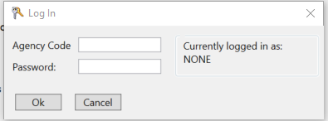

- The Agencies window on the main EW display is opened.
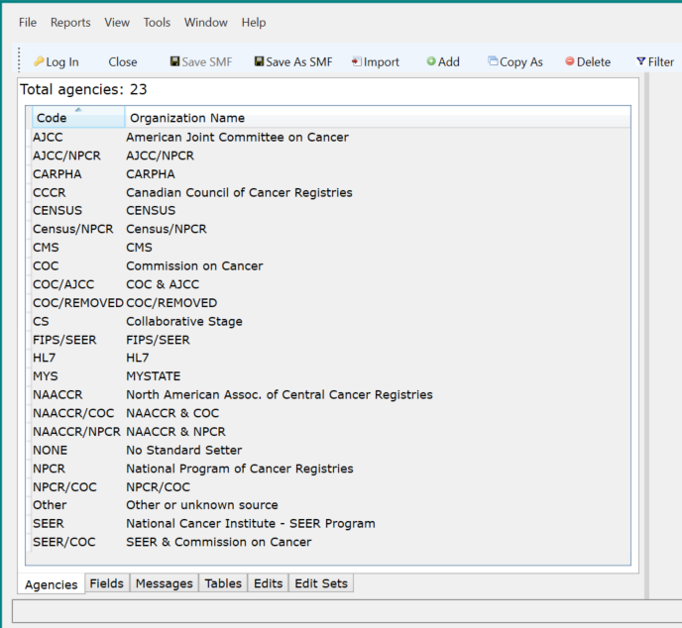
- Click on Add to bring up a new Agency screen.
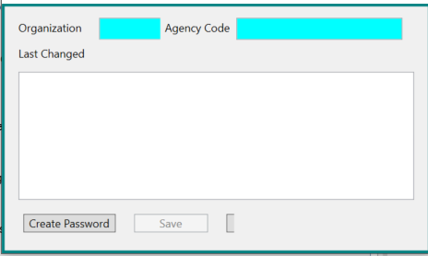
- Add an agency and provide username and password.
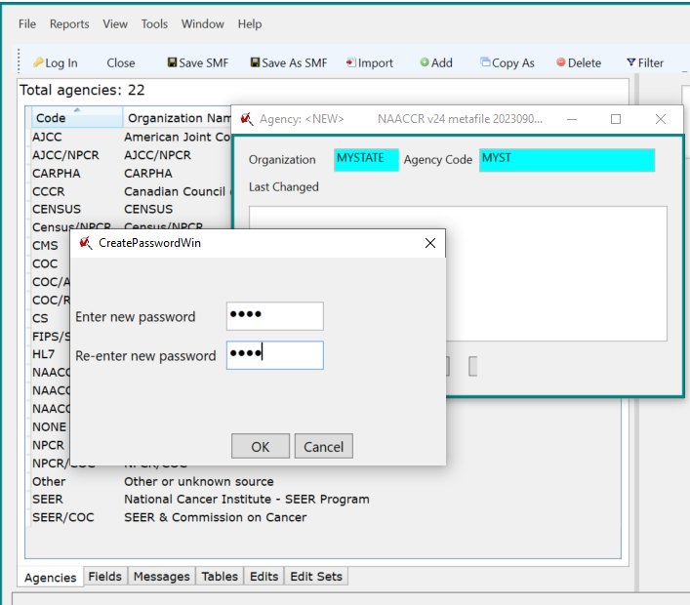
- Click OK to save the password.
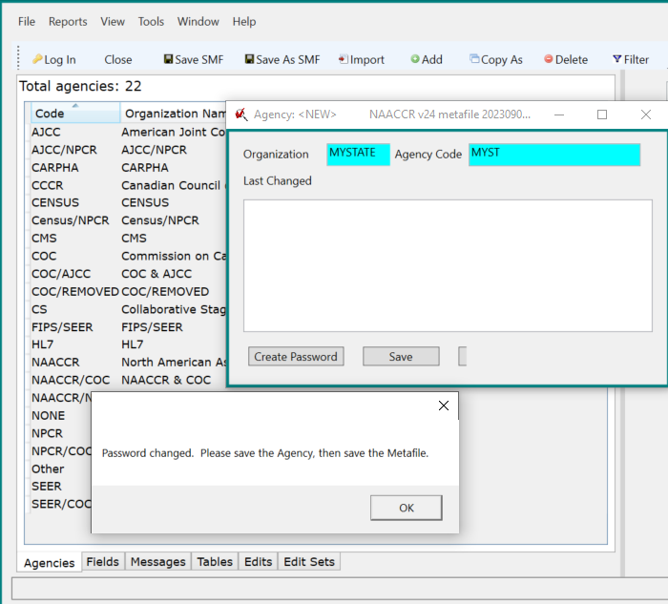
- Click OK to save the agency.
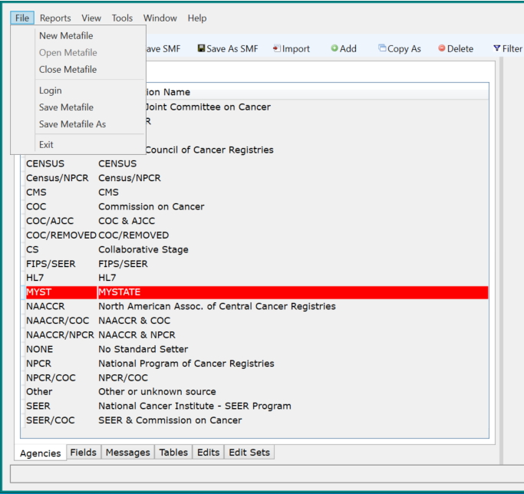
- Select File, Save Metafile As
The directory where the metafile is currently located is opened, with a window to enter the file name with the identification of file type SQLite metafile (*.smf).
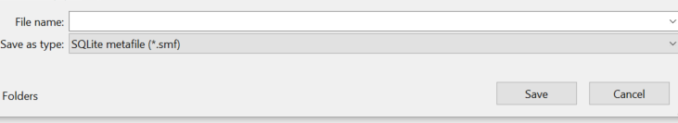
- Save the metafile. Then close the metafile or use the Log In option to log back in with the new username and password. See II.A. below for comments on naming and documenting the new metafile.

Lost Username and Password
The registry username and password will be brought forward whenever the registry agency object is imported into a new metafile.
If the existing agency password is lost, before import of any custom objects into a new metafile, the registry can create a new agency with password in the new metafile, using the same agency code as in the existing metafile. The registry can then import existing custom objects with the same agency code into the new metafile.
If the existing agency password is lost for a metafile with existing custom objects, and the registry does not want to repeat the work of merging custom objects into a standard metafile, the registry must delete the agency, and then create a new agency and password. Deleting the agency will cause all the codes for edits objects assigned to that agency to be converted to NONE. Each of these objects must then be updated with the new agency code.

CUSTOMIZING A METAFILE
As noted in the introduction, there are multiple approaches to customizing a metafile, from simply changing the name of the metafile to classify it as meeting the reporting requirements of a particular central registry, to including registry-defined data items and related edits.

Renaming the Metafile
A registry may rename a metafile without making any other changes. However, if any changes are made to a metafile, it must be Identified as modified and given a new name. See Section I.B.6-7 for screenshots of the procedure for saving a metafile with a new name. The naming convention for the standard metafile is:
- Originating agency, “NAACCR”
- Data Dictionary number for release year, such as “v24”
- Sequential alpha character for successive minor releases, such as “A” for first minor release, “B” for second minor release, and so on
- Date for release, such as “20231001”
An example of a corresponding name for a custom registry metafile might be “MYSTATE_v24_20240115”.
The new metafile name and appropriate comments should be documented within the metafile.
- Click on the Tools menu to open the Metafile Version window.
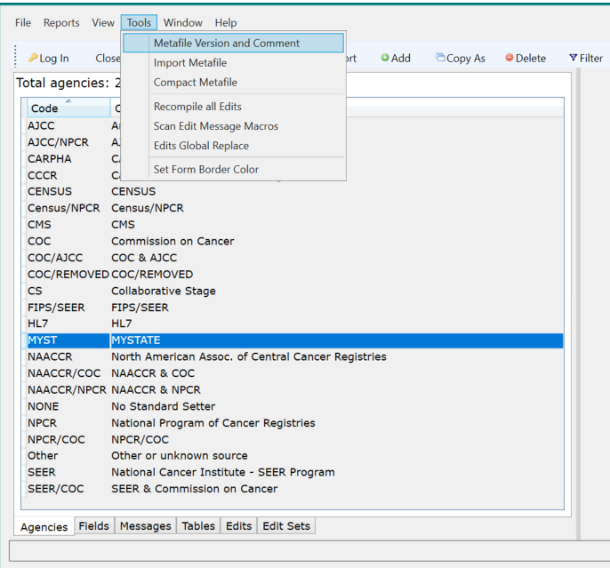
- List the name of the metafile including issuing agency, NAACCR version, and date of release in the Content Version window. Add any pertinent comments about the metafile in the Metafile Comment window, including agency contact information for any problems a user might encounter.
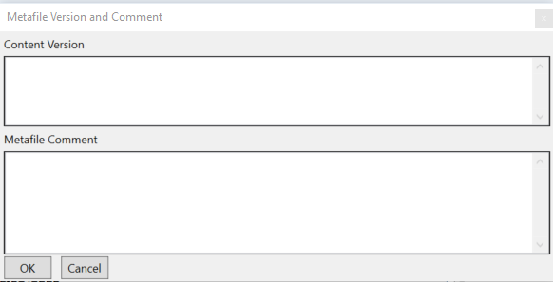
- Click on File, Save Metafile As, and enter the metafile name as prompted.

Removing Unused Objects
A registry may want to streamline a metafile for distribution to reporting facilities by eliminating objects that are not relevant to its requirements, or to simplify searching among edits, fields, messages, and tables. The standard metafile contains many objects which are not currently used in edits; it also contains edits that are not in any standard edit sets, and distinct purpose edits sets of limited use to the typical user.
A registry can take two approaches to paring down a metafile:
- Create a new metafile by importing the desired edit set(s) with dependencies from the standard metafile.
- Copy original metafile and delete extra or unused objects as desired.

Importing into a New Metafile
With this method, a new metafile is created. Agencies and the desired edit set(s) are imported from the existing metafile into the new metafile. Agencies are not dependencies, but are associated with all other edit objects, so they must be imported separately. Options for dealing with Agencies:
- Identify all required agencies for edits, fields, tables, and messages before starting import process; import only identified agencies before importing edit set.
- Import all agencies before importing edit set and retain all agencies in new metafile.
- Import only selected agencies before importing an edit set. Import any agency(s) as requested by the warning message that appears during import.
- Import all necessary agencies before importing an edit set. Identify all required agencies for edits, fields, tables, and messages after importing edit set; delete agencies not required after import.

Click File, New Metafile, enter File name, Save (see Section I.A.6-7).
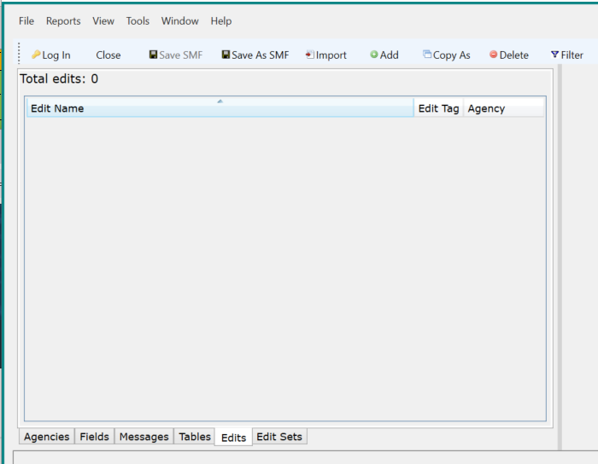

Click on Import, navigate to file importing from, select Agencies if importing all or selected.
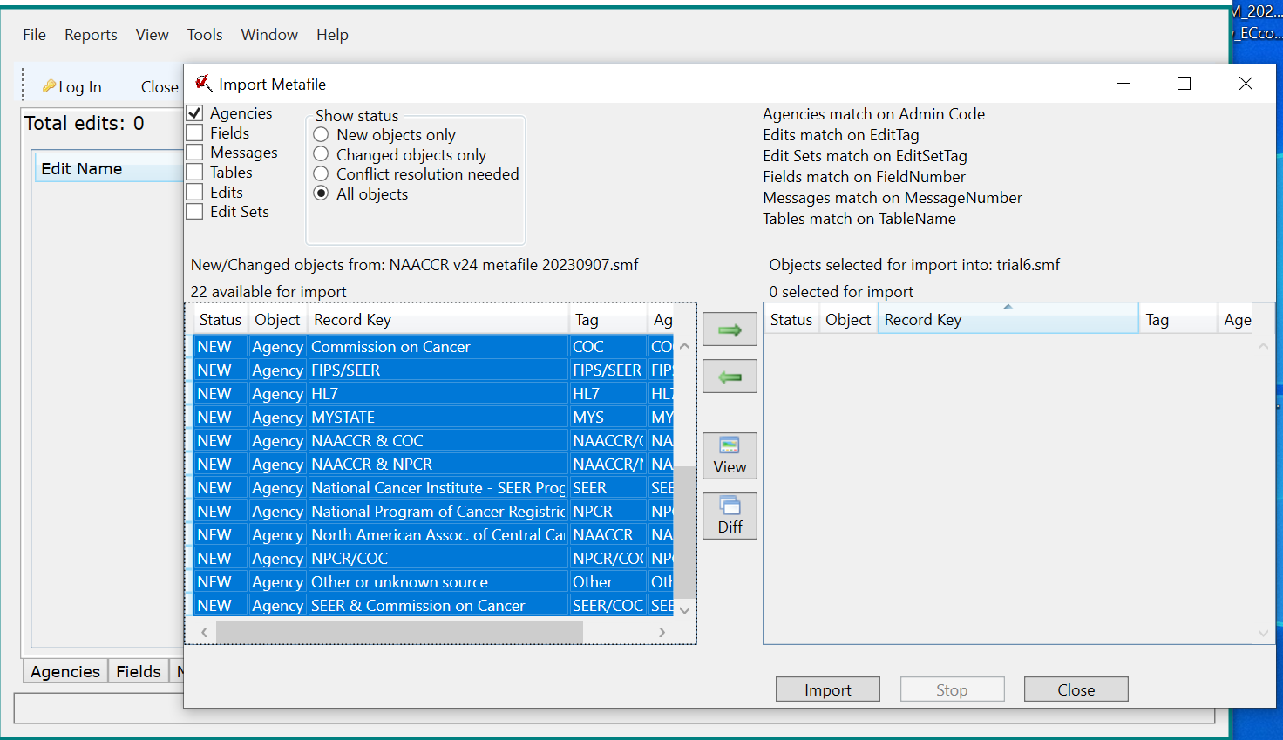

Move selected agencies to import window using right-pointing green arrow, click on import.
Select Edit Set to import.
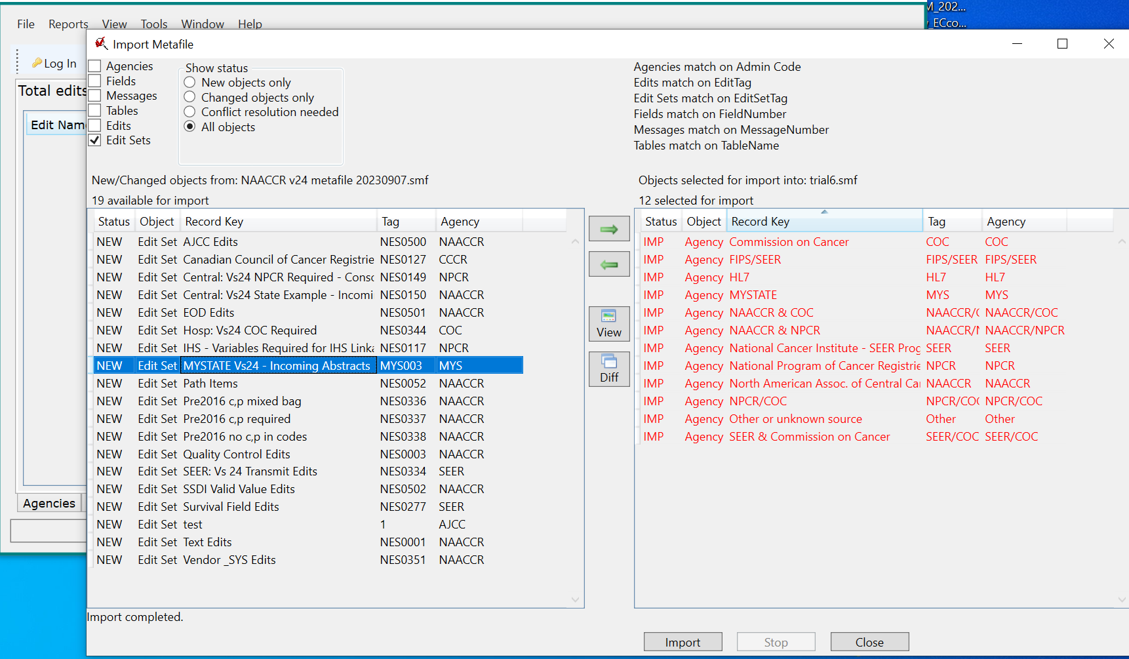

Move selected edit set to import window using right-pointing green arrow, click on import.
Message screen comes up for edit set. Select import with dependencies, check “Always do this for NEW Edit Sets”. Click OK.
Message screen comes up for first edit in edit set. Select import with dependencies, check “Always do this for NEW Edit Sets”. Click OK.
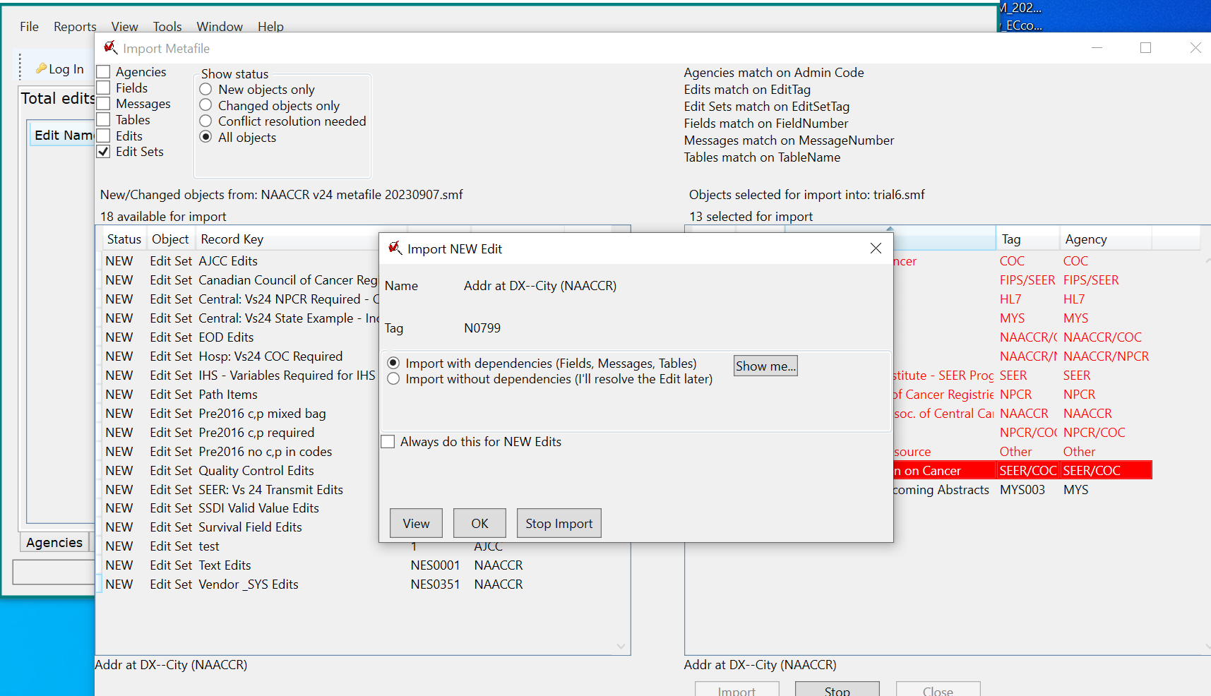
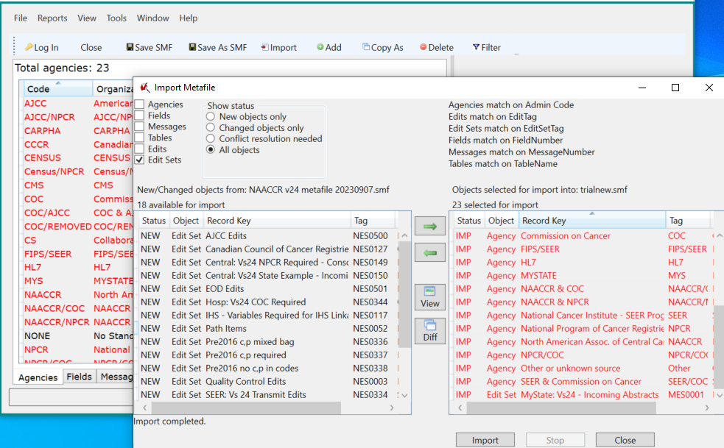

Review forms for Agencies, Fields, Messages, Tables, Edits, Edit Sets. All imported items appear in red. Delete any nonrequired agencies if desired. Save the metafile.

Deleting from Existing Metafile
Objects can be deleted from the standard metafile without being logged in with the agency username and password. Deletions can only be reversed by closing a metafile without saving changes. All deletes on Agencies, Edits, and Edit Sets include a Yes/No dialogue box. Deletes on Fields, Messages, and Tables include a dialogue box if these objects are used in edits; if they are not used in edits, they are deleted when delete is selected.
The most efficient order for deleting objects is: Edit Sets, Edits, Tables, Messages, Fields, and finally Agencies. Except for Edit Sets and Agencies, these objects can be filtered within EW to distinguish between objects used by edits and objects not used by edits.
- From list of Edit Sets, select Edit Sets to be removed and delete.
- From list of Edits, filter by not used in Edit Sets and delete.
- From lists of Tables, Message, and Fields, filter by not used in Edits and delete.
- From list of Agencies, identify by inspection those not used in any other objects and delete if desired.
If a single edit set metafile is created with the delete approach, this metafile can be updated with new releases of the standard NAACCR metafile, by carefully comparing the custom edit set with the related standard edit set. However, if a more wholesale approach is taken to streamlining the metafile or removing unused elements, a maintenance issue arises, as the next major version of the standard metafile will most likely contain the same objects that have been removed, requiring redundant deletions. The registry’s tracking system for changes to the standard metafile should include a record of all deletions.
Below are some screenshots of filtering and deleting from edit objects, and the warning messages associated with deleting an object used in edits.

Deleting Edit Sets
There is no filter on Edit Sets other than for date last modified.
A Yes/No dialogue box will appear if an Edit Set is selected for deletion.
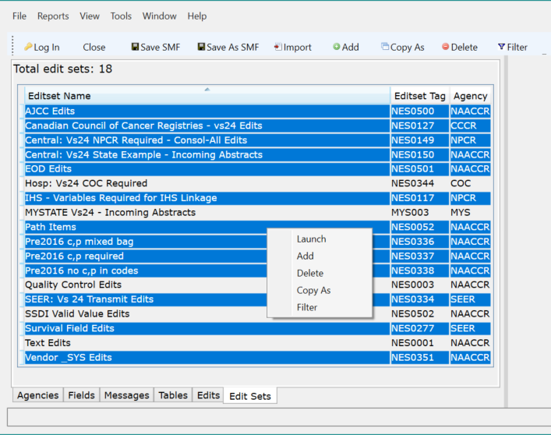

Deleting Edits
There is a filter for Edits used by Edit Sets and not used by the Edit Sets. The Edits filter for Edits Sets requires selection of the specific Edit Set(s) for inclusion and exclusion. A Yes/No dialogue box will appear if an Edit is selected for deletion (, if it is included in an Edit Set). The screen shows the filter on Edits by Edit Sets.
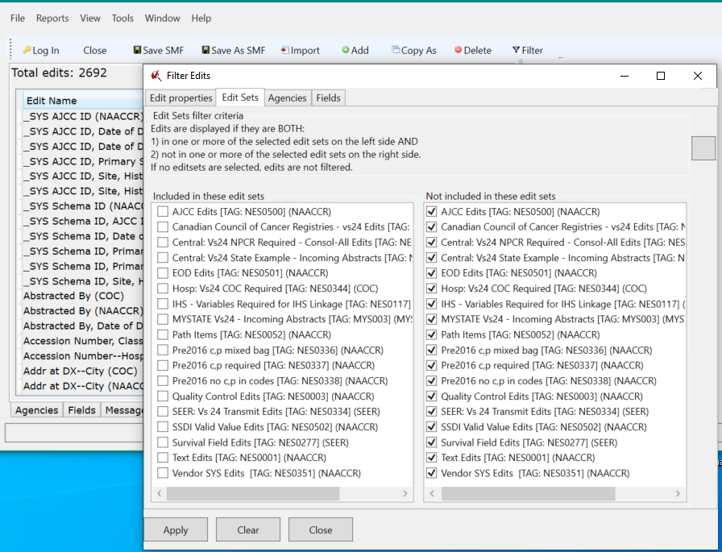

Deleting Tables, Messages, and Fields
There is a similar filter for each of these objects, used in Edits and not used in Edits.
A dialogue box will appear if delete is selected for any object used in the specific edits. Objects not used in Edits will be deleted. Message 0 is a default message that cannot be deleted. The screens show the filter options for the Tables and the Message window if Tables used in Edits are selected for deletion.
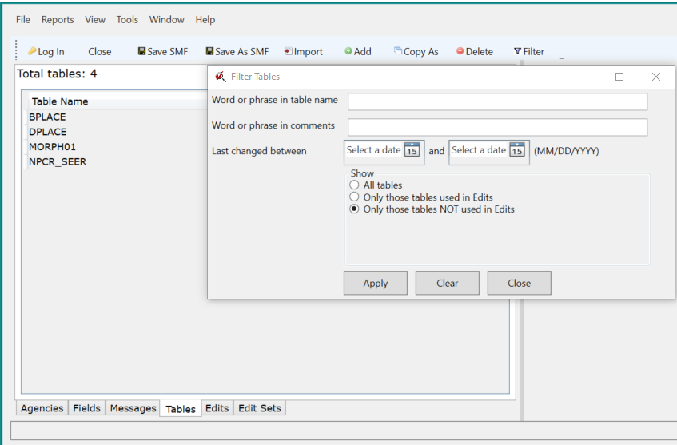
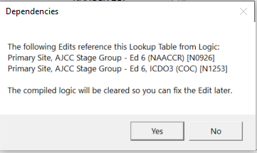

Deleting Agencies
There is no filter for Agencies. Agencies are assigned across edit objects. Agencies for all other objects must be identified visually if this list is to be shortened. Edit objects with a deleted agency will be converted to agency NONE, which can result in problems on importing between metafiles.
Agencies can be selected from the list and deleted by clicking on the menu tab or by right-clicking with a mouse. Only one dialogue window displays with a Yes/No question when deleting selected agencies.
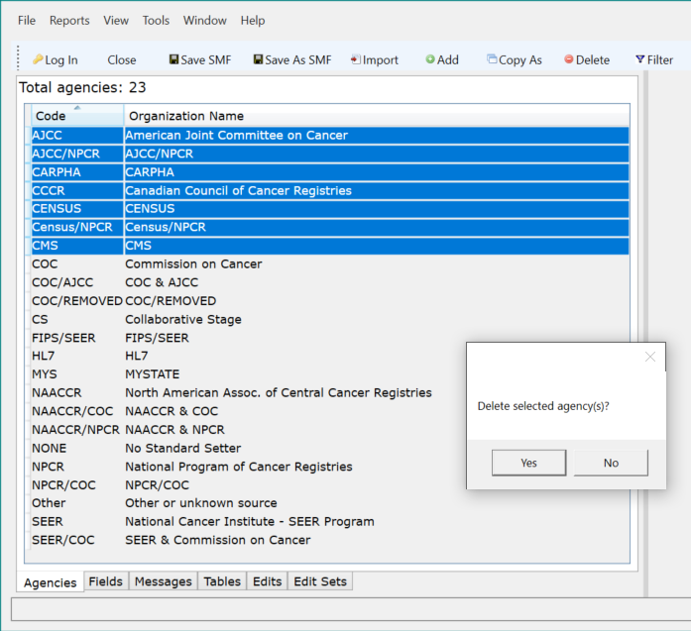

Revising and Creating New Edit Sets
The standard metafile includes edit sets designed to meet reporting requirements for CCCR, NPCR, COC, and SEER. There are additional special purpose edits sets, for example, edits for AJCC data items and EOD data items, edits on Site-Specific Data Items (SSDIs), and quality control edits. One NPCR Edit Set is for consolidated data at the central registry, while the second NPCR Edit Set is recommended for incoming data to the central registry from hospitals and other reporting facilities. A registry may use any of the standard edit sets without any modification, selecting one or more standard edit sets when running edits against a data file, using a program such as GenEdits Plus.
Registries may choose to modify a standard edit set, for example, adding AJCC, EOD, or SSDI valid value edits to an NPCR edit set, or adding quality control edits to a special run of a standard edit set. A registry may decide to use some but not all edits in the SSDI or Quality Control edit set, while keeping the selected edits as a separate edit set. A registry may decide to group standard edits involving colon cases for a special study on colon carcinoma, bringing in survival field edits. A registry may group certain edits into edit sets based on incoming data streams, such as edits for pathology reports, edits for hospital registry reports, and edits for physician office reports. Depending on the registry database management system, edit sets may be organized within a single metafile or distributed among two or more dedicated metafiles. A registry may dedicate one metafile to internal use, while distributing a metafile with a single edit set to reporting facilities.
A registry can customize an edit set in three ways:
- Delete edits from a standard edit set. This does not require an agency login, but the metafile is no longer standard and so the edit set and metafile must be renamed.
- Copy a standard edit set and add and delete edits. Rename and retag the edit set, assign and the agency. If a standard edit set is meant to be replaced by the new custom edit set, the registry must make sure that the new edit set is used in its data processing streams rather than the original standard edit set.
- Create a new edit set using the Add menu option. Name, tag, and assign the agency to the edit set.
If a registry has created multiple edit sets within a single metafile, the edit sets to be used for editing any data file must be specified by the calling program outside the metafile itself. GenEdits Plus, a stand-alone program developed by and available from NPCR, applies an edit metafile to a data file, allowing the selection of one or more edit sets for a single processing run. Other central registry systems which integrate editing with processing incoming data files must specify the edit sets to be used.
The naming and tagging conventions for standard Edit Sets for standard setter requirements:
- Name: Standard setter, release version, and target records, such as “SEER: Vs24 Transmit Edits
- Tag: NES (for NAACCR Edit Set), followed by 4 digits, carried forward to each new metafile release
- Agency: owner of data requirements for edits grouped into Edit Set. Agencies for standard Edit Sets based on the Required Status Table in the NAACCR Data Dictionary include CCCR, NPCR, SEER, and COC. NAACCR is the agency assigned to other focused edit sets.
A corresponding name for a custom edit set based on “Central: Vs 24 State Example – Incoming Abstracts” could be MyState: Vs 24 – Incoming Abstracts, with an Edit Set tag MES0001, agency MYS.
An option for identifying edits assigned to a registry’s custom edit set(s) is to assign the registry agency to all edits, including standard edits in custom edit sets. This provides an additional check on inclusion of appropriate edits in the registry edit sets, in addition to filtering edits by edit sets. The original agency included in the standard edit name together with the registry agency included in custom edits (see Section II.D.) provides a way to distinguish between standard edits and custom edits in the custom edit sets.
Following are screenshots of customizing the NPCR standard edit set, Central: Vs24 State Example – Incoming Abstracts, by adding edits from the AJCC Edits edit set. This example filters the edits first so they can be moved as a group. Edits can also be moved individually or in groups from an unfiltered list of available edits in the Edit Set window.
- Select edit set to be copied, click on Copy As in menu. Enter a new custom name, tag, and agency.
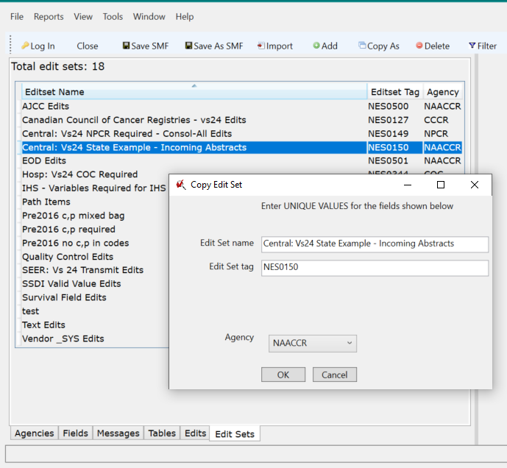

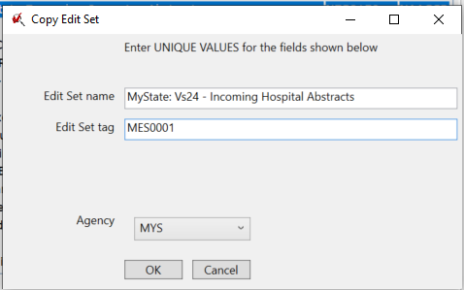
- Filter edits to identify edits in AJCC Edits edit set.
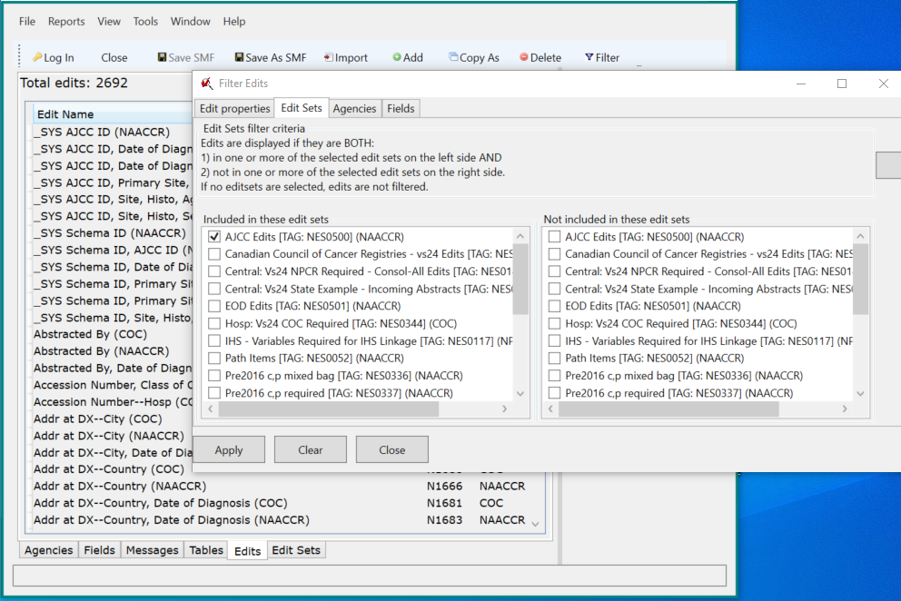
- Open new custom edit set and modify the edit set description.
Click on the filter icon at top of lefthand column to select filtered edits from Edit object. Filtered edits show in “Available Edits in this Metafile” column on left. Select edits.
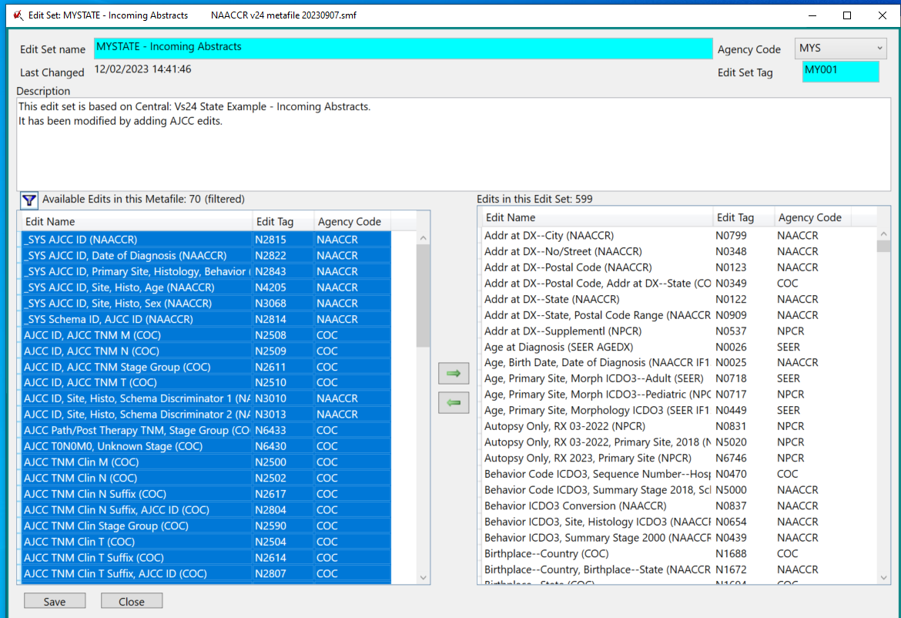
- Click on right-pointing green arrow to move edits into “Edits in this Edit Set” column on the right. Edits are moved to the bottom of right column.

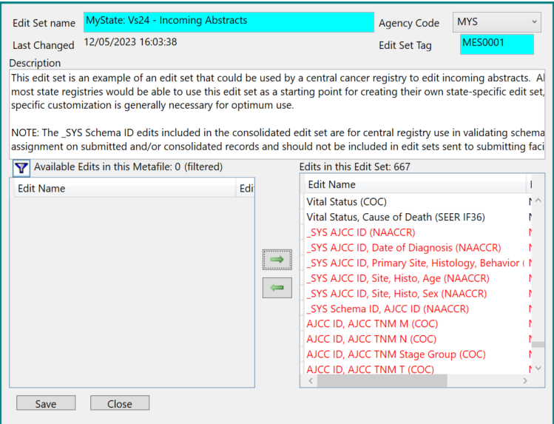
- Edits are resorted alphabetically when saving the edit set.

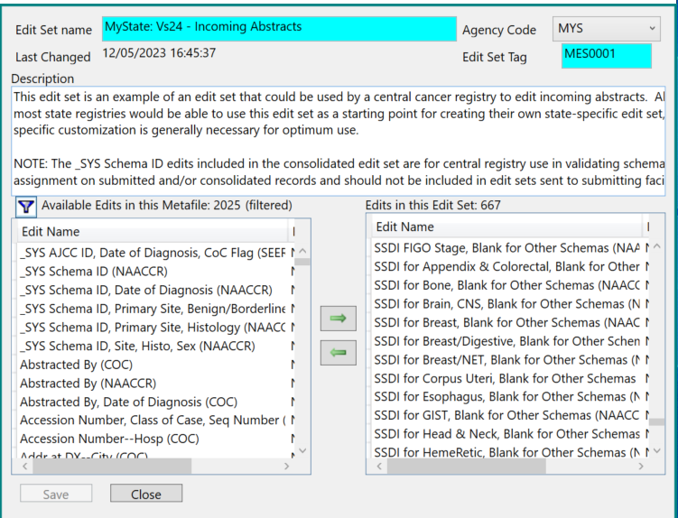
Creating a new edit set from the Add button on the menu starts with an empty edit set, but otherwise follows the same steps as above, examples 2-3 if working from a filtered list of edits, and examples 4-5 to move edits into the edit set.

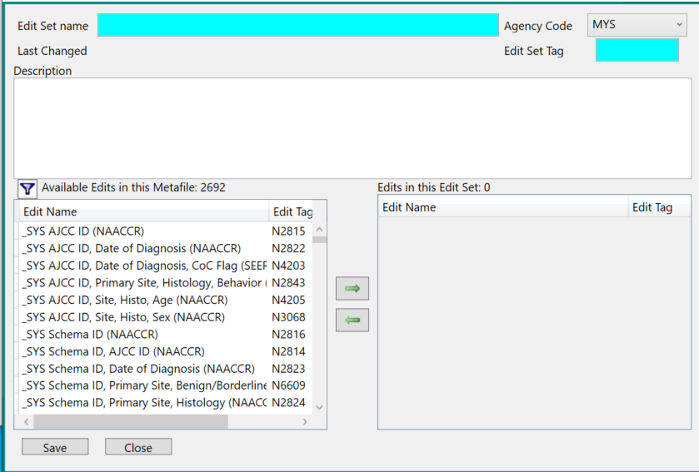

Revising and Creating New Edits for Standard Data Items
New edits can be created by copying and renaming standard edits and assigning new edit tags and agency. Edits can also be created anew from standard data items, assigning names, tags, and agency. The most common reason for changing a standard edit is to apply it to an earlier diagnosis date. A standard edit generally starts for cases with diagnosis date of the year the edit is implemented, which may be later than the year the data standard was published. Another reason for copying and modifying a standard edit is to apply “stricter” or “looser” criteria to the data relationship being evaluated, including blank and unknown codes.

Creating new edits for standard data items more likely relates to local or regional characteristics or population and geography, and local or regional data quality concerns. Potential subjects for central registry edits include:
- Edits on city by county, a level of detail which is prohibitive for a standard metafile to include for all provinces, states, and territories.
- Quality control edits between last name and race for a defined ethnic population within its catchment area.
- Edits on systematic local coding errors identified by quality control studies
- Edits on “unknown” text values.
- Edits enforcing data relationships not yet proposed to or accepted by the standard setters.
- As a special case, edits may be written for registries using data items that are mapped to standard items but with a simplified coding structure.
Whether copied from a standard edit or written anew, each edit is built and formatted as an metafile object within EW. Copied edits are already complete and just need modification in part, while existing edits can serve as templates for creating new edits. EW Help provides instructions, comments, and examples for working with edit logic. The Edit form or workspace contains the following parts:
- Edit header with windows or buttons to assign edit name, edit tag, and agency code.
- Description – text identifying purpose of edit, skips for specific data item values, content of data values or data relationships checked or validated by edit.
- Logic – edit content stated in programming language.
- Administrative Note – note of metafile in which edit first appears, documentation of changes made to edit after implementation.
- Error messages – data items ordered as they will appear in printed error messages, error messages explaining edit failure.
- Cross-References – list of edit sets where edit used, list of tables and fields used in edit logic.
- Test Bench – testing tool for edit logic.
The naming and tagging conventions for standard Edits:
- Name: fields of interest in edit logic followed by supporting agency in parentheses.
- Tag: N (for NAACCR), followed by 3+ digits. Current NAACCR edit numbers range from N0001 – N7090.
- Agency: supporting standard setter for an edit. Agencies for standard Edits are primarily based on the Required Status Table in the NAACCR Data Dictionary. Edits on data items required by a single standard setter are assigned to that agency. Edits on data items required by more than one standard setter are generally assigned to NAACCR.
The registry should follow a similar naming convention for custom edits. For standard edits copied and modified, it is recommended that the same name be used with the registry agency code in parentheses, the registry agency code assigned as agency. The registry should develop a tagging scheme which will not conflict with the NAACCR scheme, consisting of one or two alpha characters other than “N” followed by sequential numbering. The same numbers used in the NAACCR scheme could be used if desired to identify the custom edit as a copy from the original edit.
The edit description should state in plain language what the edit logic will do. Edit logic may be written to use tables if a registry is evaluating an abundance of data item instances, for example cities by county or zip code for a state.
The administrative note will contain notes for the original standard edit. These should be replaced with a new note identifying the first metafile for the new custom edit.
Error Messages can use tokens, %FX identifying the data item, X signifying number of data item in the left-hand list on the error messages screen, %VX identifying the value of the data item. It is essential that the token numbers are matched correctly to the data items in the left-hand list whenever an edit is modified. With copied edits, it is easy to make a mistake. It is recommended that the registry use a consistent ordering of fields in the left-hand list to make error reports on edit failures easier to follow. The standard edits for recent metafile version use Date of Diagnosis followed by Schema ID, AJCC ID, and remaining fields in NAACCR number order.
If a single error message can apply to all edit failures, it can be entered as the Default Error Message, and the edit logic can use the statement “return FAIL;” for all failures. If an edit requires more than one error message, additional messages can be assigned with a save_error_text(xxxx) statement with the relevant logic. It is essential here as well that the numbered error messages are placed correctly within the edit logic.
Appropriate standard error messages can be used for customized edits, either new or based on an existing edit. The agency assigned to an error message is not required to match the agency on the edit. If an appropriate standard error message is not located, an error message can be added, with the agency identified as that registry’s agency code. If an error message is added, it should be given a number starting with a high value, at least 20000 recommended, to avoid potential conflict with the almost 10,000 message numbers in the standard metafile.
All edits should be thoroughly tested using the Test Bench. Data values are entered at the top of the Test Bench form by double clicking on each data item. After selecting TEST, the evaluated logic is displayed in the middle section of the form. Edit logic highlighted in Grey has executed successfully. Greyed statements demonstrate progression through the edit logic to the result. The bottom section of the window displays the result of the edit review: Pass or Fail. Failure is accompanied with a descriptive error message(s).
The custom edit must be added to the correct edit set. A new custom edit set must be created if necessary to include the new custom edit. If the custom edit is replacing a standard edit already in the edit set, the standard edit should be removed from the edit set. Single edits may also be added to or removed from edit sets by clicking in the Cross-References screen of the edit form.

Custom Edit Copied from Standard Edit and Revised

The following is a set of screenshots demonstrating revision of a standard edit into a custom edit. Edit N7053, Grade at Autopsy (NAACCR), requires that grade autopsy is coded 8 (not applicable) or 9 (unknown); the edit is skipped for cases diagnosed before 2024. In the below example, the registry has decided to apply the edit to cases starting in 2020.
- Copy the edit and assign a new agency and edit tag.
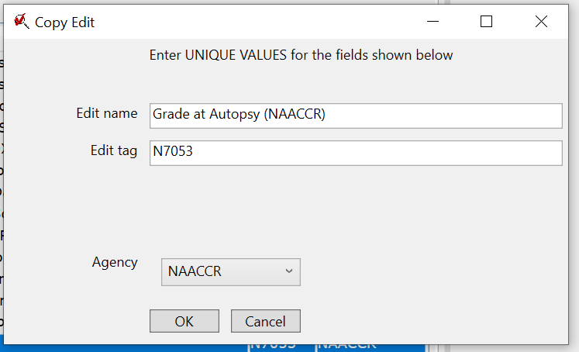

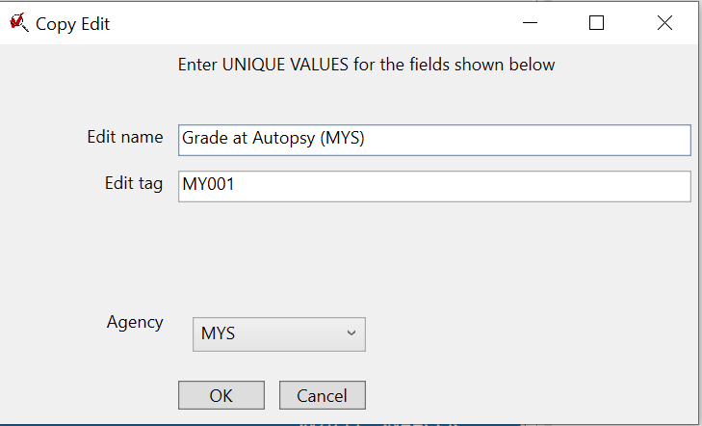
- Update the description and edit logic with a new date. The arrows point to changes from original standard edit.
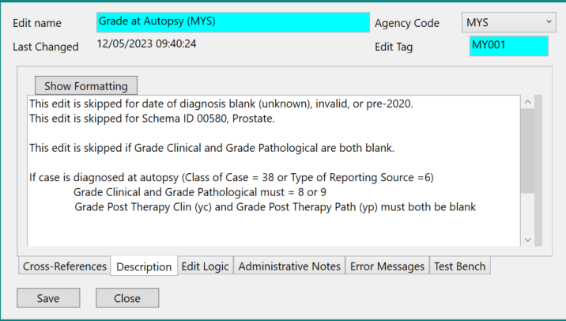

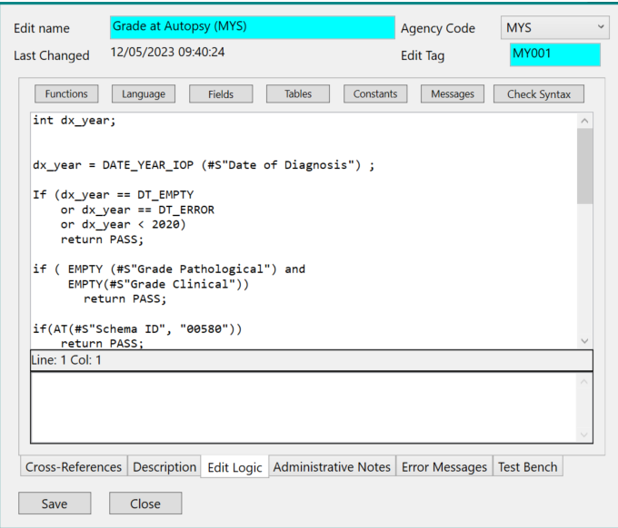
- Update the Administrative Note.
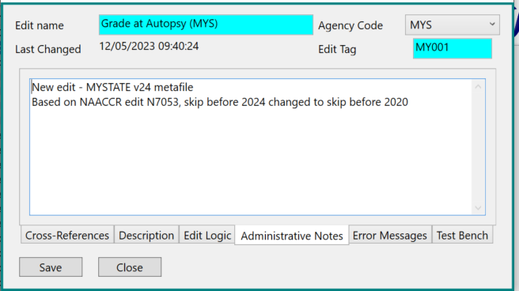
- Verify the error message is correct for the new edit content.
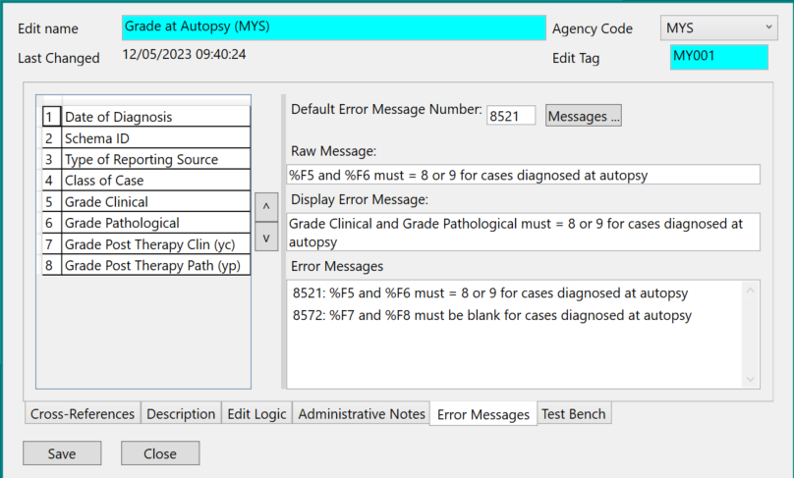
- Add the edit to the appropriate edit set on the Cross-References tab.
Click in the box next to the selected edit set, then click on "Save".

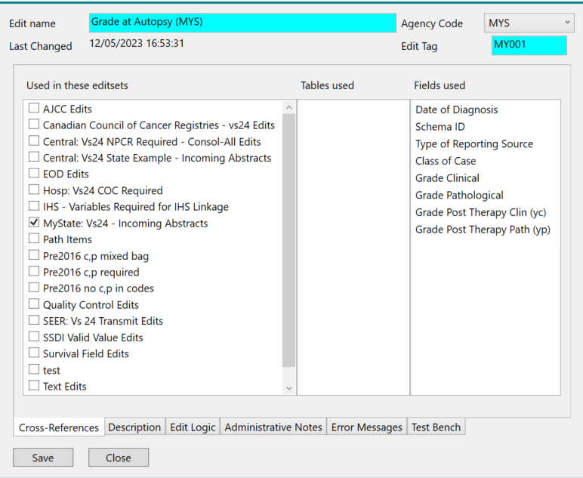

Custom Edits Using Standard Data Items
In this scenario, the registry decided to not allow unknown treatment codes. The displayed custom edit is skipped for Death Certificate Only cases and start with cases diagnosed in 2023 and later. Primary sites where 9 is required for RX Summ—Scope Reg LN are excluded. All other listed treatment data items must not = 9 or 99, unknown codes.
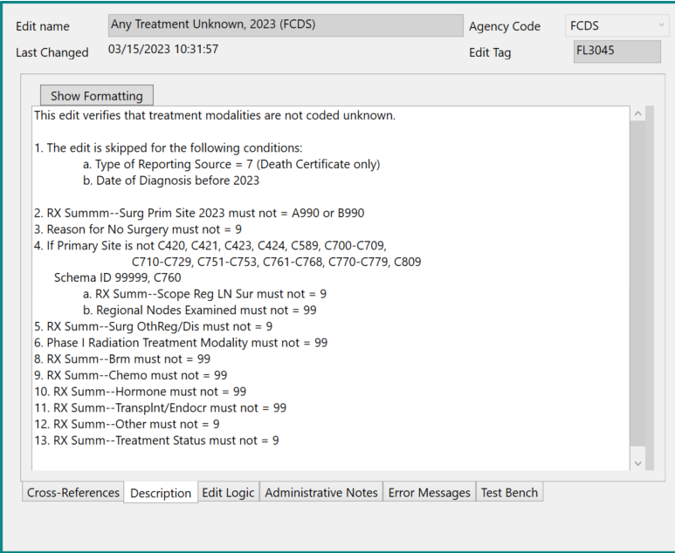

Creating a New Data Item
The final approach to customizing a metafile is to create new data items and develop pertinent edits. A registry must assign a unique name for the data item, develop a coding structure and coding instructions, specify any relationships with other existing or new data items as applicable, and publish this information to reporting entities. Registry policies and procedures will determine the research, field testing, and permissions required to establish and collect a new data item.
Types of new data items not included in standard items of interest to a central registry might be:
- Details of residency or occupation.
- Personal medical history including height and weight.
- Details of tobacco history.
- Details of other exposure history.
- Case processing and control elements.
- Patient, facility, and physician contact information.
Types of new data items that might be of more interest to reporting facilities than central registries, and therefore requested for inclusion by software vendors in their registry program, might be:
- Chemotherapy regimens.
- Hormone therapies.
- Alternative therapies.
- Clinical trial enrollment.
Standard data items are occasionally discontinued or removed from the NAACCR Data Dictionary. Any associated edits may be rewritten if they contain relationships involving other data items. If any edit cannot be rewritten, it is removed from the standard metafile. If a registry decides to keep such data items for their edits, the data items and relevant edits must be recast as custom objects.
Defining new data items and adding them as field objects in EW require new procedures. Previously data items were identified to EditWriter and metafile processing programs by their position in a flat file data layout. Layouts have been replaced by an XML data transmission protocol which identifies data items by NAACCR ID and NAACCR number. The registry must create a User Dictionary for the data item (or add to an existing User Dictionary), using the Exchange Plus program from NPCR, and add the Data Dictionary information into EW as a field object.

Data Dictionary
The Exchange Plus program may be downloaded from the NPCR website, https://www.cdc.gov/cancer/npcr/tools/registryplus/exchange-plus.htm. The Dictionary Maintenance module “is intended to help users who are not XML experts produce valid NAACCR XML dictionaries. The audience includes edit metafile administrators who may be asked to define a user dictionary based upon custom items collected at their registry.” Clicking on the program Help icon opens detailed instructions Exchange Plus. Clicking on the program Dictionary Maintenance icon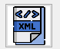 opens the workspace to create a User Dictionary. The user must specify the base NAACCR Data Dictionary (for example NAACCR-dictionary-240)and bring in an existing User Dictionary for modification or create a new one. With the base dictionary opened and a user dictionary identified, the workspace allows access to the grid for entering a new data item.
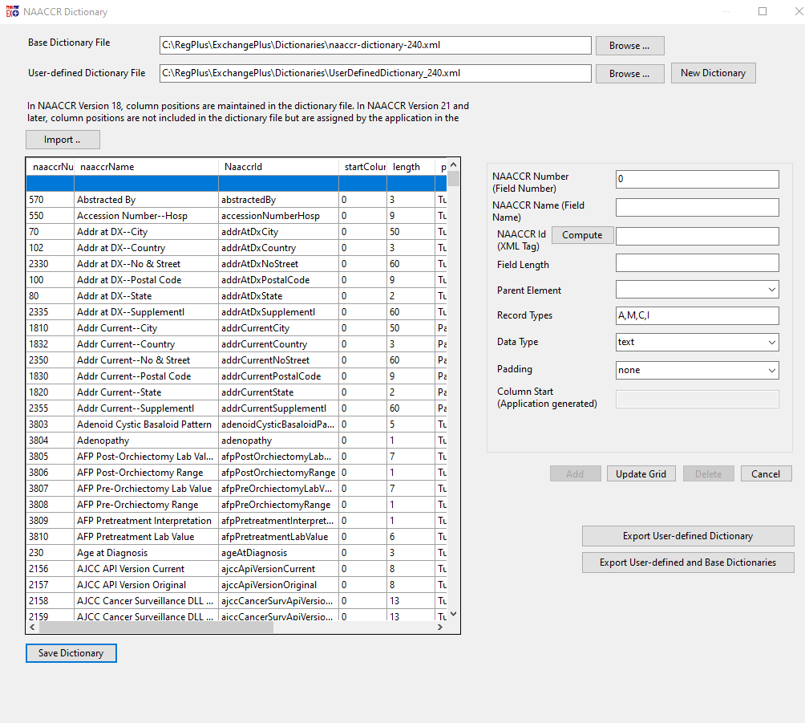
The Add button is clicked to open the grid, and the Update Grid button is clicked to save the new item. The Save Dictionary button is clicked to save the User Dictionary.
The grid elements include:
- NAACCR number (9500-99999 is suggested).
- NAACCR Name (Field Name).
- NAACCR ID (XML Tag), computed by the program.
- Field Length.
- Parent element (NAACCR data, patient, or tumor)
- Record Type, assigned as A, M, C, I.
- Data types, selected from digits, alpha, mixed, numeric, date, text.
- Padding, selected from left zero, none.

Edit Object – Fields
The User Data Dictionary file must be linked with the program that processes edits against a data file (GenEdits Plus from NPCR is one such program). However, the User Data Dictionary is not directly linked to EW. The new data item must be separately entered as a Fields edit object through the Fields form.
- Click on Add from the Fields tab.
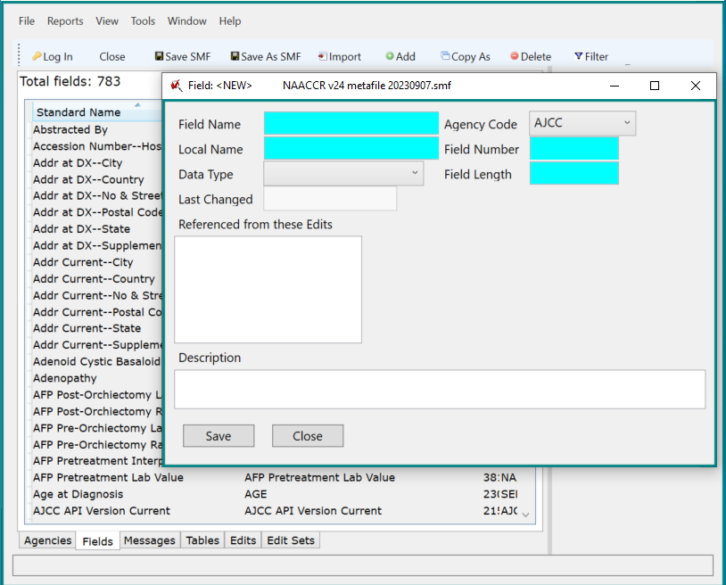
- Add Field Name – same as NAACCR Name (Field Name) in the Dictionary window.
- Add Local Name – same as Field Name.
- Add Data Type – same as Date in Dictionary window, String for all other types entered in Dictionary.
- Select Agency code from dropdown menu.
- Add Field Number – same as NAACCR Number (Field Number) in the Dictionary window.
- Add Field Length – same as Field Length in the Dictionary window.
Once the data item has been added to EW, it is available for inclusion in edits, either as a single data item or in relation to other custom or standard data items. Types of edits to consider include:
- Valid value – verify coded values are correct.
- Date – verify item is collected as of a specified diagnosis date.
- Comparative date – verify that event occurs before or after another event.
- Disease relationship – verify that item is relevant to primary site, histology, or stage.
All comments in II.D. on writing new edits pertain to edits for new data items.

New Data Item Example
In this scenario, the registry defined and collected Date of Death as a distinct data item, compared to the data items Date of Last Contact and Vital Status used to record date of death in standard data manuals. A custom data item was created in Exchange Plus and added as a field object to EditWriter.
An edit was written to check for valid date. The description and logic in the edit are very similar to many other standard edits which validate dates, illustrating a common mechanism for building new edits by using existing edits as templates.
A second edit compares Date of Death and Vital Status. This edit is similar to but not copied from standard edits which compare Date of Last Contact and Vital Status. Vital Status is a standard field, but the codes as displayed here have been defined as 1, Alive, 2, Dead, and 9, Unknown, an example of a data item that can be mapped to a standard item but with an alternate coding structure.
Following are screenshots from:
- Exchange Plus workspace adding a custom field Date of Death to a user dictionary.
- XML file for the custom data dictionary.
- Field object added to EW.
- Edit using the custom data item.
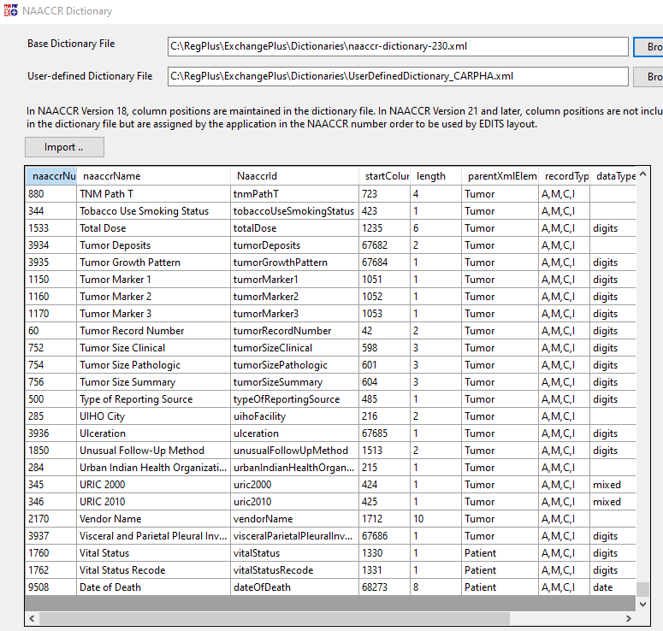
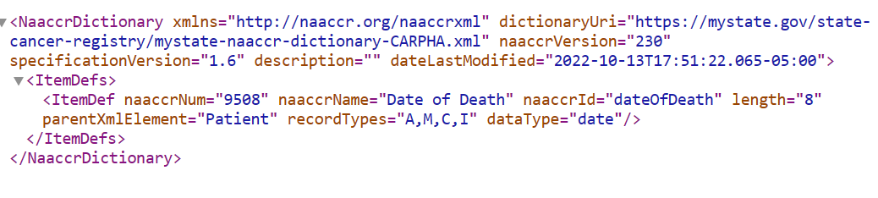
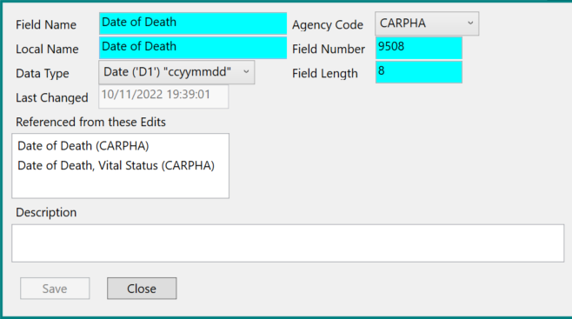
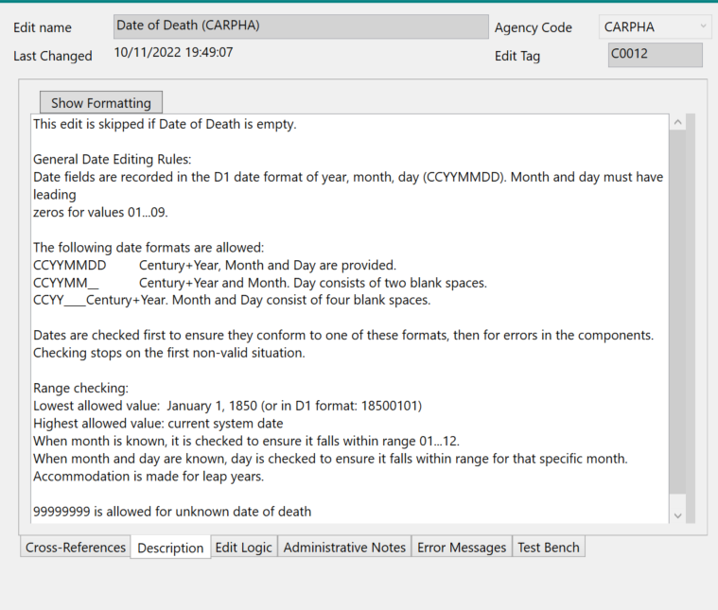
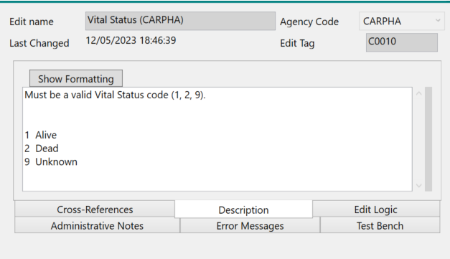
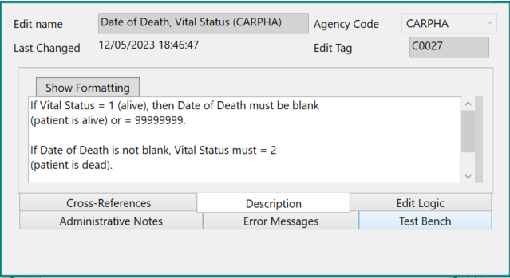

UPDATING A METAFILE
Registry data standards change with the evolution of oncology information reflecting basic research in pathologic processes and analysis of treatment protocols and outcomes. Changes in standards entail similar changes in edits, resulting in significant metafile revisions every one or two years. The NAACCR Edit Administrator and NAACCR Edit Workgroup are responsible for updates to the standard edits and metafile. Central registries that collect data from reporting facilities and transmit to the national standard setters are responsible for incorporating changes into their programs. They must review standards and edits documentation, assess their impact, and update both their own coding manuals and edit metafiles as necessary for their reporting facilities. Registries must make sure that any customizations in their metafiles remain current, as they must include new edits, updated logic, and remove outdated edits.
This section discusses metafile documentation and the procedure for updating a registry metafile to a new version of the standard metafile. As noted in the introduction, major releases of the metafile follow significant changes in the NAACCR Data Dictionary, such as new data items, new coding structures, or new reporting requirements. Interim minor releases correct metafile issues or introduce new edits. Source documents for national standards are identified as a starting point.

Standards Documentation
National standards may be published online or made available to registry software systems through APIs (application program interface) and DLLs (dynamic link library). Many standard resources are regularly updated, often on an annual basis, with accompanying change logs. NAACCR maintains the master Data Dictionary for member organizations as well as specialized data manuals and implementation guidelines for new standards. COC publishes accreditation standards including data requirements for facility cancer programs. AJCC develops staging protocols for cancer data. As well as publishing data standards for national SEER registries. SEER has pursued multiple initiatives for guiding consistent assignment of site and histology codes defined by the World Health Organization (WHO). NAACCR provides a list of standards resources at https://www.naaccr.org/implementation-guidelines/.
- NAACCR
  - Data items and codes – NAACCR Data Dictionary, Implementation Guidelines with conversion specifications for new Data Dictionary versions, Grade Manual, SSDI Manual.
  - Required data items for CCCR, NPCR, COC, SEER – Required Status Table within the Data Dictionary.
  - Primary site and histology codes – ICDO3 Implementation Guidelines, Annotated Histology List.
- COC
  - Data items and codes – STORE, CTR Guide to Radiation Coding.
  - Staging – AJCC TNM staging protocols.
- SEER
  - Data items and codes – Program Coding Manual, Pediatric Staging Manual.
  - Primary site and histology codes – Site/Histology Validation List, Hematopoietic Database, PathCHART database, Solid Tumor Rules.
  - Staging – SEER*RSA for EOD, Summary Stage 2018.

Metafile Documentation
Metafiles are posted for downloading on the NAACCR website, www.naaccr.org/standard-data-edits/. Posted along with any metafile are a change log spreadsheet, detailing changes in the new metafile from the last posted metafile, and an edit set spreadsheet identifying edit sets and all included edits by standard setter (CCCR, NPCR, COC, SEER). An edit detail report is also posted, containing a description of each edit in the metafile; this is a lengthy report, pulled from all the edits in the metafile.
The change spreadsheets for both major and minor versions of the metafile describe any changes across edit objects from the last posted metafile. The change log spreadsheet for a new major version identifies changes made in response to standard updates in the latest version of the Data Dictionary. Some new standards may result in changes across multiple edits, which may be grouped together by types of change. The change log spreadsheet for a new minor version documents similar changes across edit objects. The edit documentation identifies both new and deleted edits. The documentation on the change spreadsheet is not cumulative and is not as detailed for Error Messages as for other edit objects.
Changes for edits and tables are documented within the EW software, and the documentation should match what is on change spreadsheets. Documentation is included in the Administrative Notes tab for edits and in the Properties tab for tables. These tabs in many cases identify the first metafile version in which the edit or table was added and maintain a cumulative log of changes across metafiles. Documentation of edit issues resolved by clarification from standard setters may be included within edit descriptions. Changes for other edit objects, such as edit sets, fields, and messages, are not routinely documented within EW. Deletion of edits from the metafile is only documented in change log spreadsheets.

Assessment of Change
The revision of the Edits metafile to a new major version begins with review of the NAACCR Data Dictionary and particularly the Required Status table, http://datadictionary.naaccr.org/?c=8. Practically, the central registry will be aware of pending changes to the Data Dictionary and their standards organizations and will have decided on data items to require from reporting facilities before the metafile is released. The edit sets for the standard setters in a metafile are tied to the standard setter requirements in the Required Status table. Generally, there is an edit checking required values for each data item, an edit checking that the value is reported for each standard setter requiring the data item, and additional edits which compare reported values across related data items. The valid value and required status edits will likely be included in the first version of a new metafile. Edits across related data items may be included in the first or later versions of a new metafile.
When moving to a new major version of the metafile, the edit set spreadsheet should be reviewed to determine if a standard edit set will satisfy registry reporting requirements, or if a customized edit set will be necessary to edit all required data items. The edit detail report may be reviewed for specific information on each edit the registry is considering; the same information is also available for inspection within the metafile itself.
In addition to reviewing any new edits which may have been added to a standard edit set, the registry should review the edit set spreadsheet for existing edits which may have been moved into or out of standard edit sets. If the registry has based a customized edit set on a standard edit set that has been revised, the registry must decide whether to remain in synch with the standard edit set. An edit may have been removed from an edit set because the standard setter no longer requires editing the data item, or the edit does not serve its desired purpose, or the edit can be replaced by a similar edit from another standard setter. The registry should also review any new edits not included in a standard edit set that it typically uses, to determine if these edits meet data requirements that the registry chooses to enforce.
A registry may have custom edits for its own use in the current version of the metafile. The registry must review these edits to determine if they should be kept. If the edits are kept, the registry should also review the change log spreadsheet for any suggestions before modifying the existing customized edits. For example, if new data items are linked to a diagnosis date, an existing edit may have an open-ended diagnosis date that needs to be closed if the data item is no longer required after a certain date. Any changes to standard edits which have been copied and customized should be carefully reviewed, to determine if similar changes should be made to the customized edits.
The change log spreadsheet should be reviewed for any edits which may have been deleted from the standard metafile. The registry should determine if there is a reason to keep any deleted edits, or customized edits based on deleted edits. The change log spreadsheet should provide specific information about why an edit was deleted. Usually, edits are deleted because they have been replaced by other edits, because of unresolvable problems or conflicts in how logic has been applied to registry data, or because they conflict with other edits.
If a registry has not implemented the first version of a new major version of the metafile before a subsequent minor version is released, the registry may go directly to the subsequent version without first implementing the initial version. Each of these metafiles contains the full complement of edits available at the time of release, they are not supplemental, so a registry would be best served by starting with the current version of the metafile in use. As noted previously, the change spreadsheets are not cumulative, so the registry must review any spreadsheets detailing changes from the existing metafile in use to the metafile being installed as the new major version.

Update Procedures

No Changes to Metafile
After the registry has downloaded the NAACCR standard metafile, identified the data items to be collected and edited, and reviewed the edit set contents, the registry may decide to use one or more standard edit sets without customization. If deemed appropriate by the agency, the NAACCR standard metafile is ready for use in its downloaded form. The registry may choose to rename the metafile at this point to demonstrate that it has been reviewed and approved for use.

Custom Changes from Current Metafile Added to New Major Version
If the registry has custom objects in the metafile currently in use and wishes to retain them after a change to a major version of the metafile, the custom objects must be imported into the new metafile. The following screenshots demonstrate the import process. The new major version of the metafile is the target metafile, and the current metafile with the registry’s custom objects is the import metafile.
- Open the new metafile and select Import. Navigate to the current metafile and open.
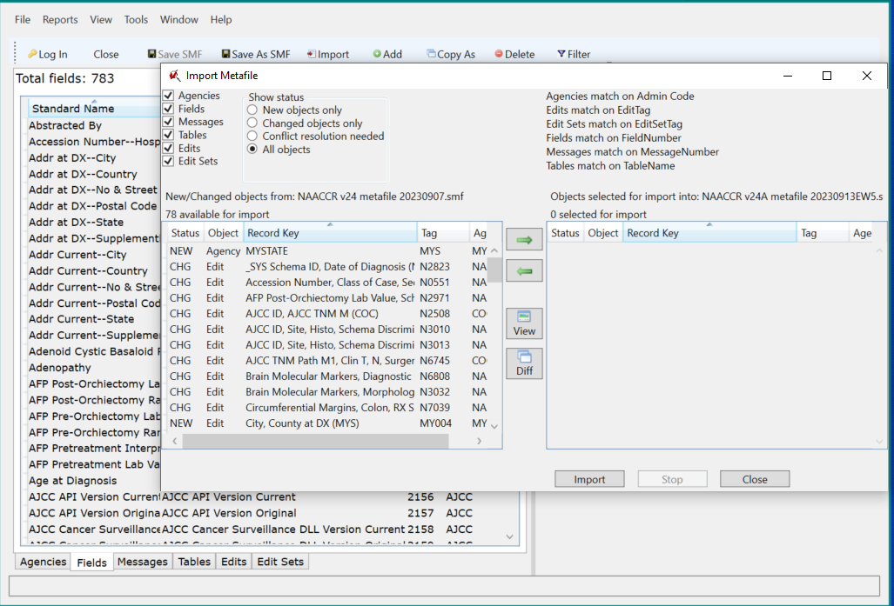
- Click in Agencies in left column at top. Sort on Agency in New/Changed objects window. Select custom agency identified by registry agency code. Move to import window by Click on right-pointing green arrow. Click on Import.
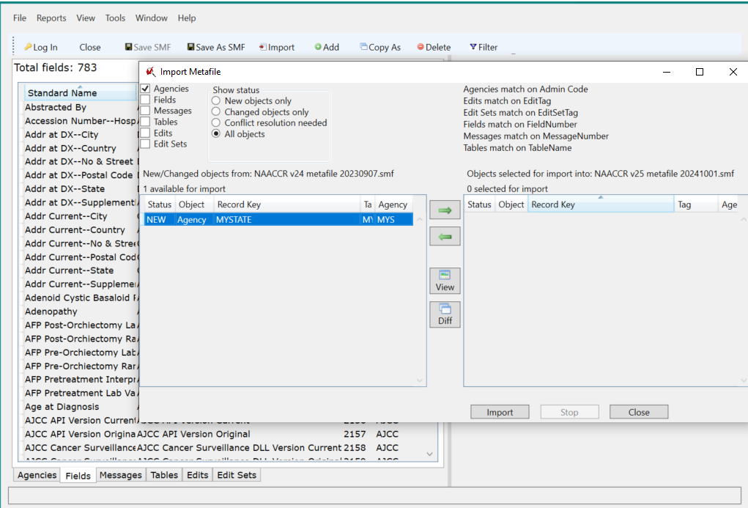
- Unclick Agencies in left column at top, click in Fields, Messages, Tables. Sort on Agency in New/Changed objects window. Select custom objects identified by registry agency code, move to import by clicking on right-pointing green arrow.
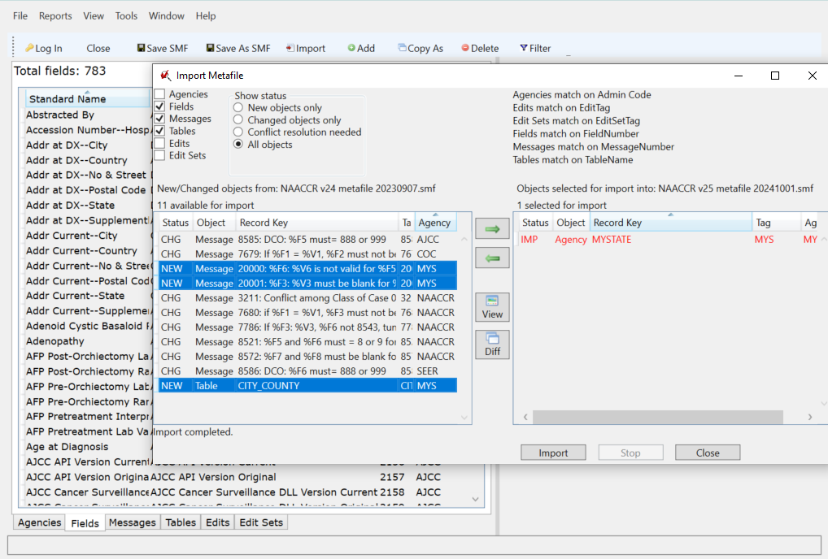
- Unclick Agencies in left column at top, click in Fields, Messages, Tables. Sort on Agency in New/Changed objects window. Select custom objects identified by registry agency code, move to import by clicking on right-pointing green arrow.
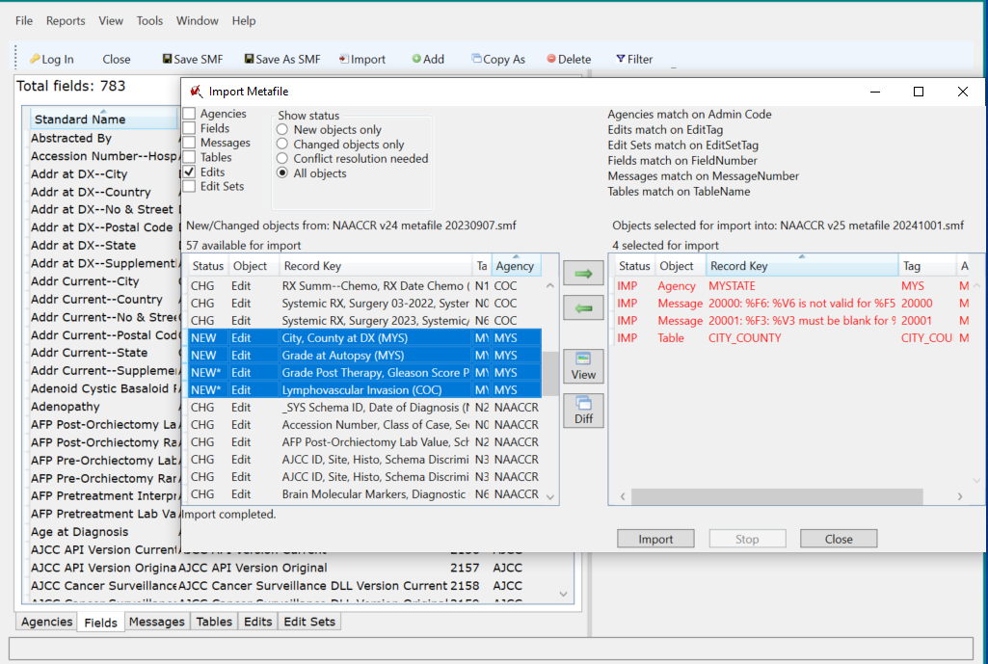
- Unclick Fields, Messages, Tables in left column at top, click in Edits.
Select custom objects identified by registry agency code, move to import by clicking on right-pointing green arrow. Click on Import.
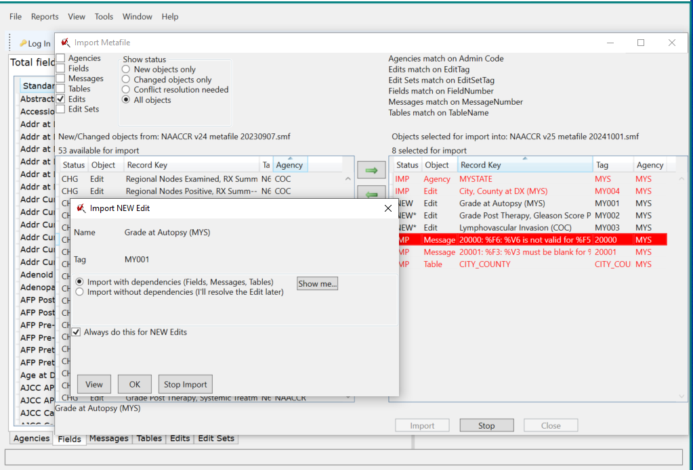
- Click on Import with dependencies if this message comes up, click in Always do this for NEW Edits, click OK.
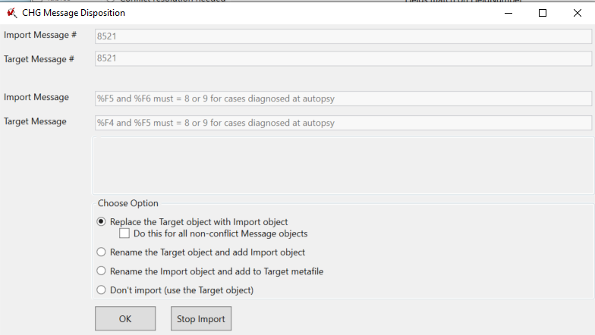
- If a warning message shows, evaluate for applicability to the custom edit. Click on Replace Target object with Import object, click on Do this for all non-conflict Message objects, if this message comes up. Make a note to check that the changed error message is okay if it is included in any standard edit.
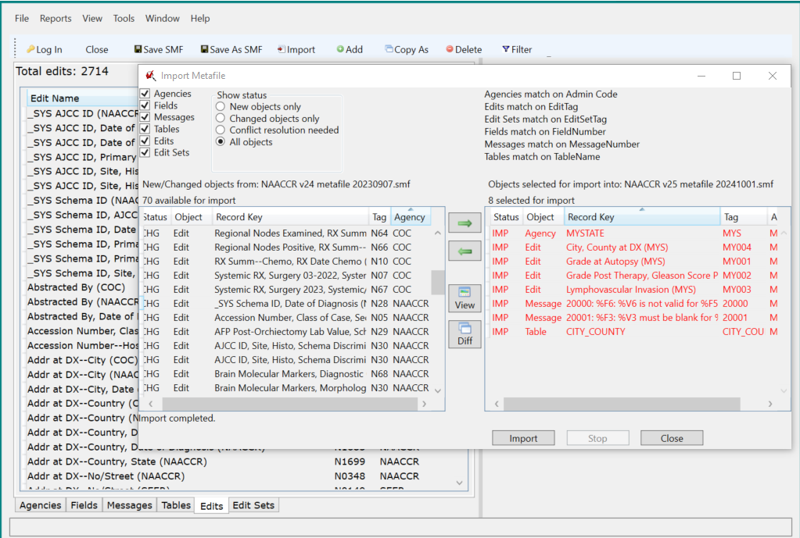
- Unclick Edits in the left column at top, click in Edit Sets.
Select custom objects identified by registry agency code, move to import by clicking on right-pointing green arrow. Click on Import. Click on without dependencies. Importing edit set with dependencies runs the risk of reintroducing objects that have been deleted from the new standard metafile.
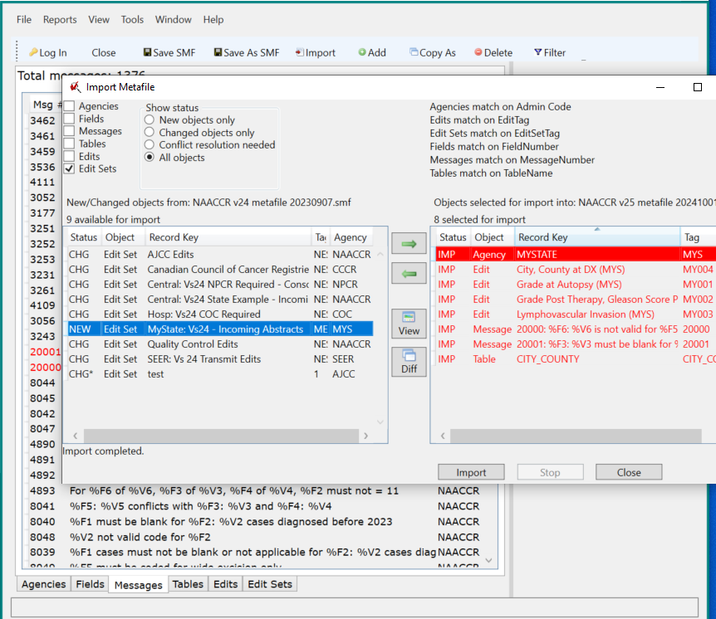
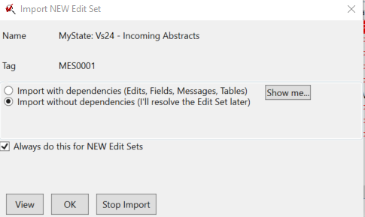
- Close the Import Screen, import is completed.
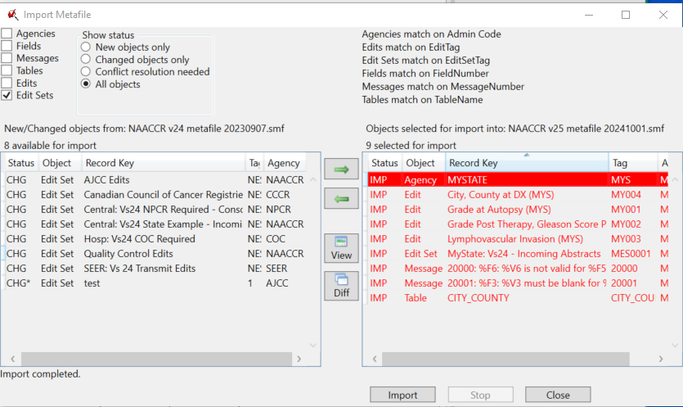

Custom Changes with a New Minor Version
Minor versions of a metafile are generally released to correct problems discovered when the metafile is put into use and applied to thousands of cancer records.
- Errors may be found in edit logic.
- Unforeseen interpretations of new coding and staging rules may occur.
- Standard setter requirements may be modified or update after initial release.
- New edits may be postponed at initial release for further review.
A central registry has options for updating to minor releases, depending on the amount of work they have already put into the major upgrade, the extent of customization, and the volume of changes in the minor release.
- Little or no time spent on upgrading to the major release – upgrade directly to the new minor version of the metafile. All relevant change spreadsheets must be reviewed for possible changes affecting custom edit objects.
- Registry metafile upgraded to new major release with smooth process within manageable time frame – upgrade directly to the new minor version of the metafile, moving all custom objects into the new minor metafile from the previously upgraded major, excluding edit sets. Bring custom edit sets forward depending on the amount of work for setting them up and their balance between standard and custom objects.
- Registry metafile upgrade to new major release with considerable effort and time – import the changes from the new minor release into the customized major release.
The following are screenshots demonstrating the procedure for importing from a new minor version of the metafile into the major version of the customized registry metafile. Here the new minor version of the metafile is the import file, and the major customized metafile is the target. The changed objects are identified in the import process and could be accepted as a group, or the changes between the import (new) object and the existing (target) object could be reviewed one by one through the Diff function available in the import tool.
- Open the existing major version of the metafile as the Target metafile.

Select Import, Navigate to the new minor version of the metafile as the Import metafile.
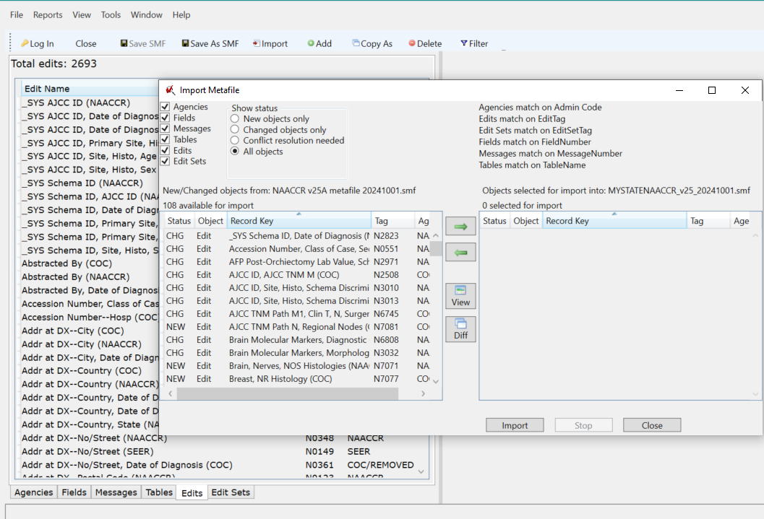
- Select any new or changed Agencies and import. If no changes, select any new or changed Tables, Fields, and Messages to import. Move to import by clicking on right-pointing green arrow.

- If a warning message comes up, click on Replace the target object with Import object, click on Do this for all non-conflict [type of] objects. Make a note of the object number involved, so the object in the metafile can be reviewed after the import is complete to verify that it is working correctly.
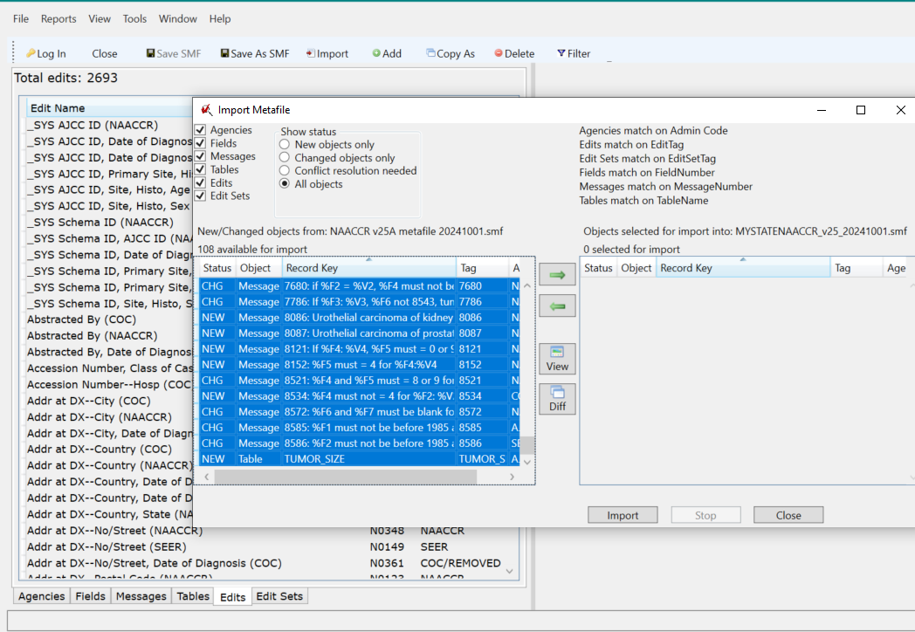

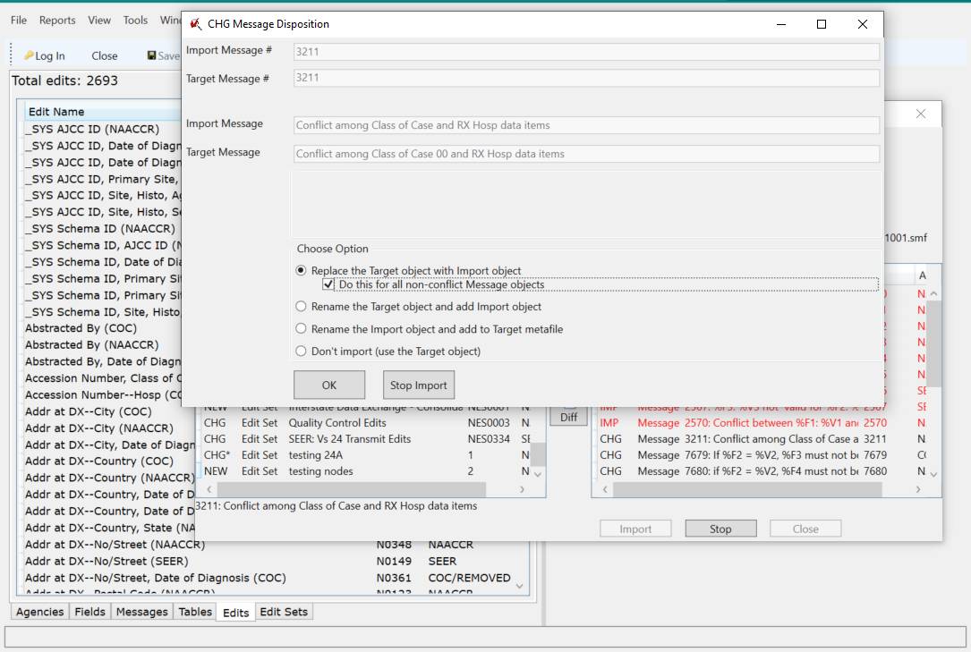
- Select any new or changed Edits to import. Move to import by clicking on right-pointing green arrow.
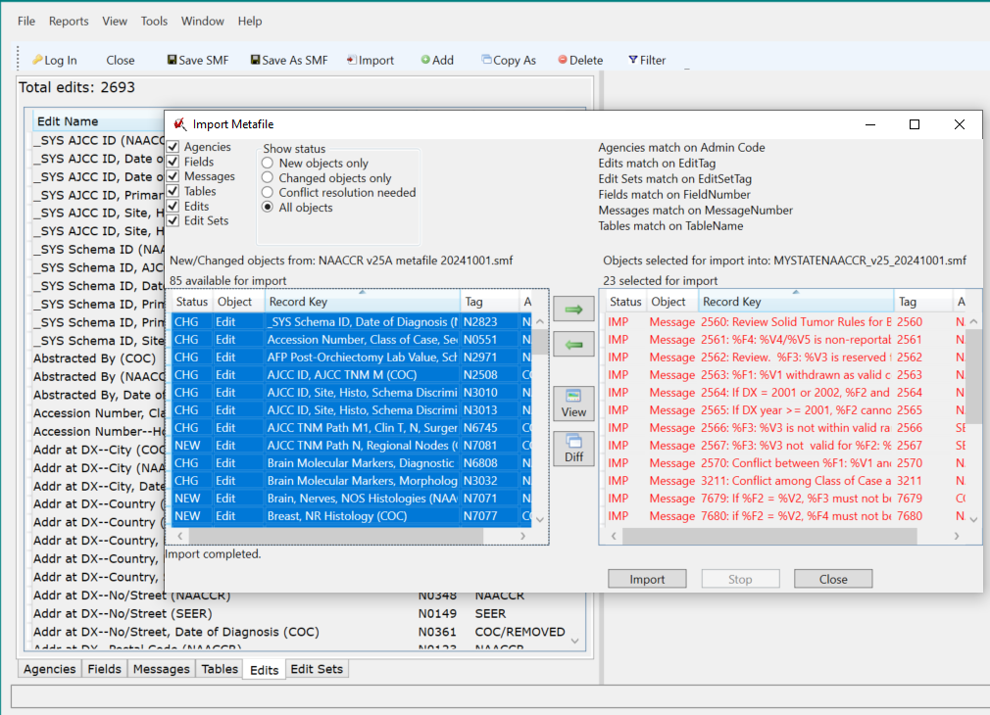
- Click on the View button to display a text file of any import or target object if review desired before object imported. Click on the Diff button to display a text file of both import (on bottom) and target (on top) object for visual comparison before object imported. The text files can be entered into a local diff program if available for automated comparison. The files will be stored in a Diff subdirectory in the EditWriter6 directory. (The files are retained in this directory and must be removed by the user.)
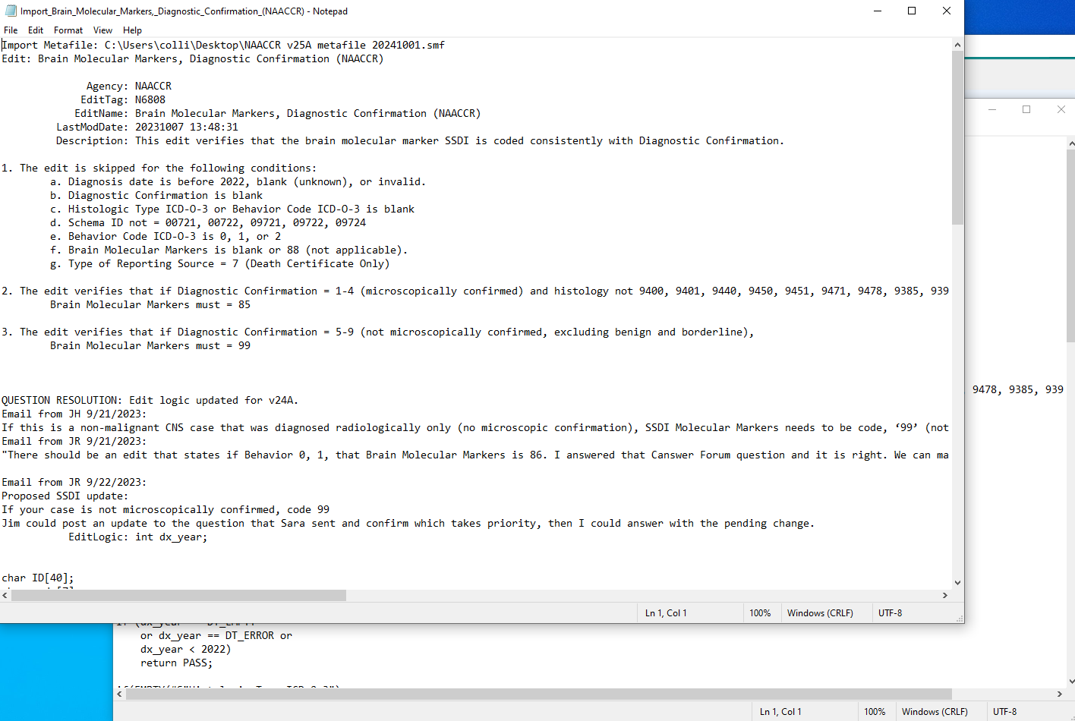
- Select any new changed Edit Sets to import. Move to import by clicking on right-pointing green arrow. If there are any “new” Edit Sets that have been previously removed from the custom metafile, they can be left out of the import if the registry has not copied from them for custom edit sets. If they have been copied previously and the copies customized, the registry would benefit from closely reviewing the edit sets either before or after import to determine if any changes should be made to the customized edit sets.

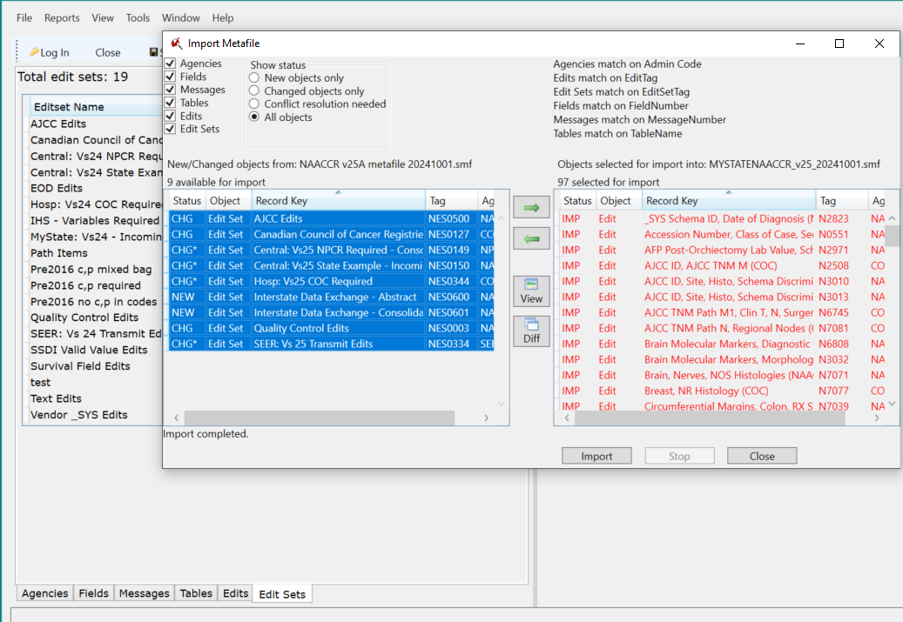
- Close the import screen, import is completed.
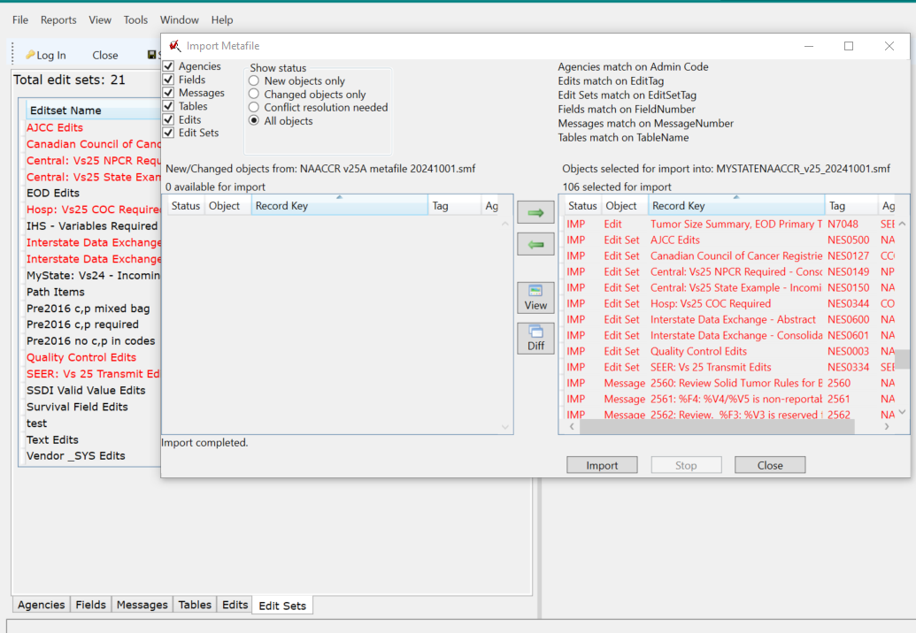

PUBLISHING THE METAFILE
The NAACCR Edits Clearinghouse on the NAACCR website “provides a space where central registries can share their central registry specific edit metafiles with other central registries, software vendors, and users of their registry metafile.” Central registries have traditionally sent their metafiles to software vendors supporting facility registries within their catchment areas. Registries are now strongly encouraged to publish their metafiles on the Clearinghouse. Vendors can receive notice of new metafiles, and readily obtain them for inclusion within their software products. Other central registries may also obtain and review any posted metafiles. Thus, the Clearinghouse provides the potential for registries to share ideas for edit development.
The NAACCR website also hosts an XML User Dictionary Portal, where registries can post and share their user dictionaries. These user dictionaries reveal the scope of customized data collection that registries have taken on to enhance the quality of data collection tailored to local registry requirements. Data Dictionaries were posted by 16 central state registries and reviewed. A total of 228 custom items were identified, ranging from 2 to 47 items for the registries, median 10-11. The following table groups these custom items by informal category. They include a combination of data items requested from reporting facilities, and data items for internal use to track data verification as well as manage data transmission and processing.
Personal ancestry/tribe/religion | 3
Personal history of cancer | 17
Height/Weight | 15
Genetic testing | 8
COVID 19 | 19
Alcohol, tobacco use | 24
Exposures | 3
Patient contact | 2
Family history | 11
Geocoding/address changes | 27
Address at death/date of death/DC file number | 3
MD name/specialty/contact information | 23
Facility information | 4
Site recode | 1
Tumor characteristics | 2
Biomarkers | 10
Path report | 2
Treatment date | 1
Other text | 2
Data verification | 21
Inclusion in research studies | 5
Data exchange agreement | 1
Data links | 7
Case controls | 10
Other | 7

