INSTRUCTIONS for IMPORTING NAACCR V21B
- If v18D has not been updated to V21, import V21B as major metafile version.
- If v18D has been updated to v21 or v21A but no customization changes have been made, particularly to edit sets, consider importing V21B as a major metafile version.
- If v18D has been updated to v21 or v21A and registry has invested in customization changes, import V21B as minor version update using following instructions. Also refer to Help function in EditWriter,

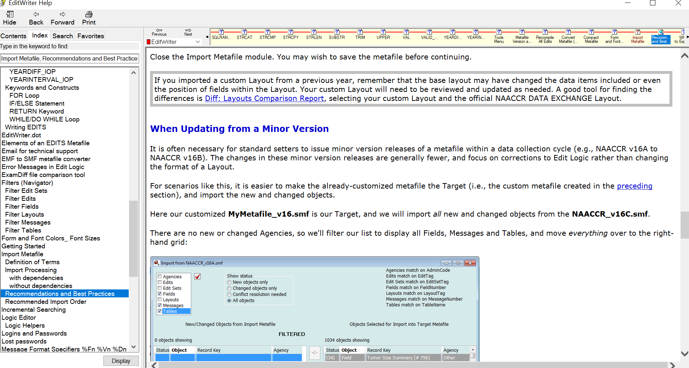
- If CUSTOMIZED data items in layout, create report if required to compare addition of custom data fields to imported layout
Go to Layout Screen
Select Layout
Select Reports, Layouts
Select All items in Navigator list
Select OK
Save report

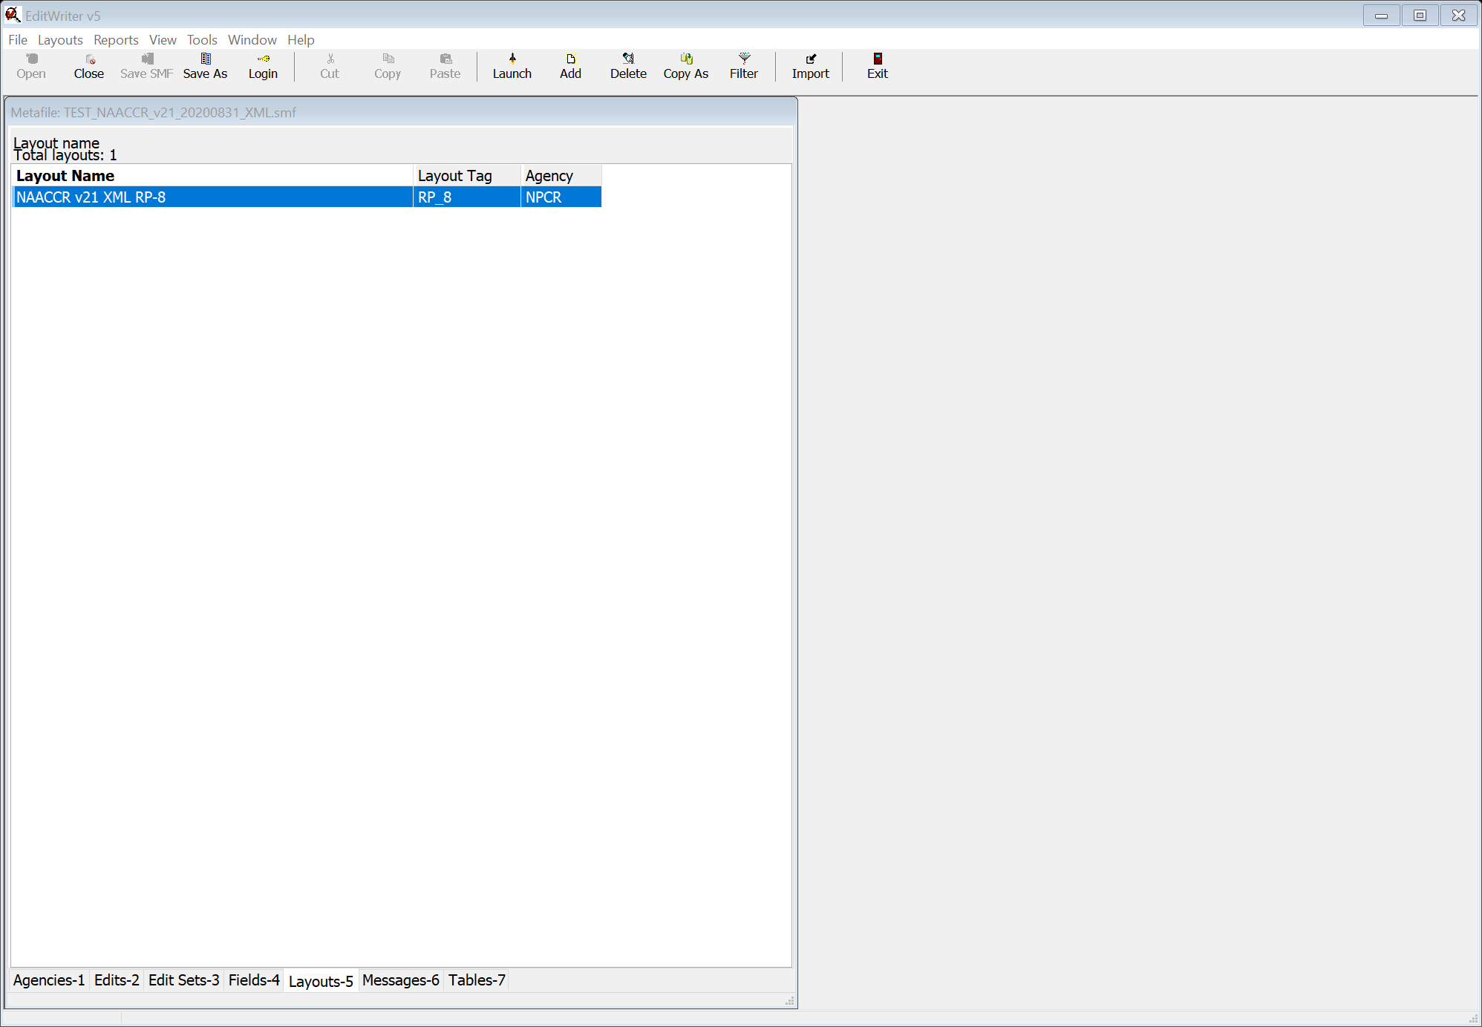
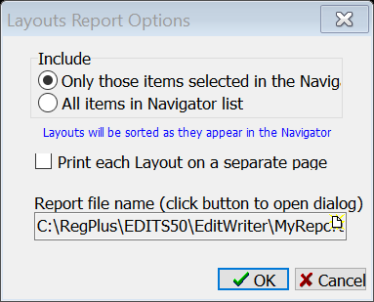

- If CUSTOMIZED edit sets in metafile, create edit set reports to verify that changed edits are included in customized edit sets
Go to Edit Set screen
Select custom edit set(s)
Select Reports, Edit Sets
Select Only those items selected in the Navigator
Select Ok
Save report
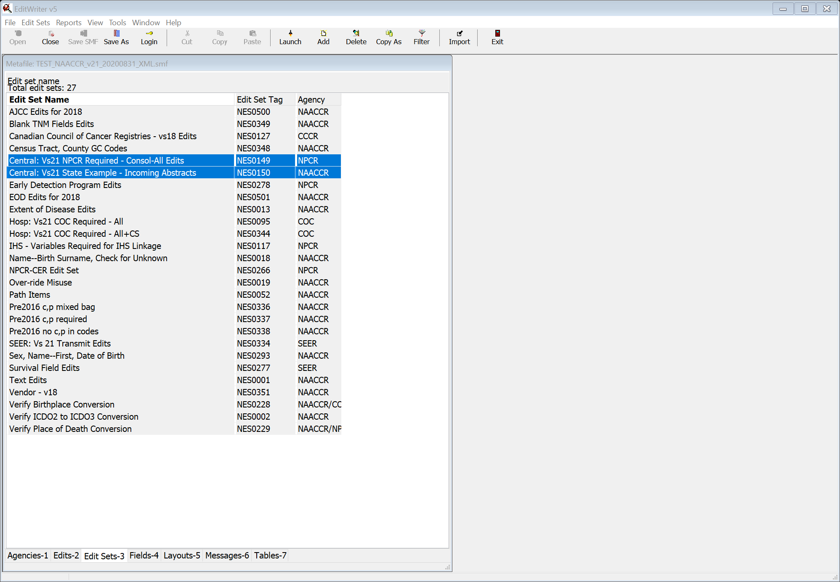
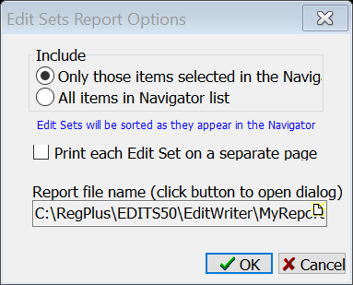

- Download new Metafile from NAACCR website
Open Registry Metafile
Select Tools, Import Metafile
Navigate to downloaded metafile, NAACCR_v21B_20210315_XML
On Import Screen
Select Show Status All Objects
Select Match Edits on Edit Tag
Select Match Edit Sets on Edit Set Tag
Select Match Layouts on Layout Tag
Select Ok
Deselect all objects in upper lefthand box
Select Fields in upper lefthand box
Select Field item from import list
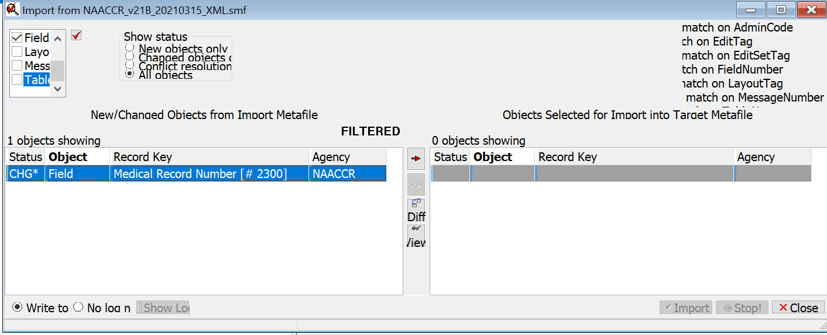

Move field to right
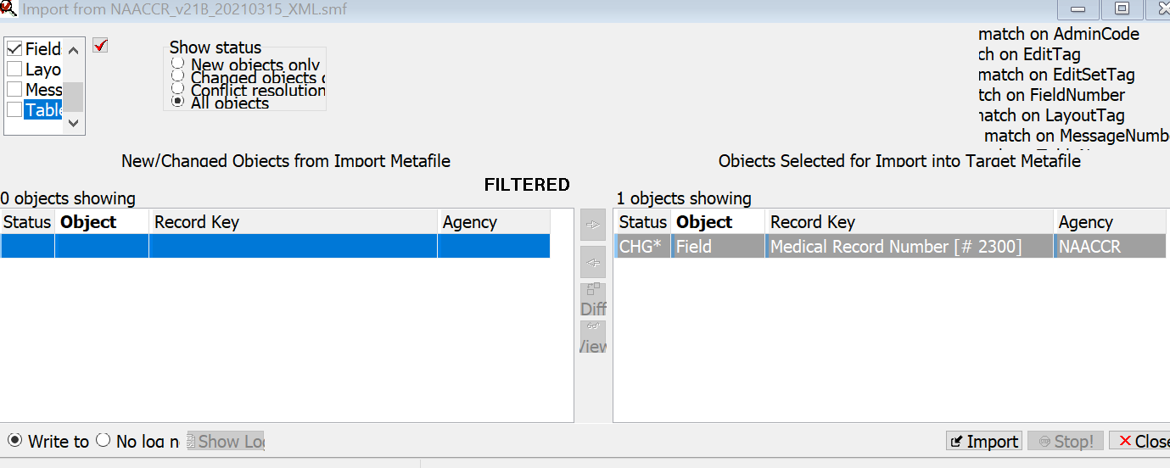

Select Import
Select Replace Target object with import object
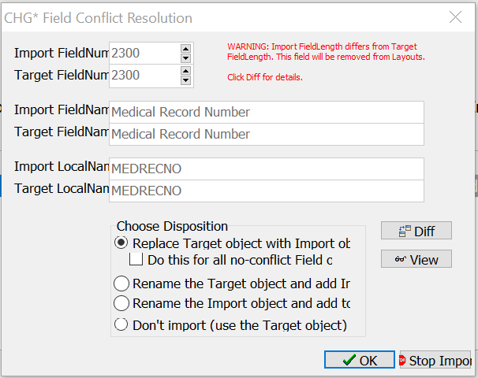
Select OK
Field will be imported and highlighted in red
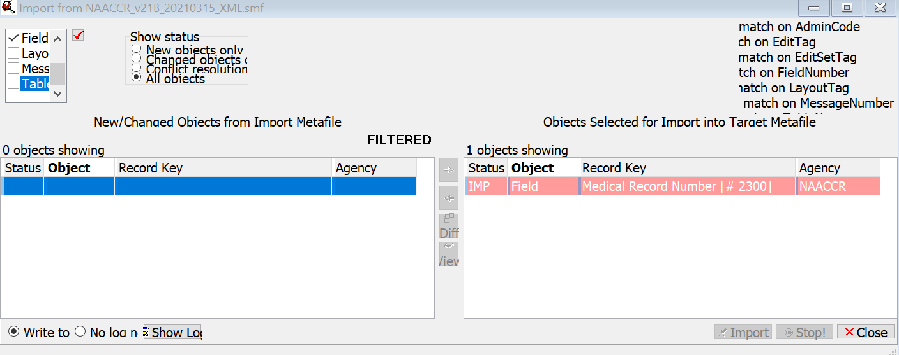

Select Messages in upper lefthand box
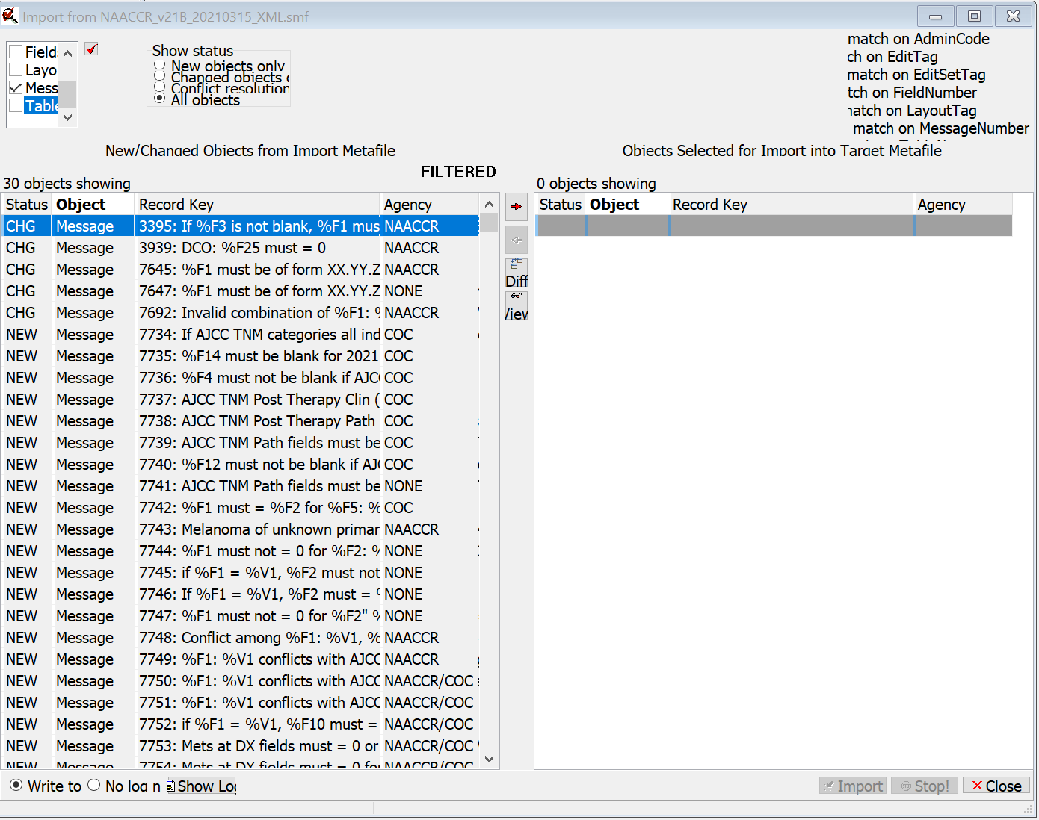

Move Messages to right. For moving any object, hold down Shift key, select first and last item, to select
all items together.
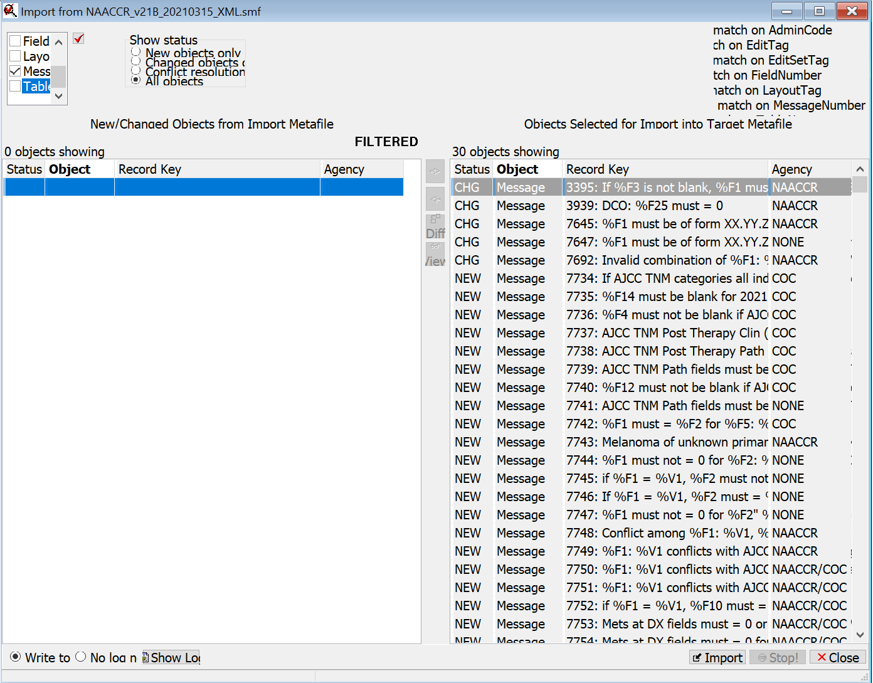

Select Replace Target object with Import object in CHG Message Disposition for 3395, 3939, 7645, 7647, and 7692
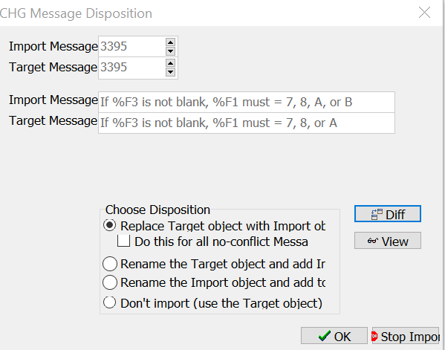
Error Message will be imported and highlighted in red.
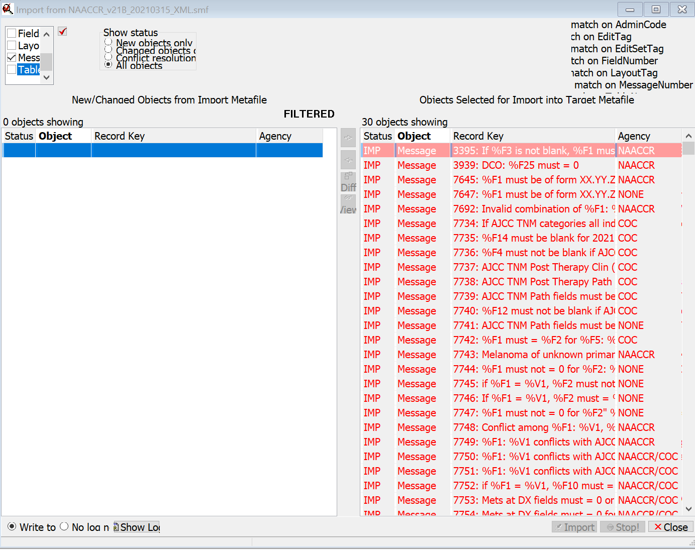

Select Tables in upper lefthand box
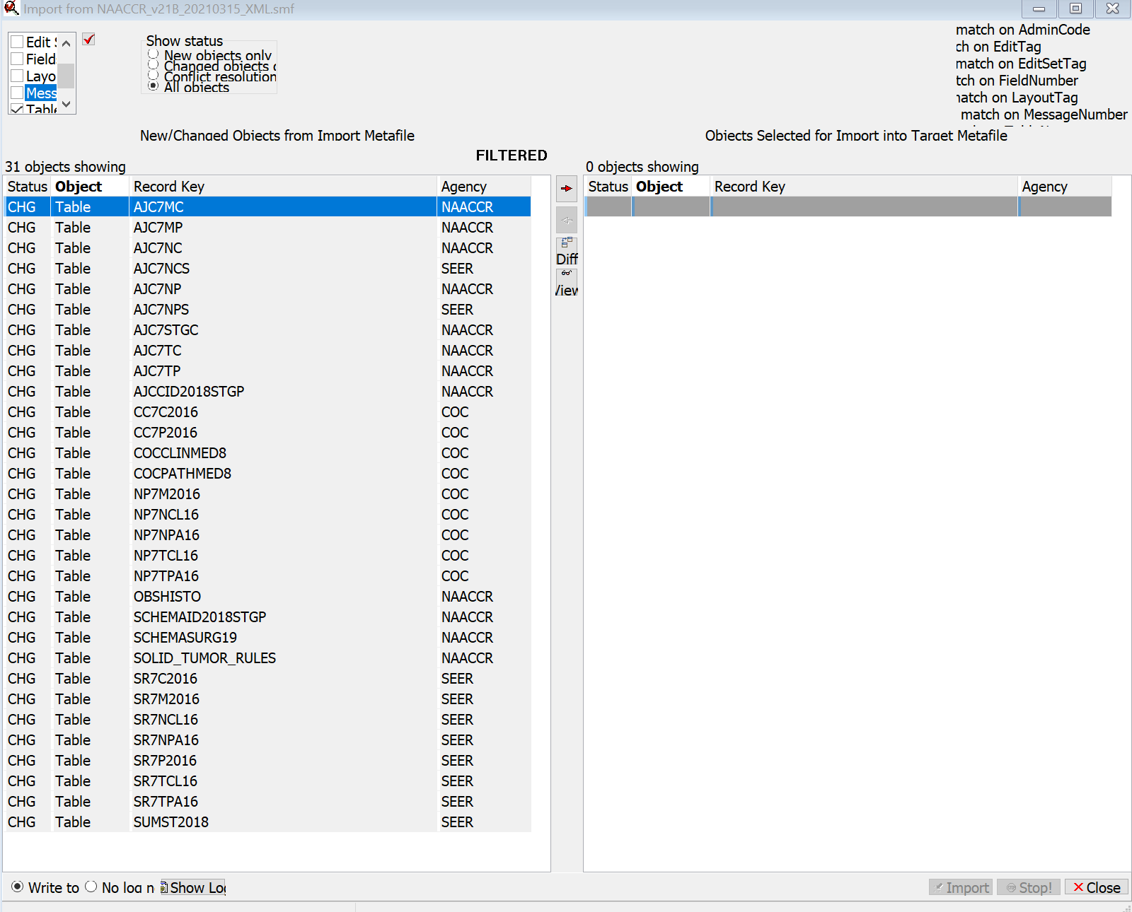
Select Tables from Import list
NOTE: Tables starting with AJC7, CC7, NP7, SR7 are used by AJCC edits for TNM 7th Edition staging. If the registry does not use these edits, the tables are not required to be imported. All other tables should be imported. Using the View option in the middle column will bring up a list of edits where each table is used. See “Used in Edits” at the bottom of the next screen shot.

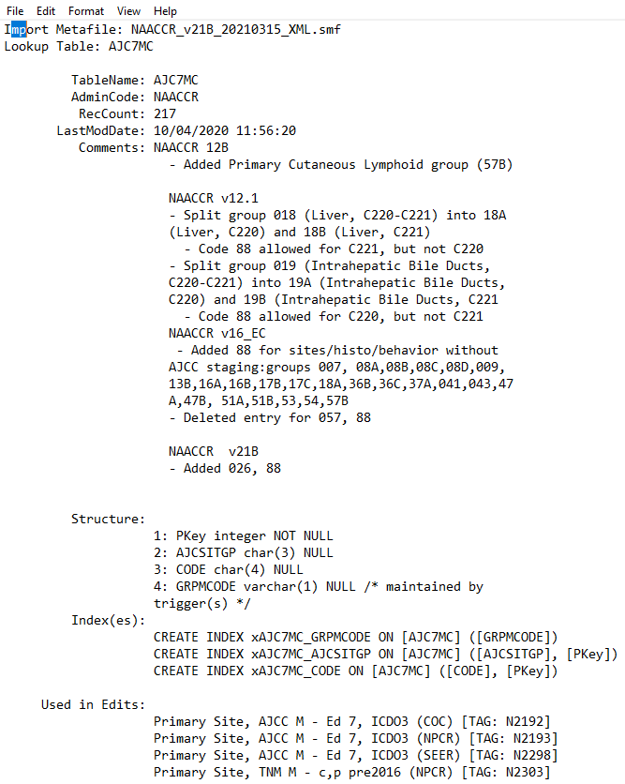

Move tables to right.
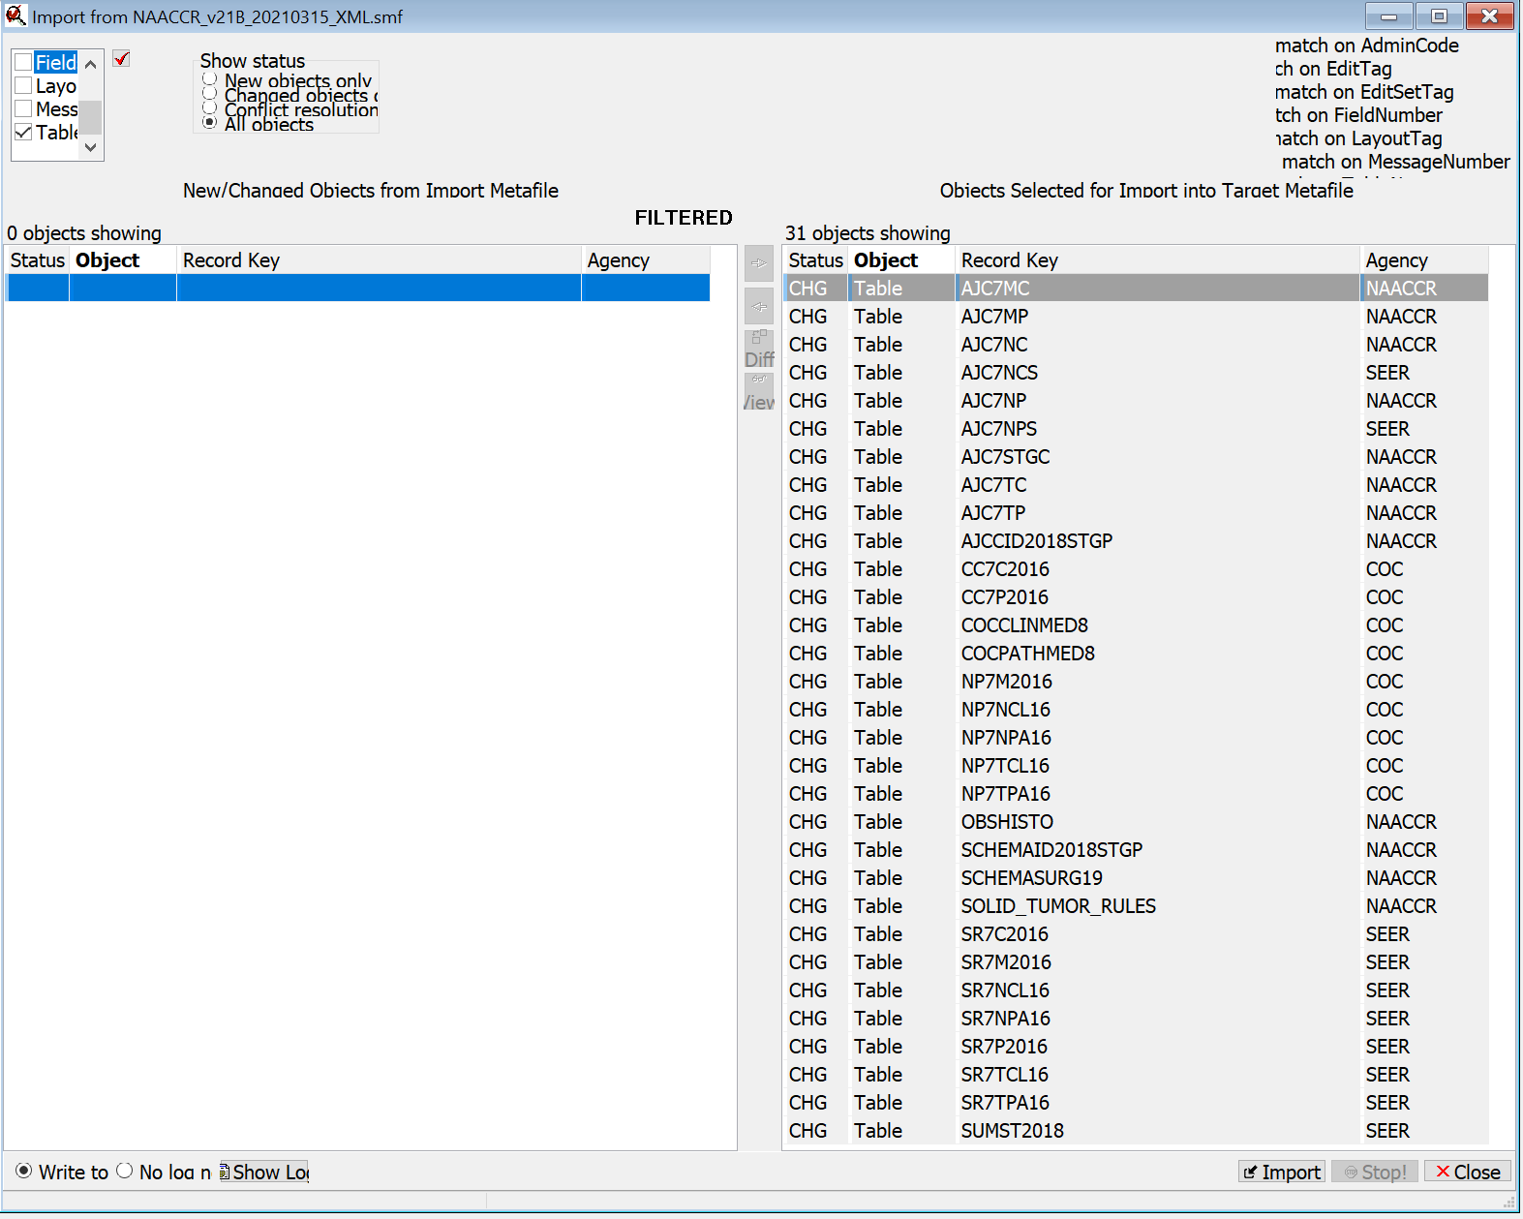

Select Import
Select Replace Target object
Select Do this for all no-conflict Tables
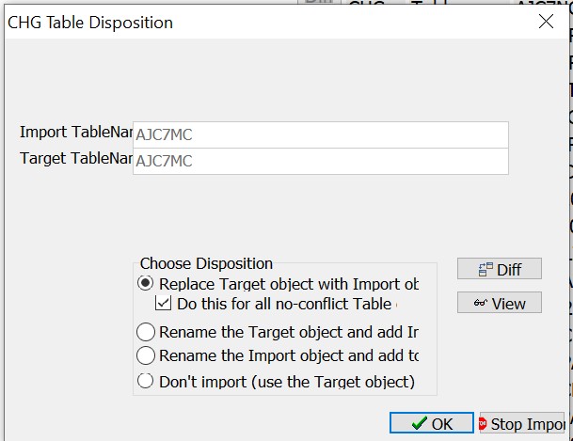
Select OK
Tables will be imported and highlighted in red
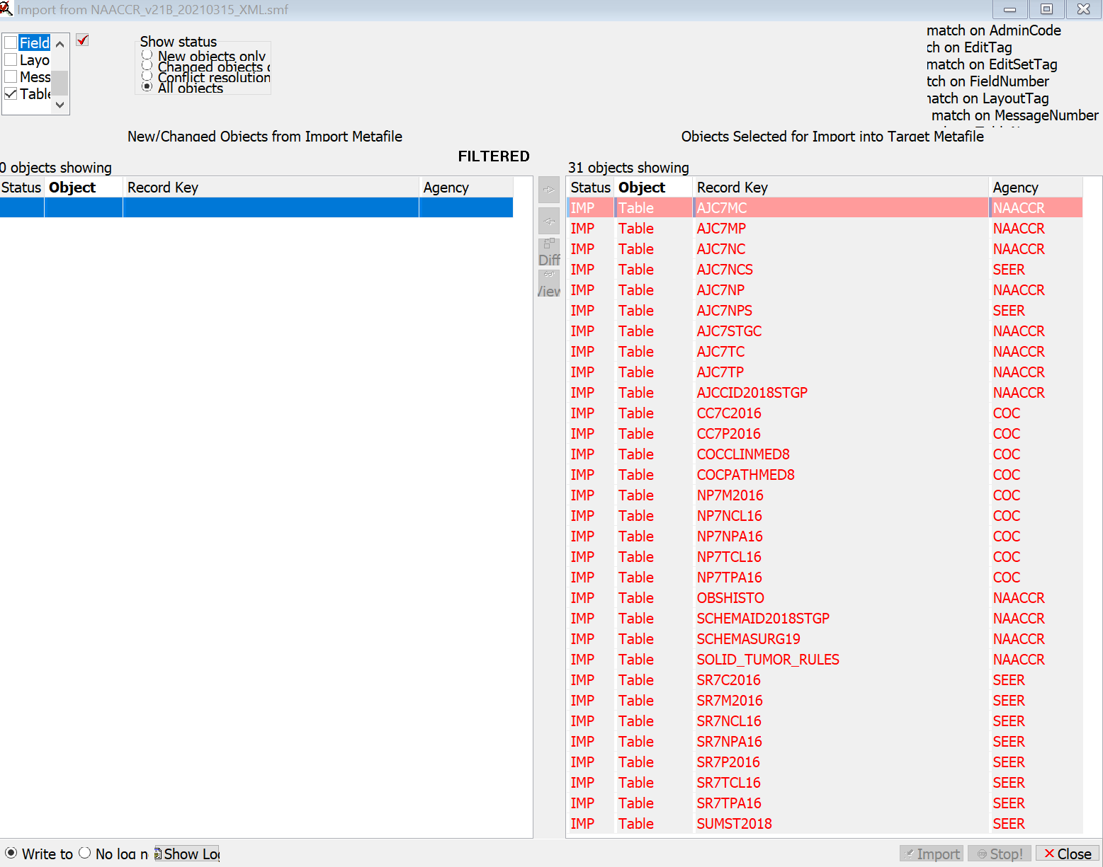

Select Edits in upper lefthand box
Select all Edits that Registry will use, of possible changed edits

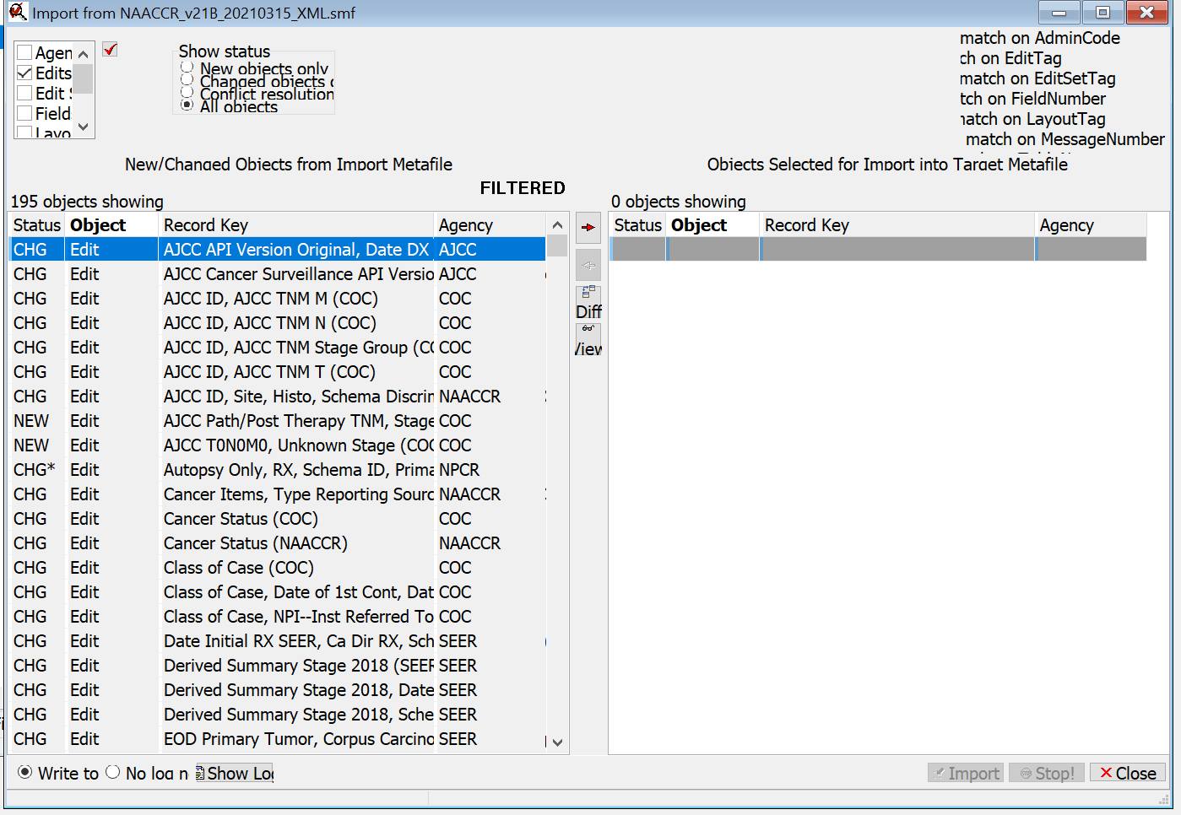

Any edit can be viewed by selecting the edit and clicking on “View” in the middle column. If a Diff program is installed, the difference between the import edit and the target edit will be highlighted.
Example of edit marked with CHG*, indicating change in critical feature of edit:
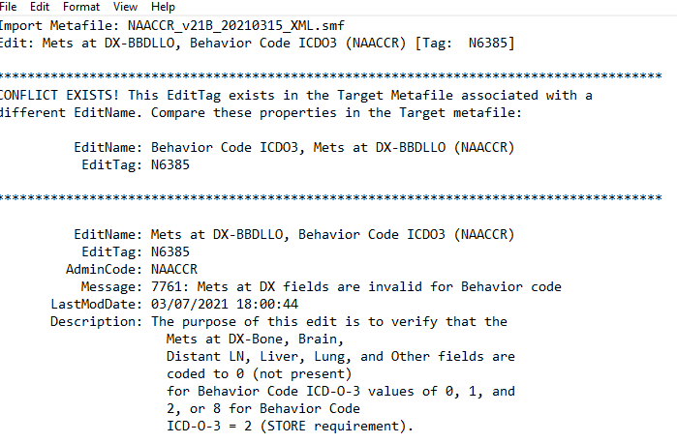

Example of Diff review of this edit:
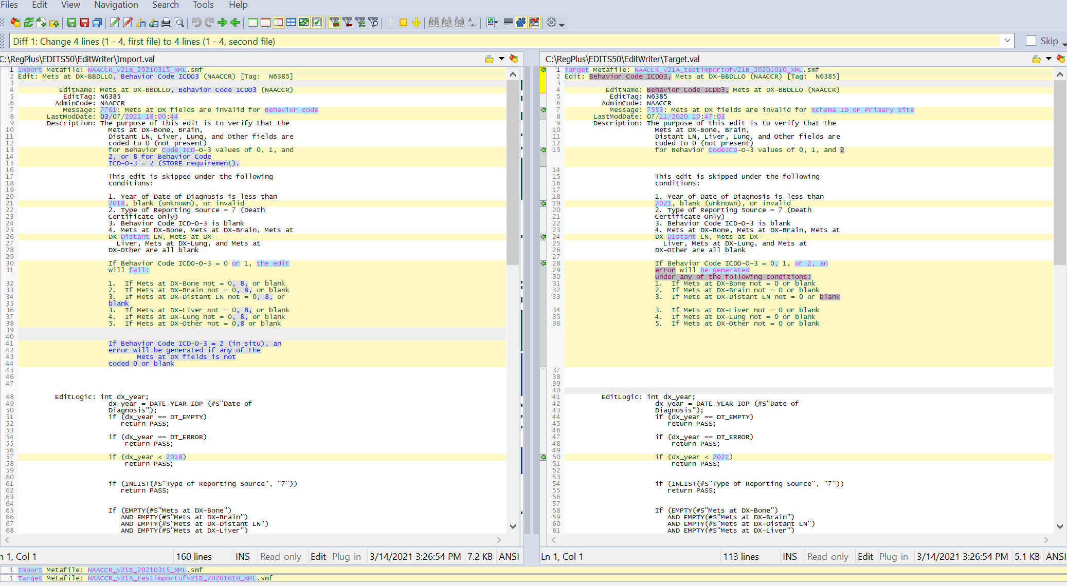

Move selected edits to right
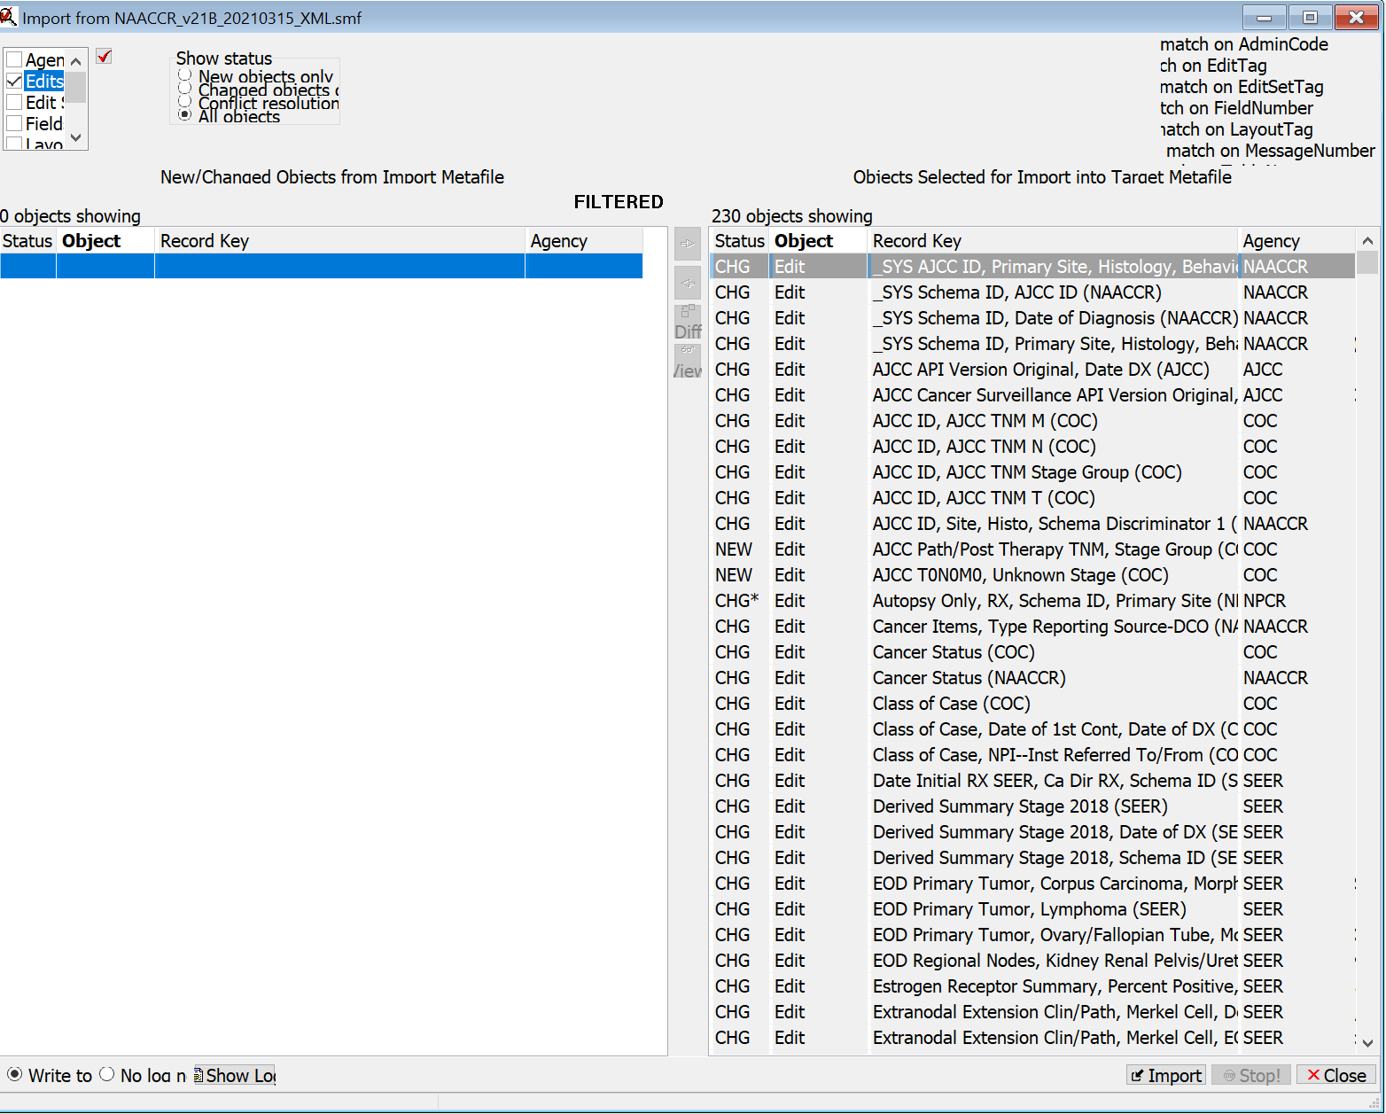

Select Import
Select Import without dependencies
Select Do this for all no-conflict edit objects
Select OK
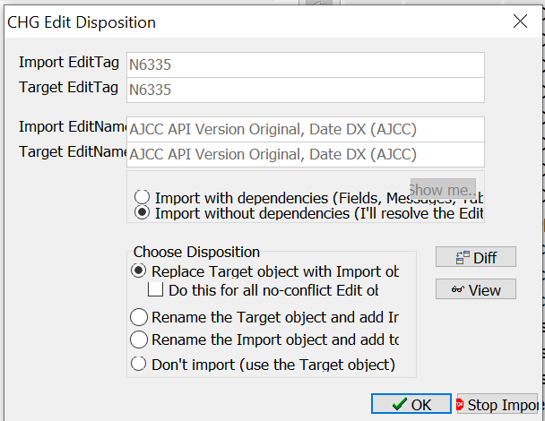

Select OK for all message screens that come up for N5020, N3038, N4911, N6385, N6363, and N5018 (example screen shown). You can check View and Diff on each of these edits if desired.

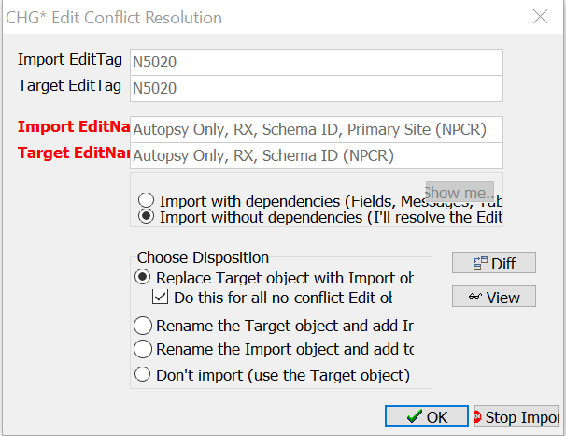

Edits will be imported and highlighted in red.

Select Edit Sets in the upper lefthand box
Select all edit sets that registry will use, of possible changed edit sets. If the registry has customized edit sets, all standard edits in those edit sets will be updated. The registry must move any new edits into its customized edit sets. New edits are N6430 –N6437.

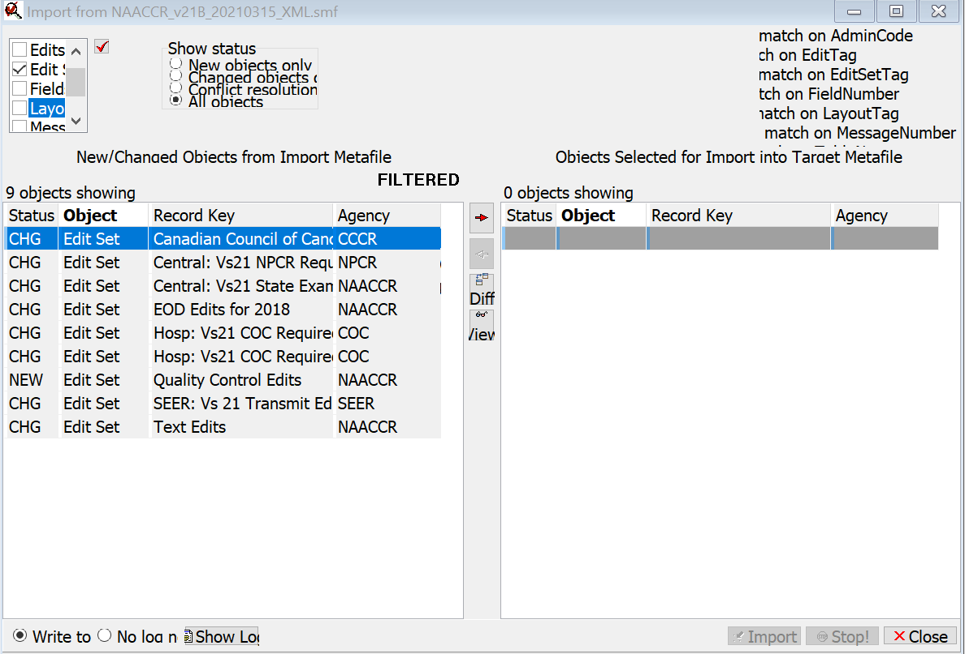
Move to right

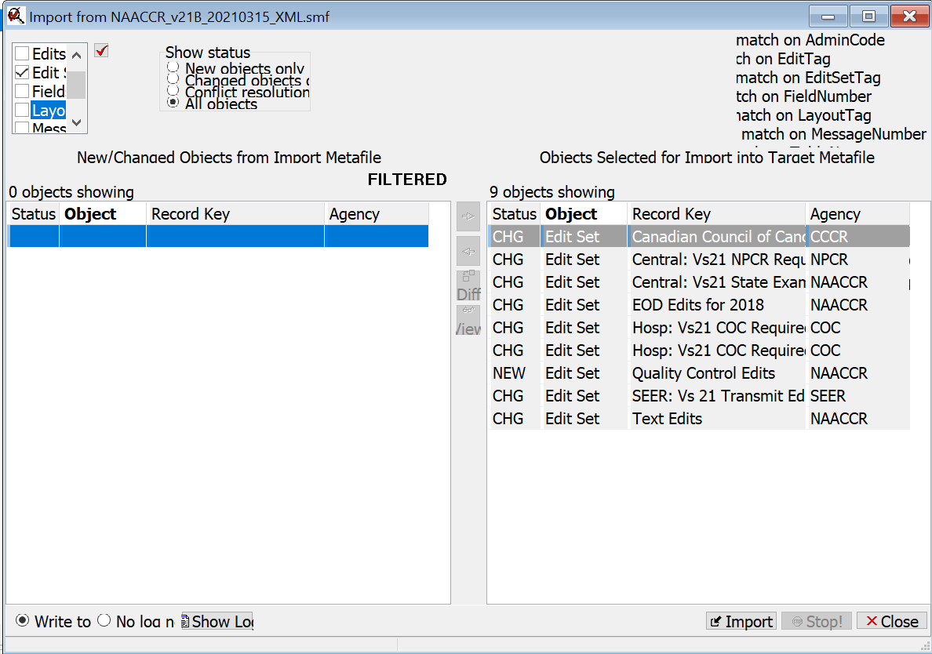

Select Import
Select Import without dependencies
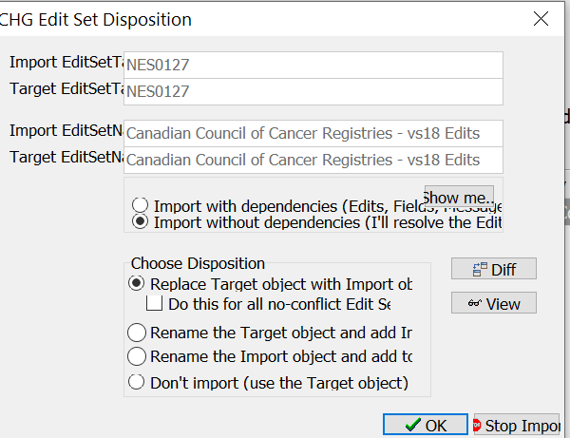
Select OK

Edit Sets will be imported and highlighted in red.

Select Layouts from upper lefthand box.

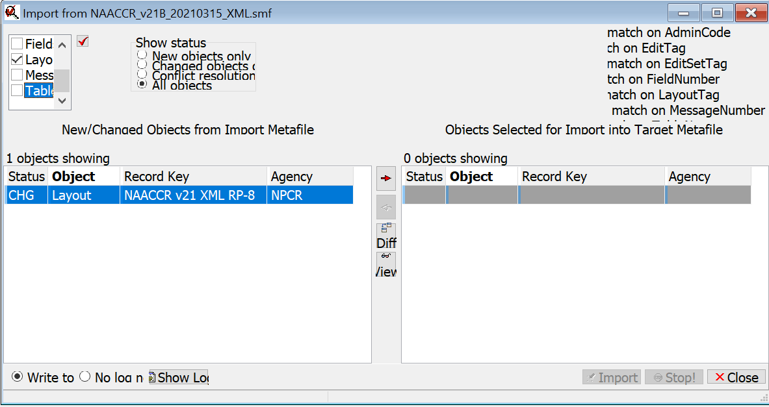
Select NAACCR v21 XML RP-8, move to right
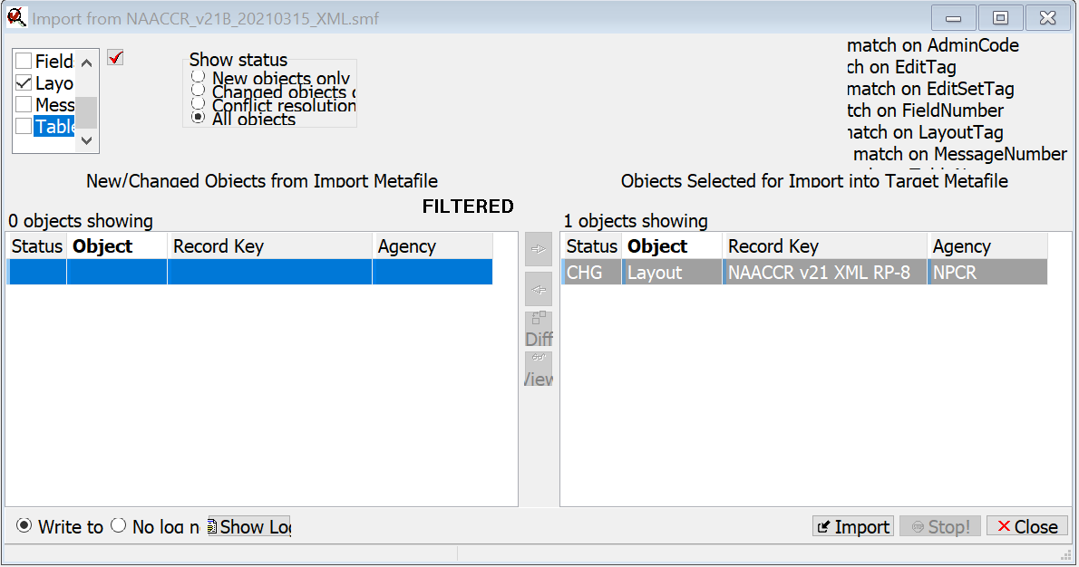

Move to right

Select Import
Select Import without dependencies
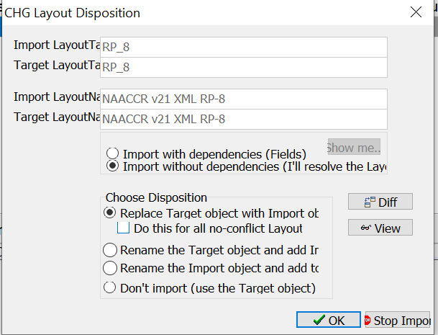
Select OK
The layout will be imported and highlighted in red.
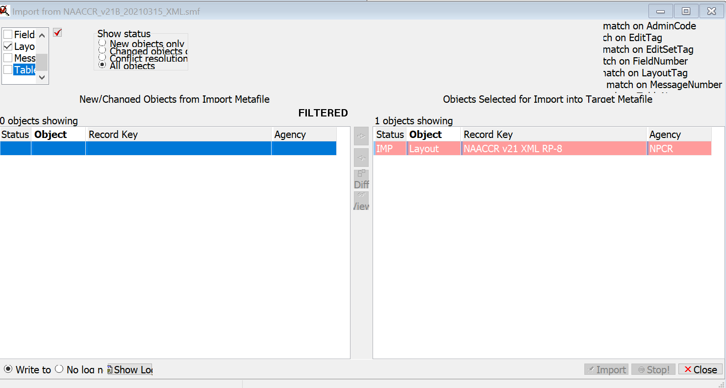

Close Import window

IF CUSTOMIZED DATA ITEMS
Copy layout, assign new name, layout tag, your agency
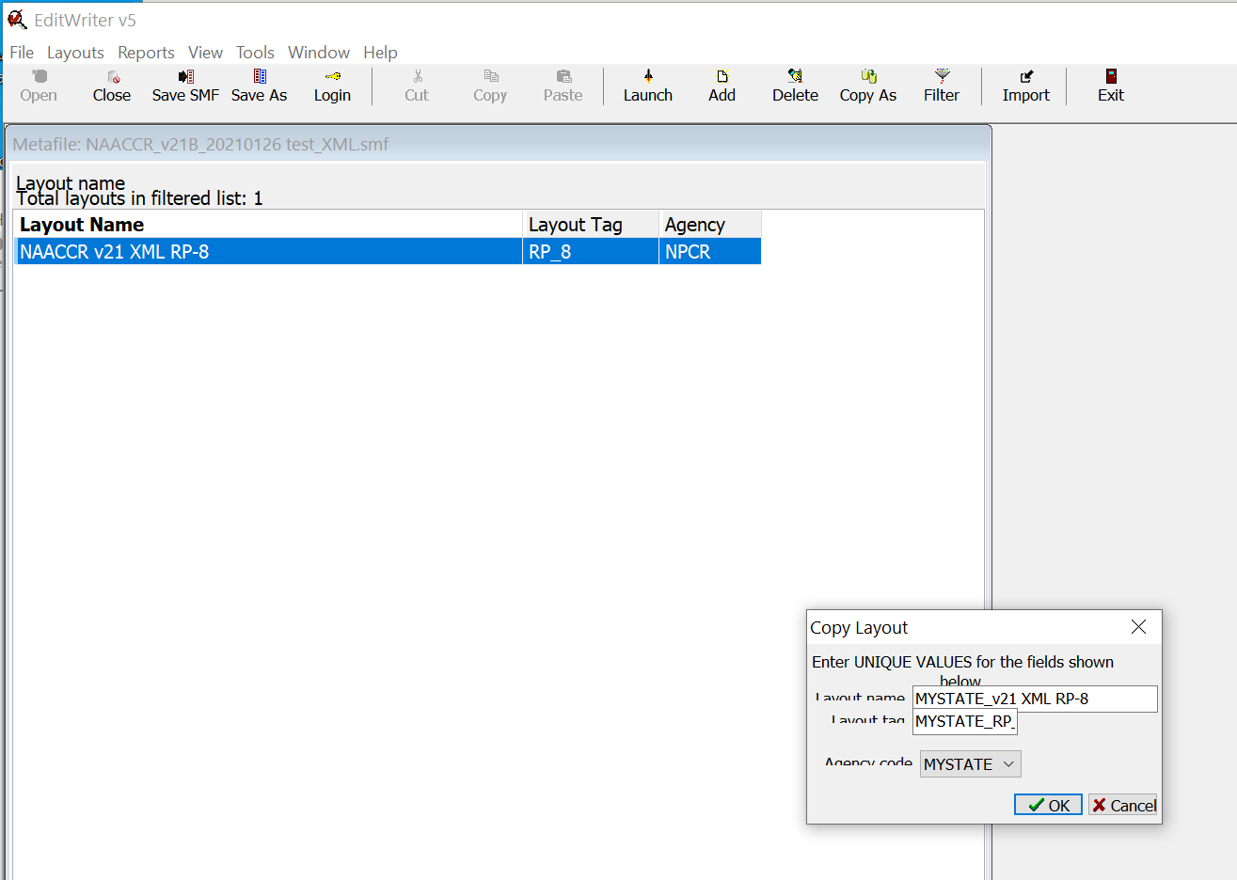

Open Layout
Highlight last item in list, ECC Flag, S, 1
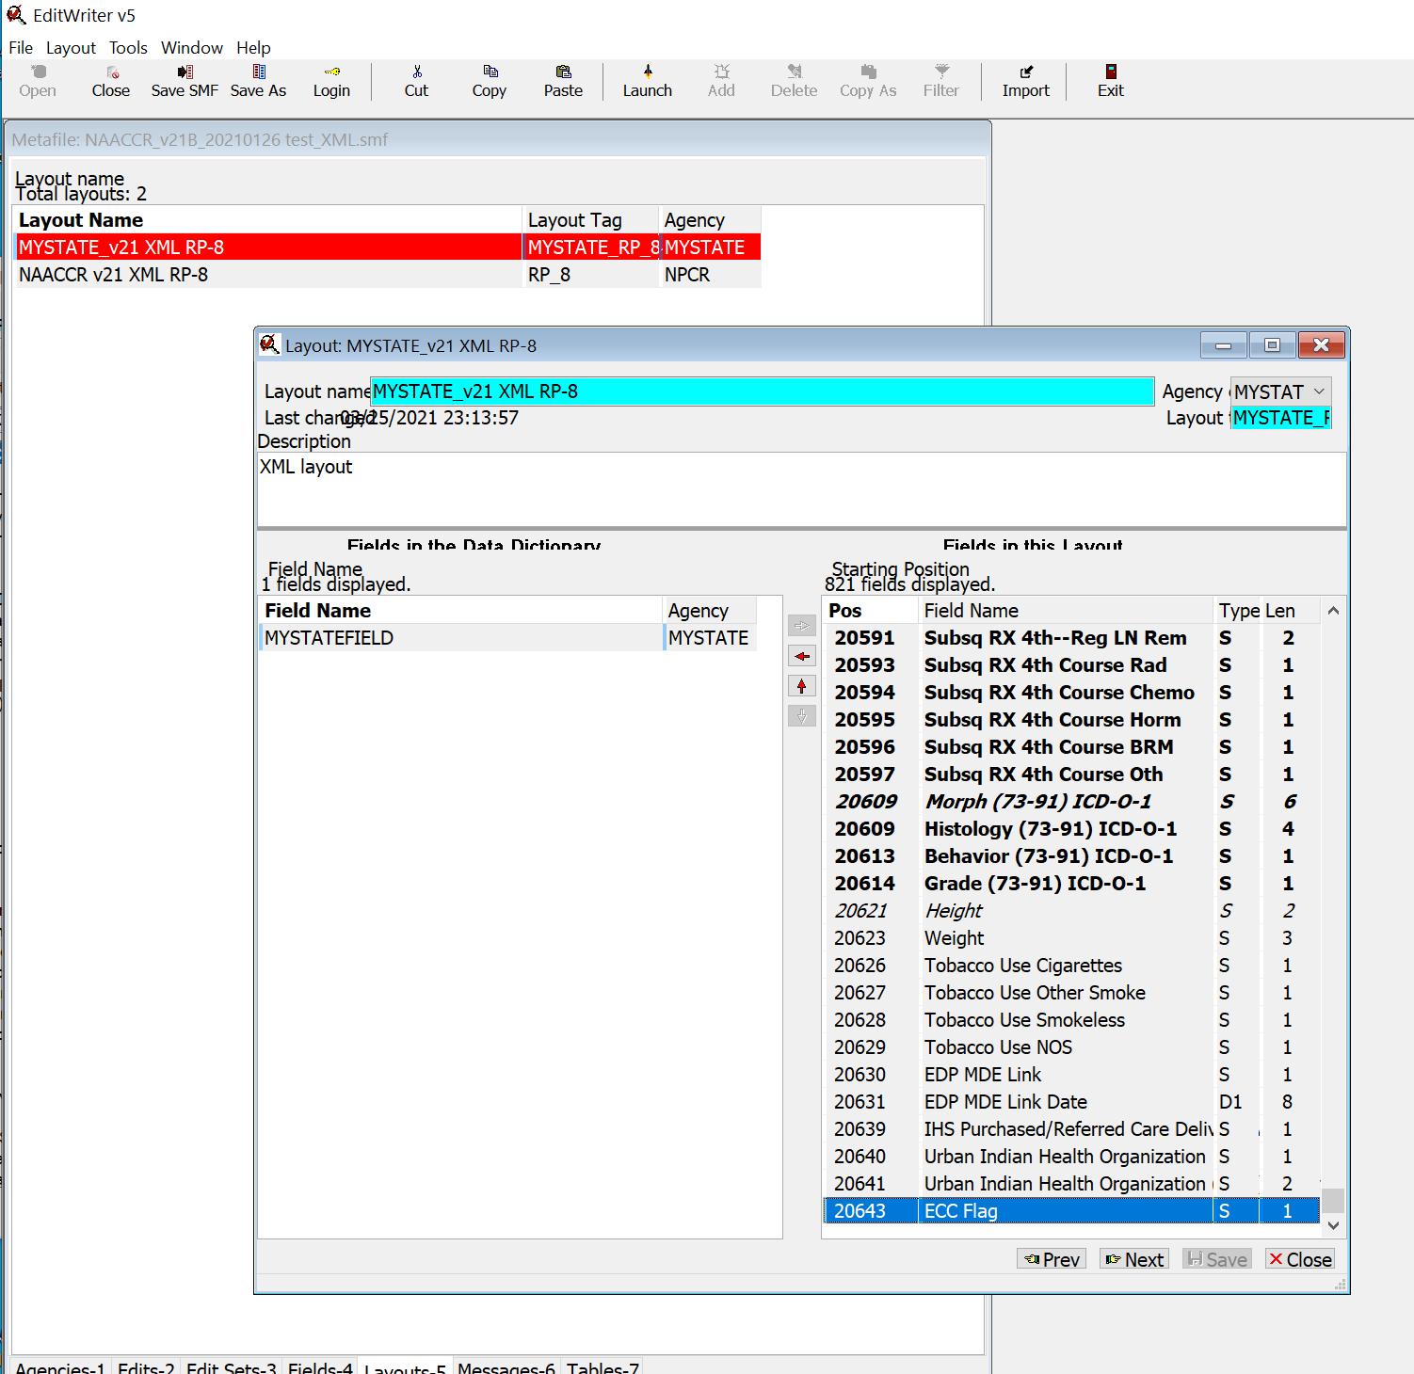
Enter custom fields in Data Dictionary order after 20643, ECC Flag,
Use Report from starting layout to enter fields in correct order
` if necessary
Save Layout and close
Select Tools, Recompile all edits
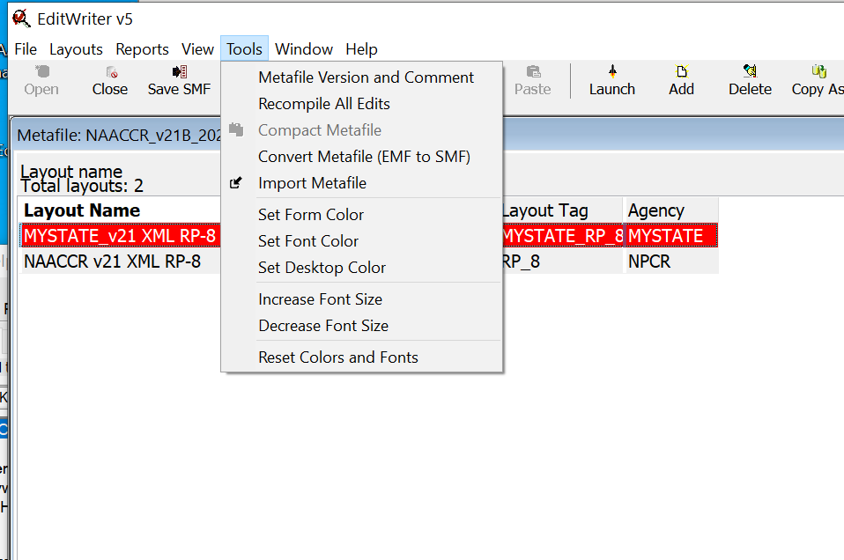

Verify custom edit sets with report from initial metafile if required
Select Tools, Metafile Version and Comments
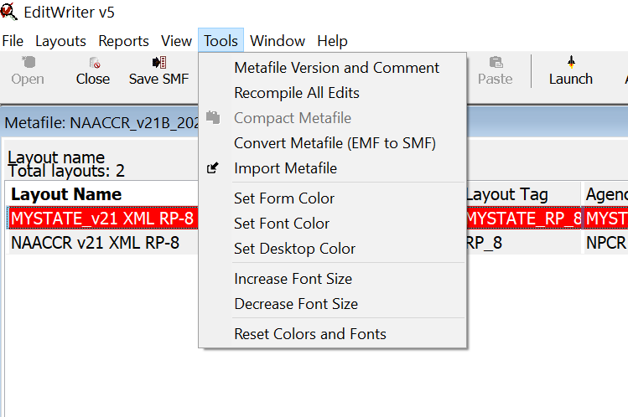

Update with appropriate information

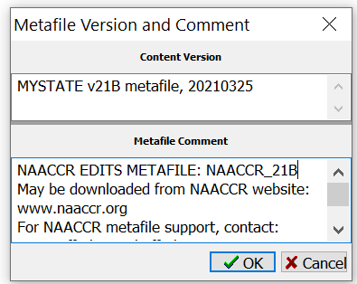
Save metafile

