INSTRUCTIONS for IMPORTING NAACCR V21A
- If V18D has not been updated to V21, import v21A as major metafile version.
- If v18D has been updated to v21 but no customization changes have been made, particularly to edit sets, consider importing v21A as major metafile version.
- If v18D has been updated to v21 and registry has invested in customization changes, import v21A as minor version update using following instructions.

- If CUSTOMIZED data items in layout, create report if required to compare addition of custom data fields to imported layout
Go to Layout Screen
Select Layout
Select Reports, Layouts
Select All items in Navigator list
Select OK
Save report

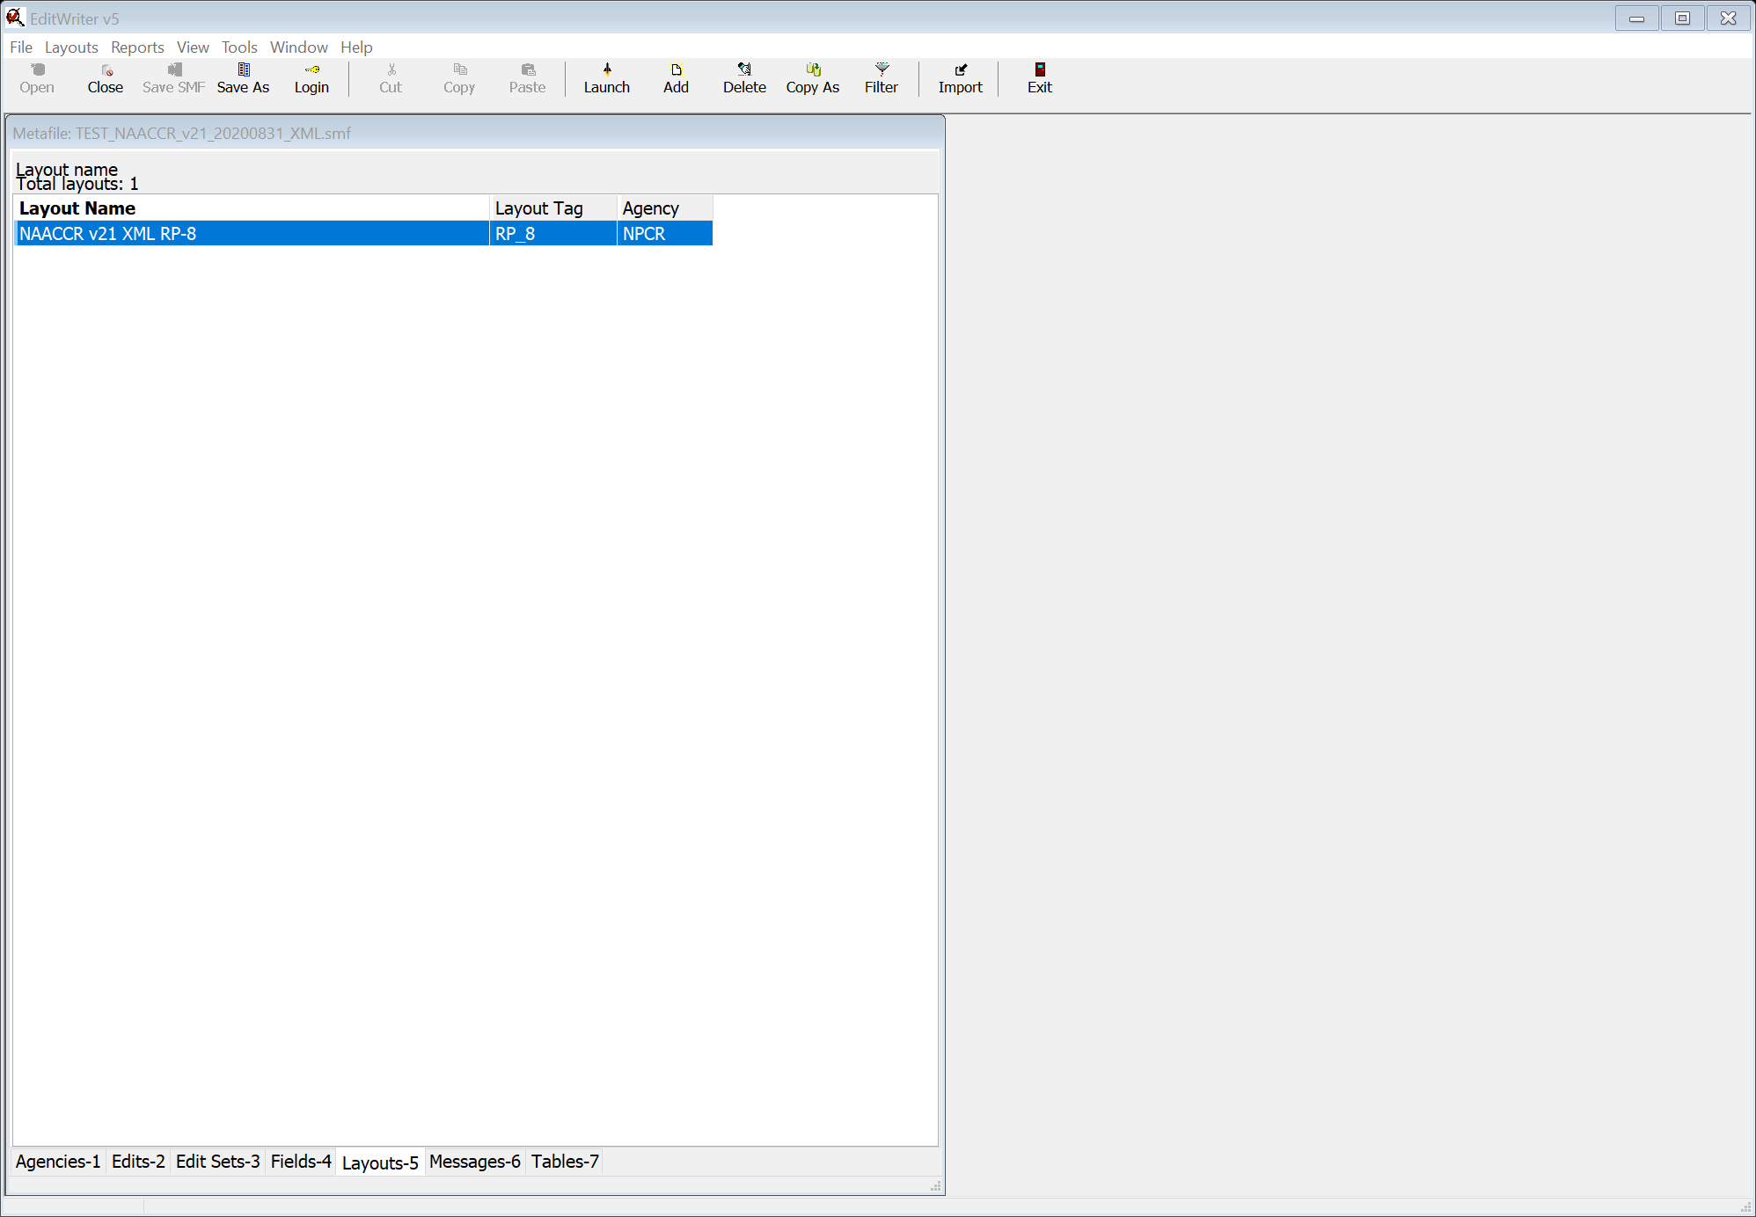
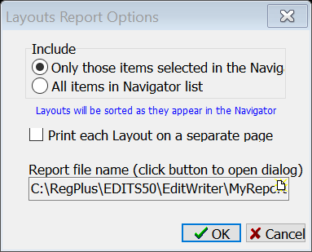

- If CUSTOMIZED edit sets in metafile, create edit set reports to verify that changed edits are included in customized edit sets
Go to Edit Set screen
Select custom edit set(s)
Select Reports, Edit Sets
Select Only those items selected in the Navigator
Select Ok
Save report
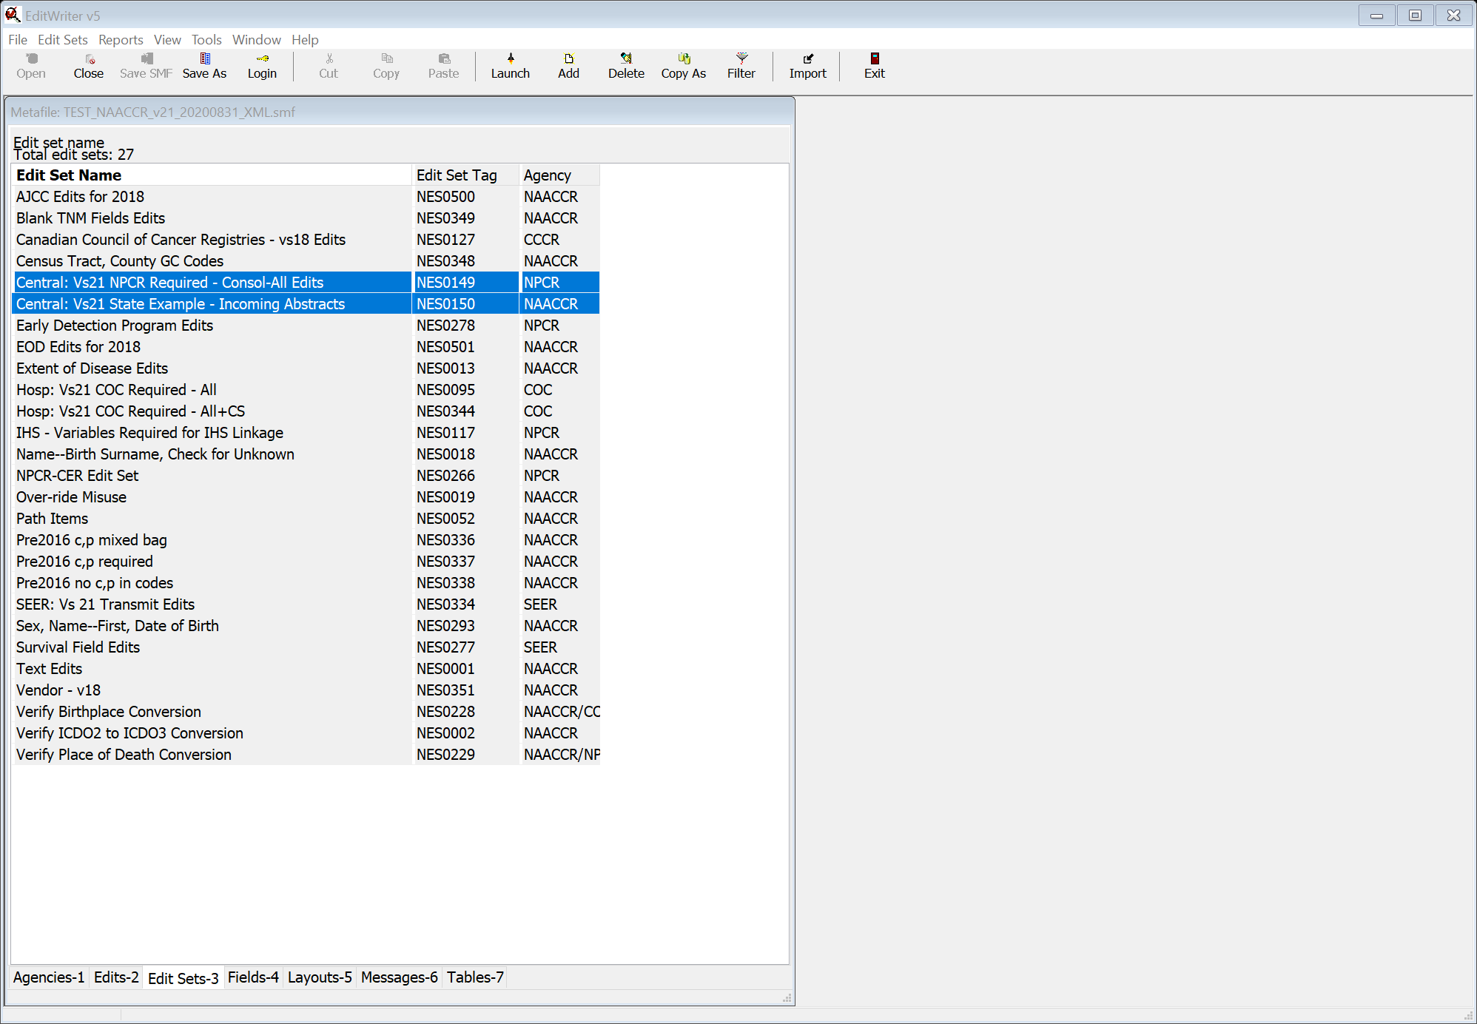
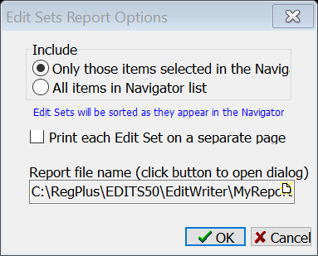

- Download new Metafile from NAACCR website
Open Registry Metafile
Select Tools, Import Metafile
Navigate to downloaded metafile, NAACCR_v21A_20201010.XML
On Import Screen
Select Show Status All Objects
Select Match Edits on Edit Tag
Select Match Edit Sets on Edit Set Tag
Select Match Layouts on Layout Tag
Select Ok
Deselect all objects in upper lefthand box
Select Fields in upper lefthand box
Select all Field items
AJCC ID
Autopsy
Cause of Death
COC Coding Sys—Current
COC Coding Sys—Original
Date of Inpt Adm
Date of Inpt Disch
Date of Last Cancer (tumor)Status Flag
ECC Flag
EHR Reporting
IHS Purchased/Referred Care Delivery Area
NPI—Physician—Primary Surg
Path Reporting Fac ID 5
Rad—No of Treatment Vol
RX Text—BRM
RX Text—Chemo
RX Text—Other
RX Text--Radiation Other
Sequence Number—Central
Urban Indian Health Organization (UHO) Facility
Urban Indian Health Organization

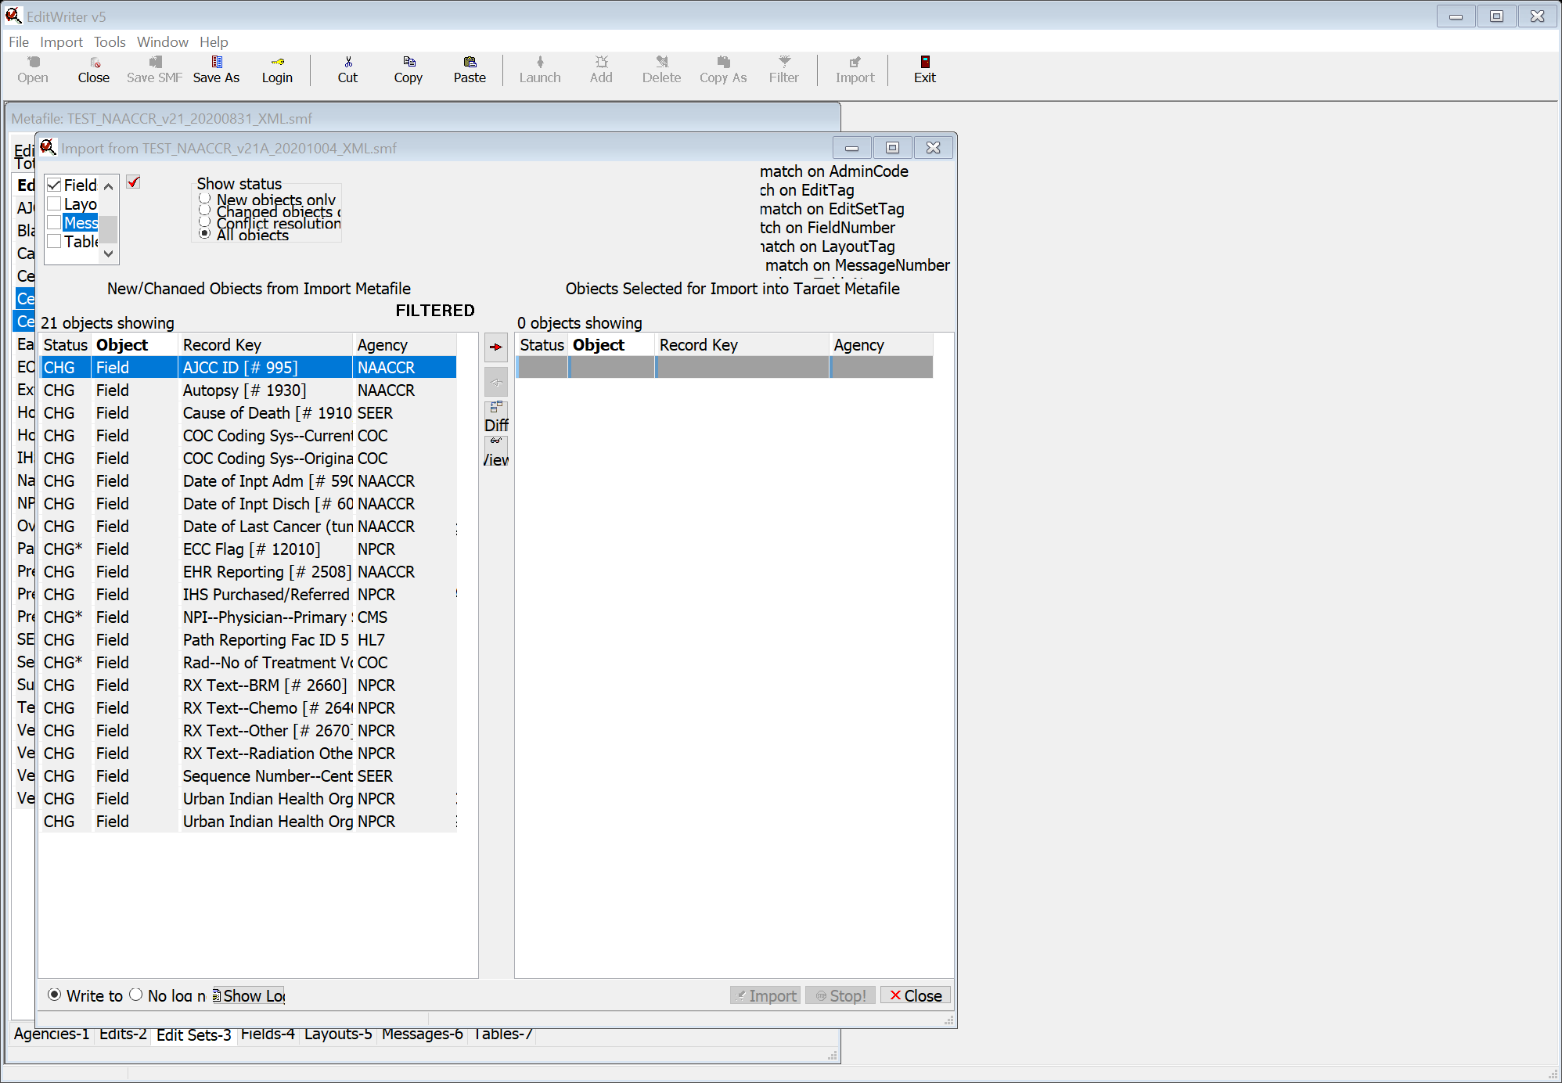

Move all fields to right
Select Import
Select Replace Target object with import object
Select Do this for all no-conflict fields
Select OK

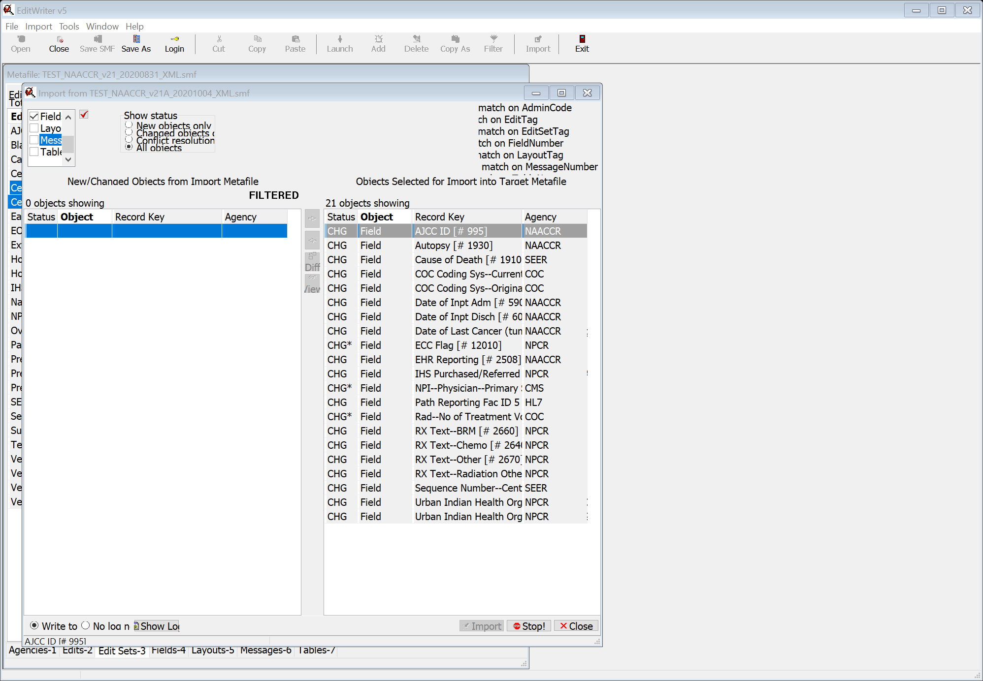
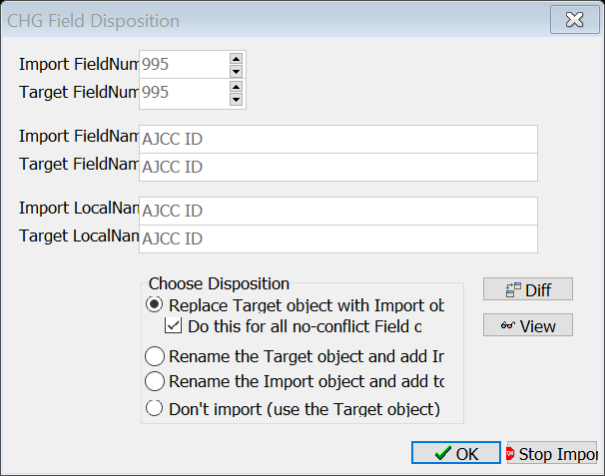

Select OK when warning comes up for ECC Flag
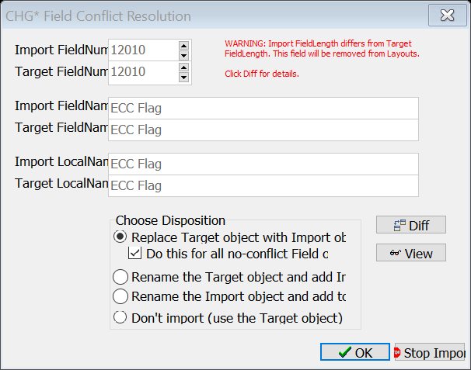
Select OK for NPI—Physician—Primary Surg
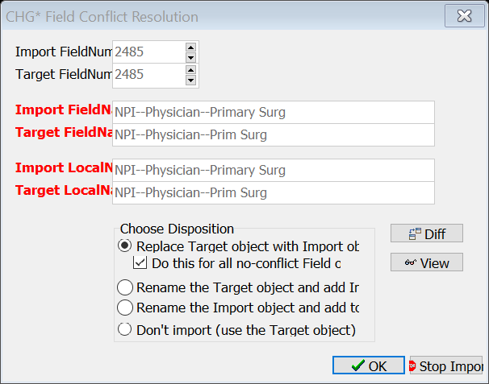
Select OK for Rad—No of Treatment Vol
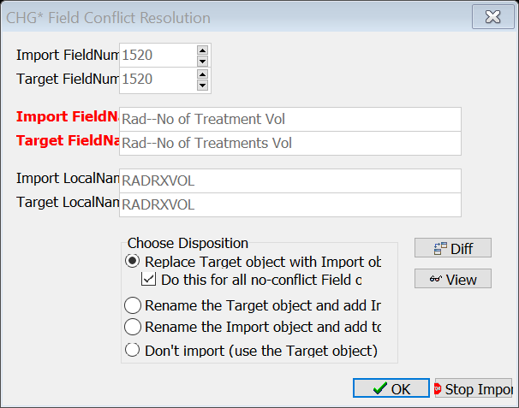

Select Tables
Select All Tables
AJCCID2018STGP
DISCRIM1SEER
SCHEMASURG19
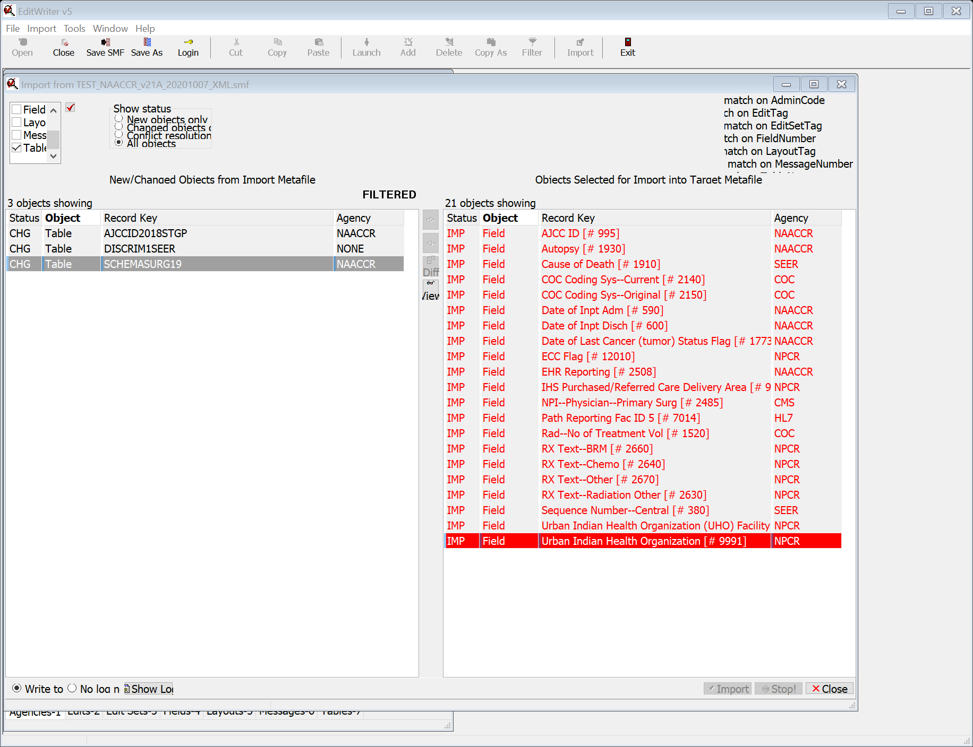
Move tables to right
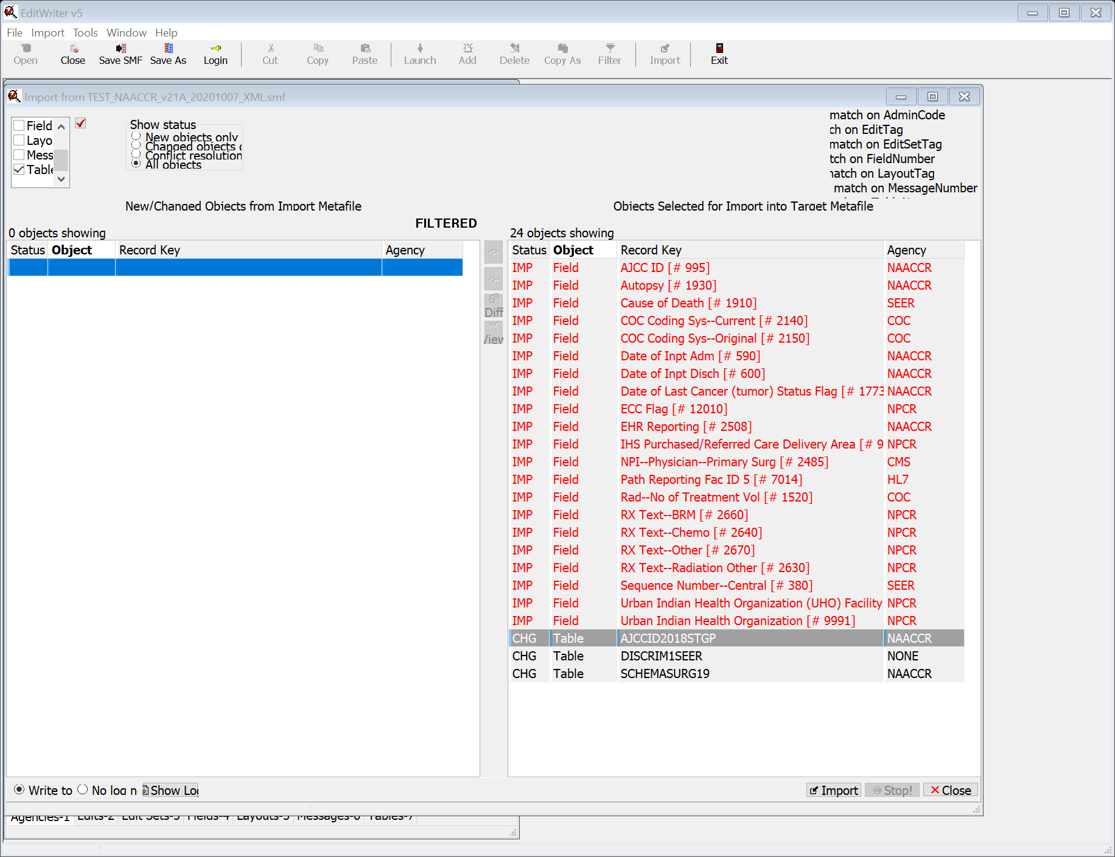

Select Import
Select Replace Target object
Select Do this for all no-conflict Tables
Select OK
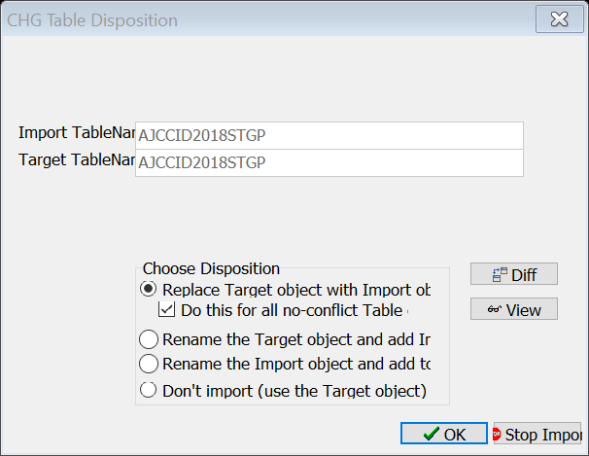
Select Edits
Select all Edits that Registry will use, of possible changed edits:
AJCC ID, AJCC TNM Stage Group (COC)
AJCC ID, Site, Histo, Schema Discriminator 1
AJCC TNM Items, Type Reporting Source
Date Initial RX SEER, Ca Dir RX, Schema ID (SEER)
EOD 2018, Date of Diagnosis (SEER)
Extranodal Extension Clin/Path, Merkel Cell, Derived SS2018 (SEER)
Extranodal Extension Clin/Path, Merkel Cell, EOD Regional Nodes (SEER)
Extranodal Extension Clin/Path, Merkel Cell Summary Stage (NAACCR)
Extranodal Extension Clin/Path, Merkel Cell, Summary Stage 2018, CoC Flag (SEER)
Gleason Patterns Clinical, Schema ID
NCDB—SARSCoV2—Test (COC)
NPI—Physician—Primary Surg (NAACCR)
Obsolete Histology ICDO3, Date of DX
Primary Site, T 2016 – Ed 7 (COC)
Radiation Items, DX Post 2017 (COC)
Rad—No of Treatment Vol (COC)
Rad—No of Treatment Vol (NAACCR)
Reason for No Radiation, Date of DX (NPCR)
RX Date Rad Ended, Rad—No of Treatment Vol (COC)
RX Date Radiation, Rad—No of Treatment Vol (COC)
RX Hosp—Scope Reg LN Sur, Schema, Primary Site (COC)
Schema ID, Site, Histo, Schema Discriminator 1 (NAACCR)
Schema ID, Site, Histo, Schema Discriminator 1 (NPCR)
Surgery Rad, Phase I Rad Surg (SEER)
Surgery, RX Date Surgery, ICDO3 (COC)
Surgery, RX Date Surgery, Schema ID (COC)
Systemic RX, Surgery, Systemic/Sur Seq (COC)
Systemic RX, Surgery, Systemic/Sur Seq (SEER)
Tumor Size Clinical, Date of Diagnosis (SEER)

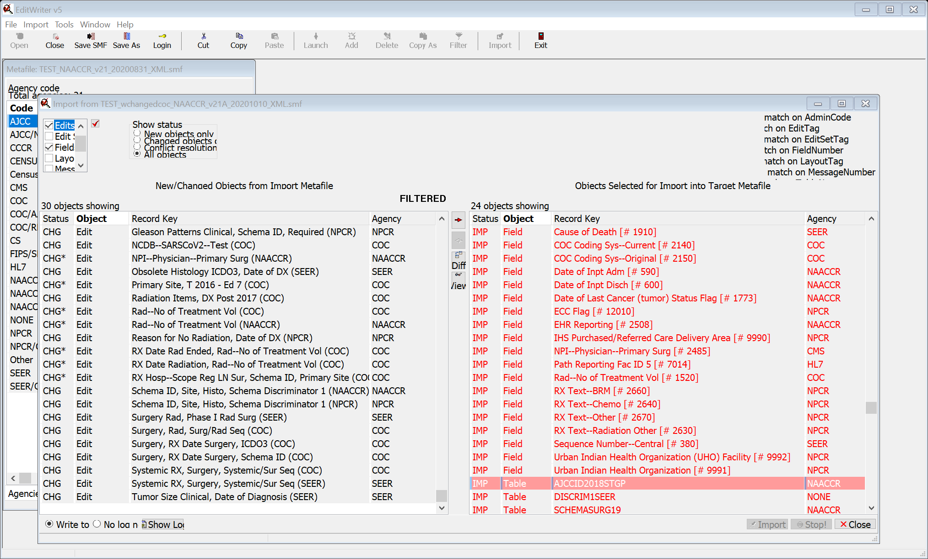

Move edits to right
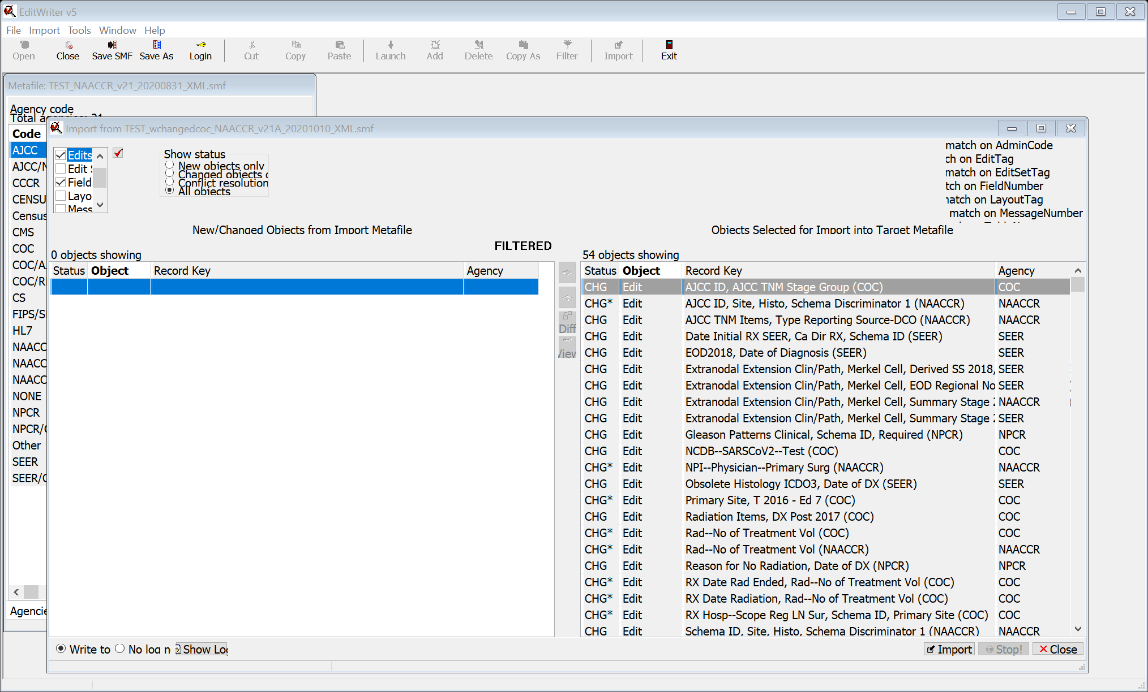
Select Import
Select Import without dependencies
Select Do this for all no-conflict edit objects
Select OK
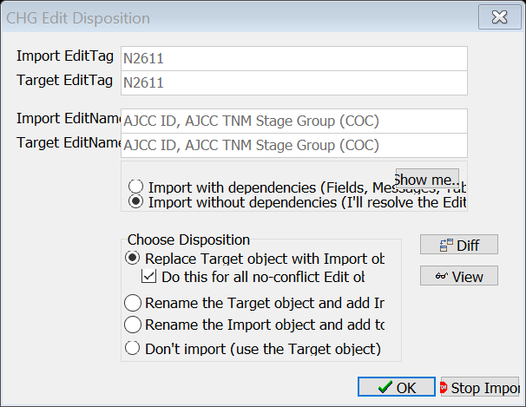
Select OK for all message screens that come up (example screen shown)
AJCC ID, Site, Histo, Schema Discriminator 1 (NAACCR)
NPI—Physician—Primary Surg (NAACCR)
Primary Site, T 2016 – Ed 7 (COC)
Rad—No of Treatment Vol (COC)
Rad—No of Treatment Vol (NAACCR)
RX Date Rad Ended, Rad—No of Treatment Vol (COC)
RX Date Radiation, Rad—No of Treatment Vol (COC)
RX Hosp—Scope Reg LN Sur, Schema ID, Primary Site (COC)

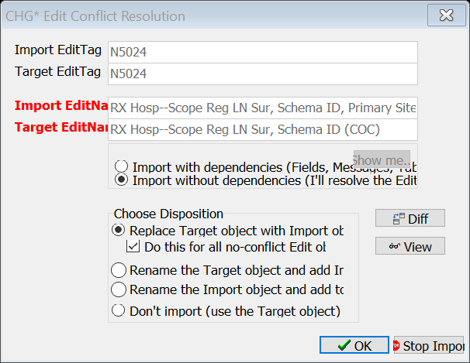

Select Edit Sets
Select all edit sets that registry will use, of possible changed edit sets:
Blank TNM Fields Edits
Census Tract County GC Codes
Central: Vs21 NPCR Required – Consol-All Edits
Central: Vs21 State Example – Incoming Abstracts
Early Detection Program Edits
SEER: Vs 21 Transmit Edits
Vendor – v18
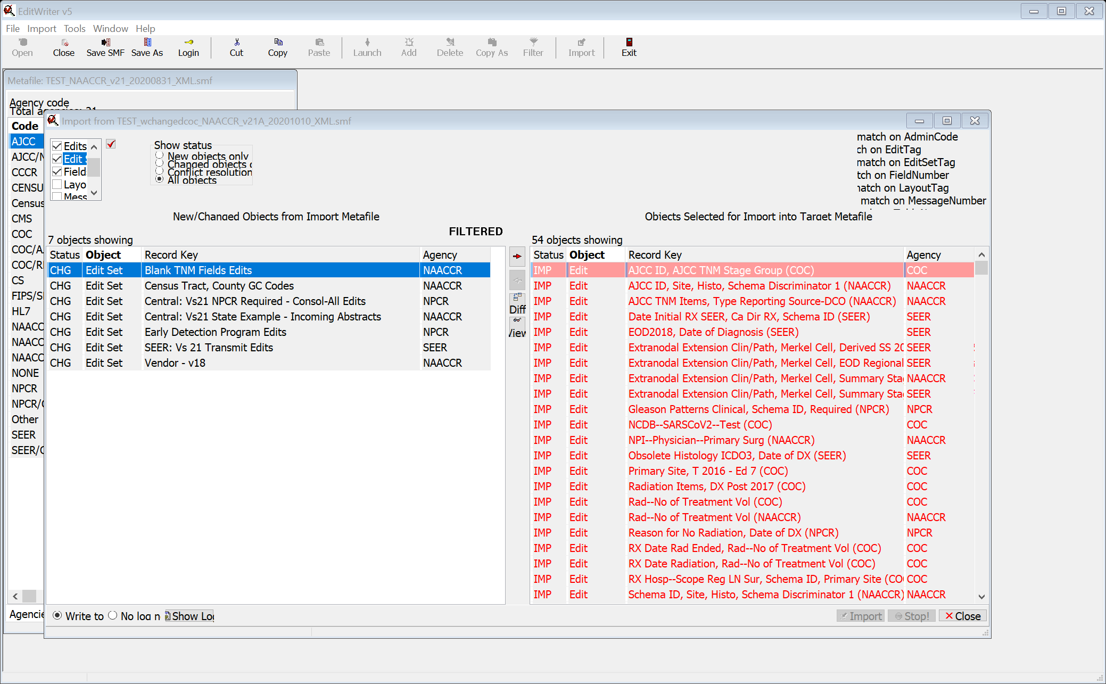
Move to right
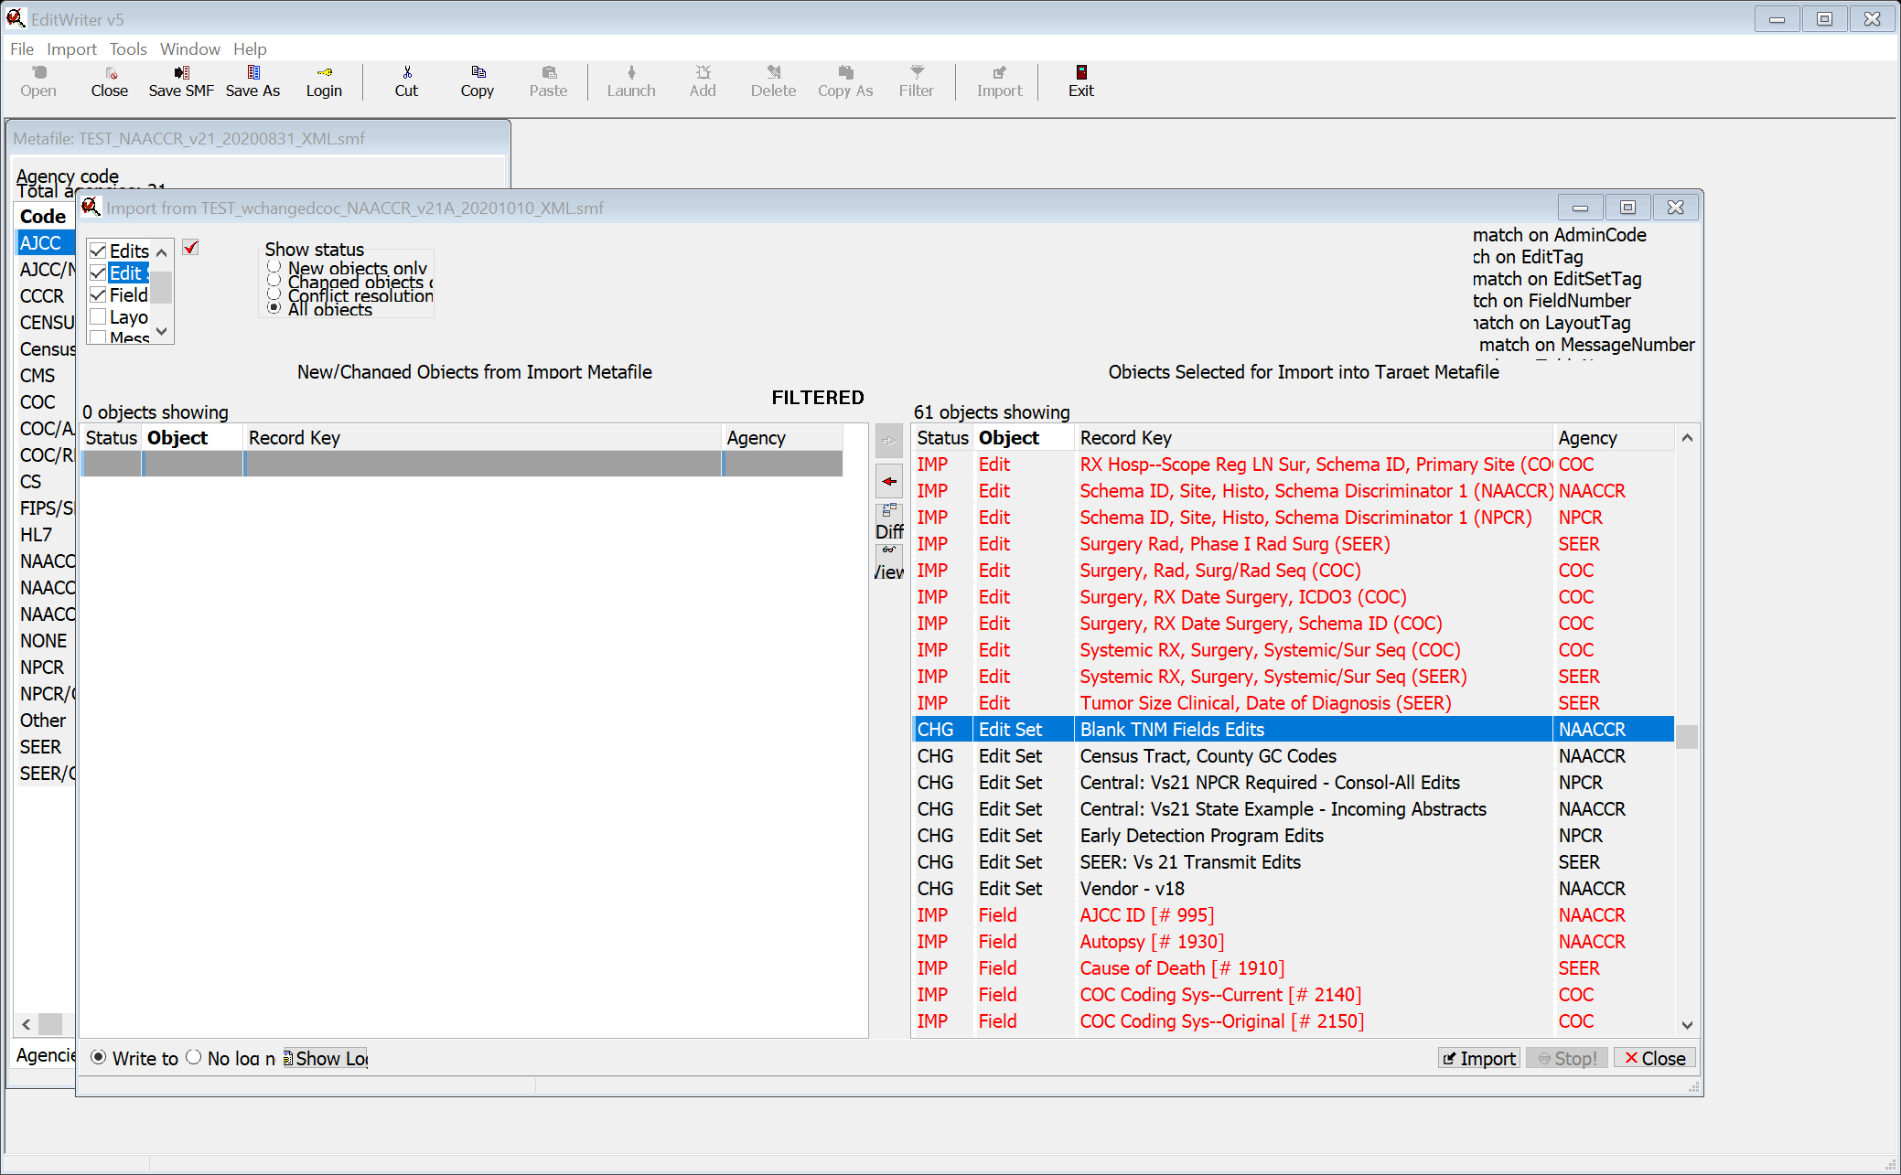
Select Import
Select Import without dependencies
Select do this for all non-conflict objects
Select OK
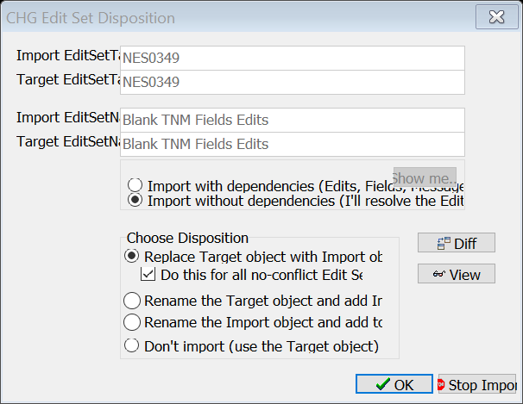
Select Layouts
Select NAACCR v21 XML RP-8
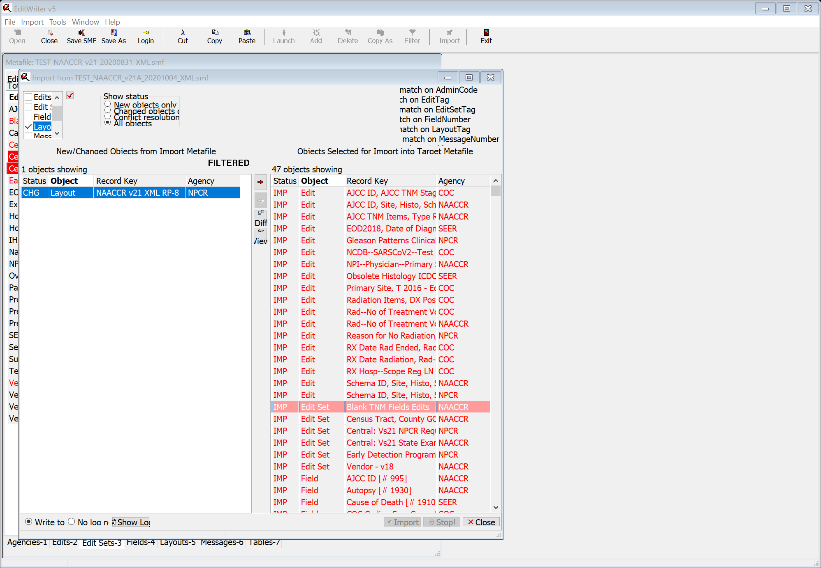
Move to right
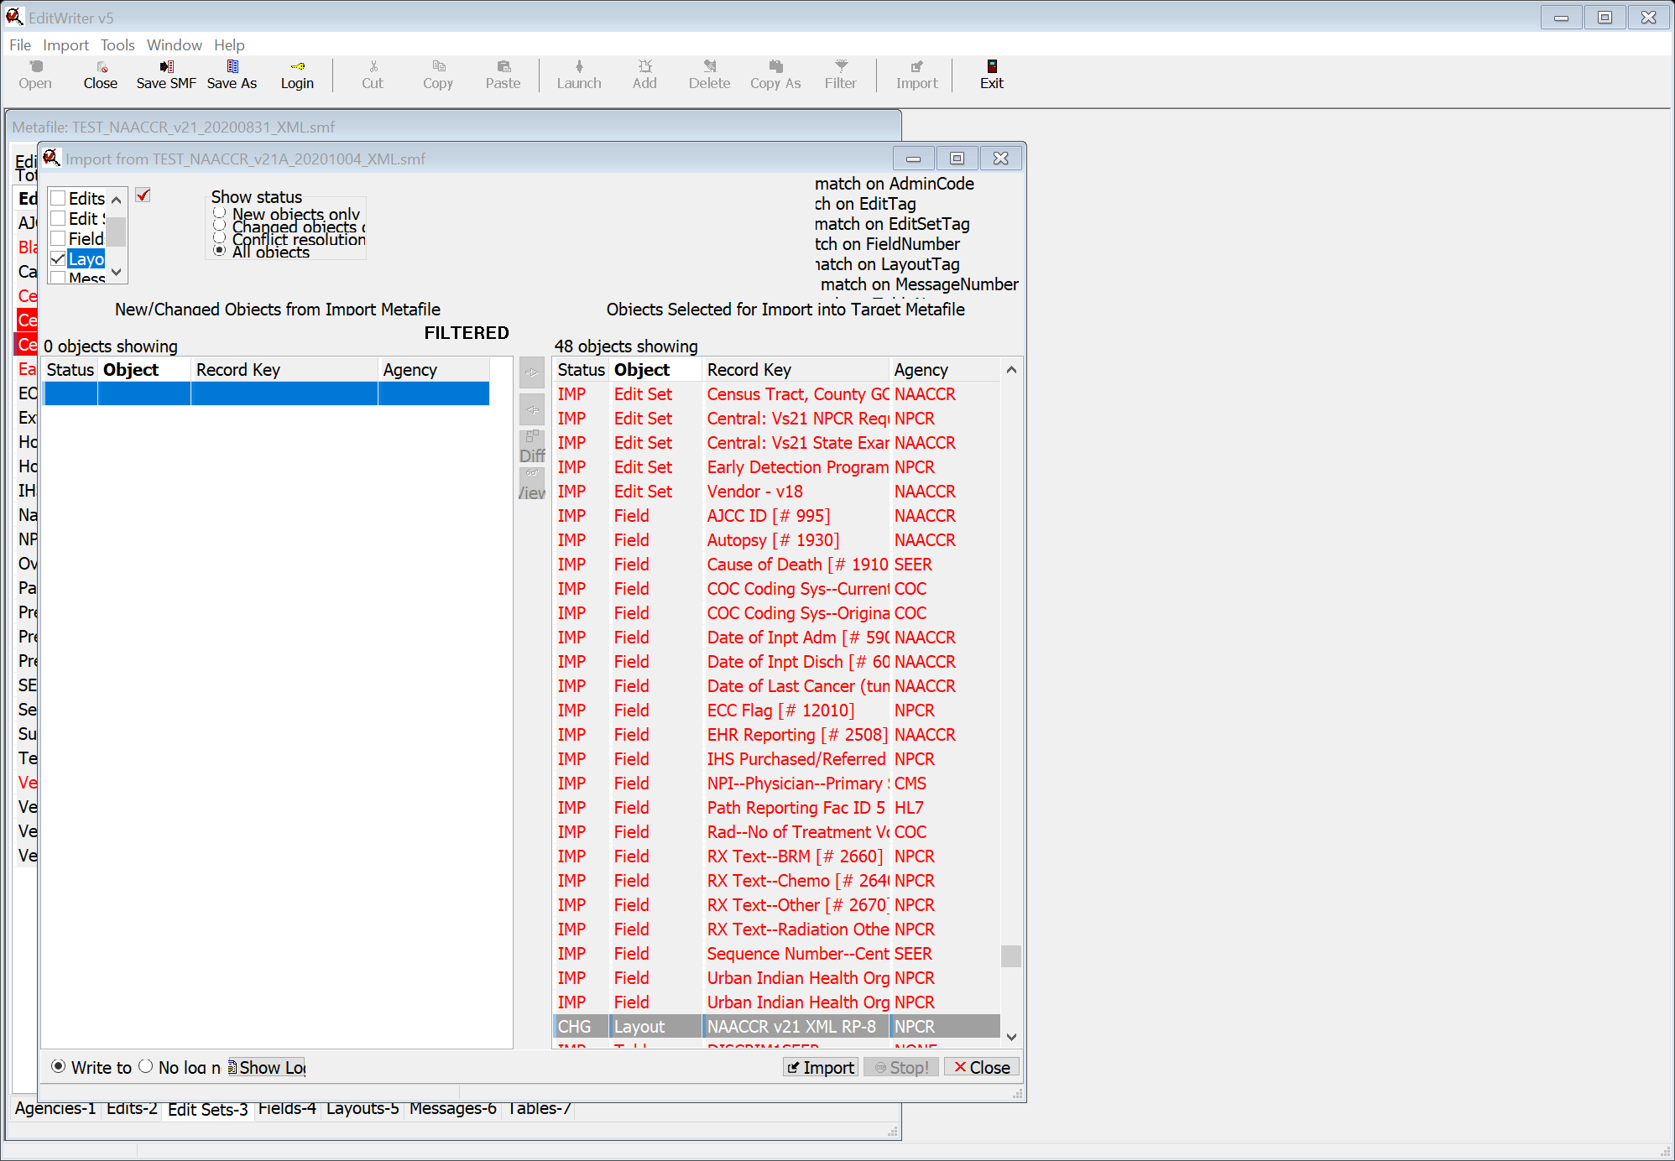
Select Import
Select Import without dependencies
Select OK
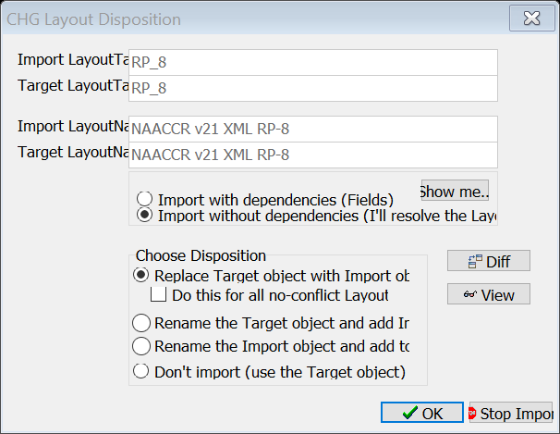

Close Import window
IF CUSTOMIZED DATA ITEMS
Open Layout
Highlight last item in list, ECC Flag, S, 1
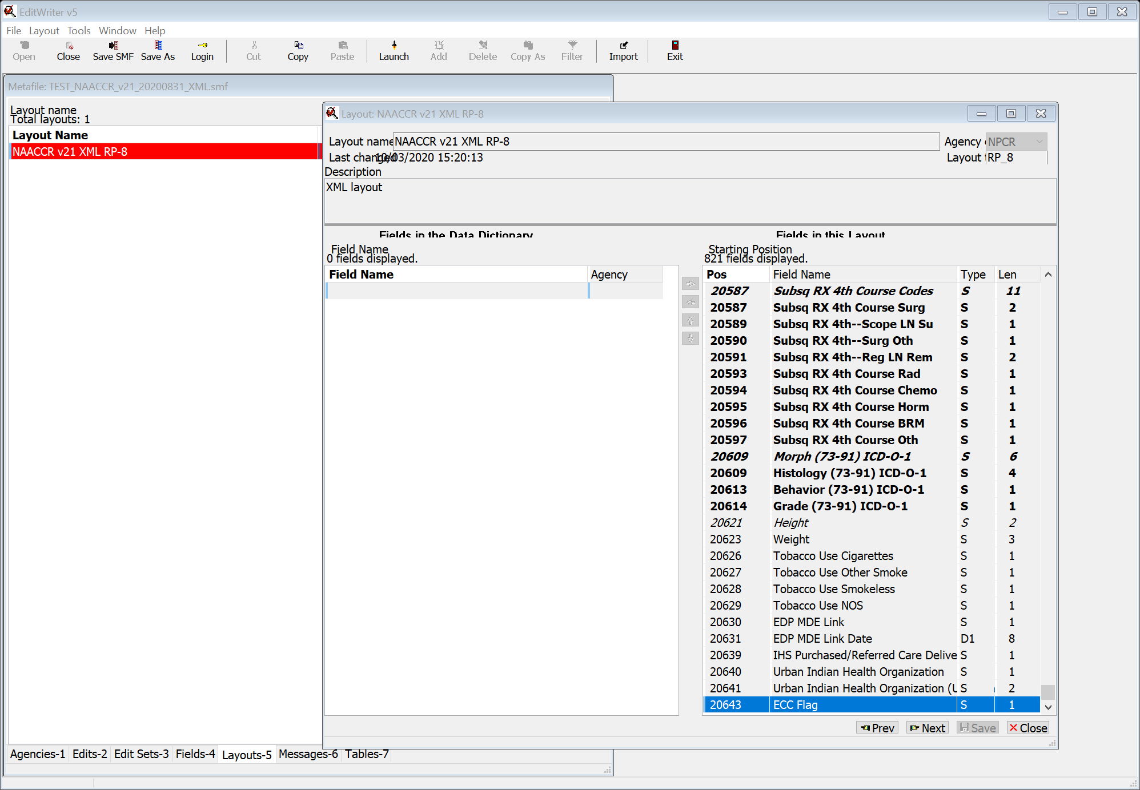
Enter custom fields in Data Dictionary order after 20643, ECC Flag,
Use Report from starting layout to enter fields in correct order
` if necessary
Save Layout and close
Select Tools, Recompile all edits
Verify custom edit sets with report from initial metafile if required
Select Tools, Metafile Version and Comments
Update with appropriate information
Save metafile

