From Edit Writer
Edit – Primary Site, M 2016 – Ed7 (COC-NPCR)

Site: C482 Peritoneum
Histology: 9052/39 (Epithelioid Mesothelioma)
You can see other details on this case below in a couple of tests I ran.
Mesothelioma code is in the Male range and not in the Female range.
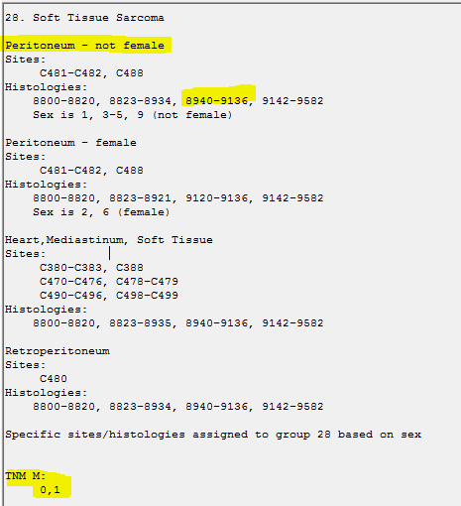
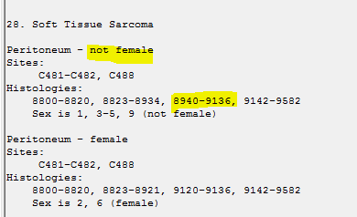
And not in this range.
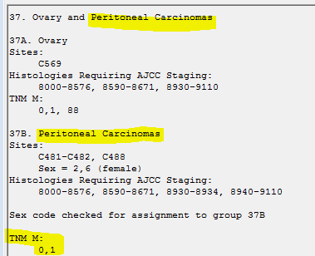

Test Validation with the way I think the case should be coded. The SSF variables are coded due to the options that appear for Peritoneum.
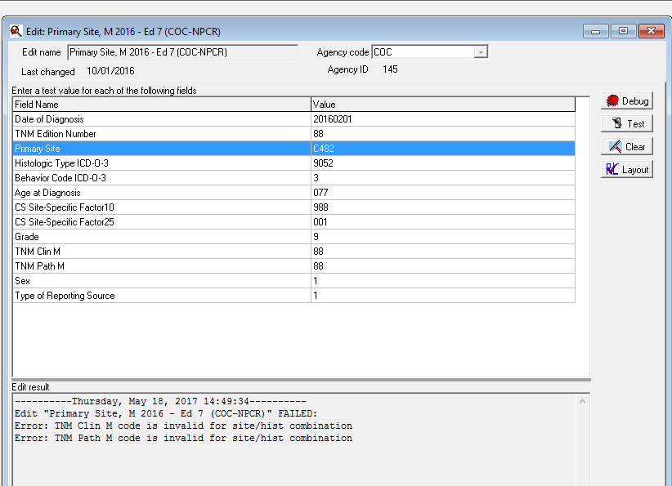
But, if you use the TNM M: 0,1 options given above for the Soft Tissue Peritoneum for Male (non- female) that includes the Mesothelioma code 9052.

